**FINAL PORTFOLIO**

TEAM 4

**CleckShopHub**

**Team Members:**

**Abhishek Poudel 77356791**

**Amulya Shrestha 77356835**

**Biliyas Maharjan 77356769**

**Biraj Shrestha 77356838**

**Shasank Shrestha 77356844**

**Soya Shrestha 77356846**

**Sushan Bhandari 77356704**

**TABLE OF CONTENS**

5. Frequently Asked Questions pg117

# Project Planning

## Project Charter V1

**Project Charter**

|  |
| --- |
| Project Title CleckShopHub |

Version Control

|  |  |  |
| --- | --- | --- |
| Version | Date | Summary of changes |
| 1 | 03/03/24 | Initial version |
|  |  |  |

Project Justification

|  |
| --- |
| The project aims to develop an e-commerce website platform for independent local businesses located in a vibrant suburb of Cleckhuddersfax. These local businesses have grown and offer local products. As national chains and convenience stores are expanding, the local stores are realizing that they need to adapt different measures to satisfy the needs of the customers.  Traders have thus decided to develop a joint e-commerce website as a solution. The website shows various products that they offer and expands their reach beyond normal business hours. Traders want to provide their customers with a pleasant purchasing experience, with an emphasis on convenience which the website can provide.  The e-commerce website is made specifically to address traders' and customers' needs. Customers may easily browse products by shop or category due to the user-friendly layout. Every retailer keeps a unique range of products, giving clients plenty of options. Every user will find the website easy to navigate as it is accessible on both desktop and mobile devices.  An integrated basket that covers every shop, single payment for all products, and simple buying experience is an essential part of the system. Orders are picked up from a specified location. PayPal payment is one of the payment ways that provides security and flexibility.  For traders, the system gives a user-friendly interface to manipulate their products and shop information. Weekly and monthly financial reviews provide insights into income and overall performance. With separate logins for buyers and traders, and an admin interface for management, the website ensures security and privacy.  All things considered, the e-commerce website is a perfect example of a modern and cultural fusion. CleckShopHub is set to fulfill the changing demands of their community while maintaining the integrity of their local shopping by adapting to the present while staying true to their tradition. |

Project Scope

|  |
| --- |
| S - Specific   * Establish an online marketplace, called Cleckshophub, to let inhabitants of Cleckhuddersfax buy locally produced goods by filling the gap between convenience shop hours and consumer schedules. * Ensure that the website is adaptable to various devices and screen sizes. * Provide options for users to sign up, log in, and add items to their shopping carts. * Include a review and rating system to collect product feedback for quality assurance. * Provide a navigation menu for easy browsing of product categories with searching and sorting options. * Provide necessary content, including product images and descriptions. * Ensure secure transactions via PayPal or Stripe to enable users to make payments.   M - Measurable   * Provide traders with reports to help them track sales and get valuable insights. * Track the number of orders and related payments to evaluate the effectiveness of the platform. * Provide an elaborative dashboard that shows the progress of the entire project.   A - Achievable   * Create search and sort functionalities to improve the user experience. * Implement quality control techniques using client feedback and ratings. * Allow unregistered users to add things to their wish lists while encouraging registration for further advantages.   R - Relevant   * Analyze sales data to inform business growth plans for traders. * Collect client input to find areas for enhancement and improve the user experience. * Present statistically important data in a visual format for rapid examination and decisions.   T – Time Bound   * Project Start Date [03/03/2024] * Project Deadline [25/05/2024] |
| **Customer Interface**   * The Customer Interface caters to a vibrant local market, supporting 5 to 10 traders and delivering a diverse choice of products that are easily discovered using an advanced search and sorting engine. * Comprehensive product pages offer important features such as price, nutritional information, and allergens, allowing shoppers to make informed decisions. * Designed for universal accessibility, the interface is responsive across all devices and browsers, increasing user engagement. * Features consolidated shopping cart and wish list capabilities, improving the shopping experience for both visitors and registered customers, as well as increased security through email verification of account actions. * Emphasizes security and usability with a user-friendly layout and safe user data management, providing a trustworthy and efficient purchasing experience. * Features a system for selecting pickup times, assessing orders before confirmation, as well as email summaries after purchase to confirm specifics and build consumer trust. * Enhances product interaction with a quick-view modal, making browsing and purchasing easier by presenting important information and rapid ordering alternatives.     **Trader Interface**   * Traders may easily manage their profiles and product listings, with a full dashboard providing insights into sales, consumer behavior, and inventory management. * Advanced product management capabilities are included, allowing for easy additions, changes, and removals of products via CRUD (Create, Read, Update, Delete) activities, ensuring that their offers stay current and appealing. * Provides sophisticated order management tools that allow traders to track and fulfill client orders effectively using numerous filtering options, hence increasing operational efficiency and customer satisfaction. * It has a secure login system that ensures important corporate information is kept secret and only available to authorized individuals. * Provides access to analytical tools and reports, offering traders with useful data on sales patterns and performance indicators to help them make smart decisions. * Provides a responsive interface design, allowing traders to manage their operations from any device while maintaining flexibility and continual access to their business. * Gives traders the chance to reply to customer evaluations, encouraging direct connection with the customer base and providing an opportunity to enhance service and product offers based on feedback.   ﻿**Management Interface**   * Provides an administrator-only login site for managing the platform's operations. * Allows for the maintenance and monitoring of trader accounts, ensuring a diversified and high-quality product offering. * Provides access to a set of analytics and reporting tools for analyzing sales success and user interaction. * Quality control and product inspection elements are included to ensure that the platform's criteria are met. * Creates weekly reports on orders and financial activities to ensure smooth operations and payments. * Tracks site usage and visitor statistics, which helps with platform strategic planning and improvement. |

Duration

|  |
| --- |
| Project Start Date: 03/03/2024  Initiation Date: 05/03/2024 |

Estimated Budget

|  |  |  |  |  |  |  |  |  |  |  |  |  |  |  |  |  |  |  |  |  |  |  |  |  |  |  |  |  |  |  |  |  |  |  |  |  |  |  |  |  |
| --- | --- | --- | --- | --- | --- | --- | --- | --- | --- | --- | --- | --- | --- | --- | --- | --- | --- | --- | --- | --- | --- | --- | --- | --- | --- | --- | --- | --- | --- | --- | --- | --- | --- | --- | --- | --- | --- | --- | --- | --- |
| |  |  |  |  |  | | --- | --- | --- | --- | --- | | Team Member | Hours per day | Days per week | Total working week | Total working hours | | Abhishek Poudel | 3 | 5 | 10 | 150 | | Amulya Shrestha | 3 | 5 | 10 | 150 | | Biliyas Maharjan | 3 | 5 | 10 | 150 | | Biraj Shrestha | 4 | 5 | 10 | 200 | | Shasank Shrestha | 4 | 5 | 10 | 200 | | Soya Shrestha | 3 | 5 | 10 | 150 | | Sushan Bhandari | 3 | 5 | 10 | 150 |   Total Working Hours: 1150 Hours |

Roles and Responsibilities

|  |  |
| --- | --- |
| Name | Role |
| Abhishek Poudel |  |
| Amulya Shrestha |  |
| Biliyas Maharjan |  |
| Biraj Shrestha |  |
| Shasank Shrestha |  |
| Soya Shrestha |  |
| Sushan Bhandari |  |

## Project Charter V2

**Project Charter V2**

|  |
| --- |
| Project Title: CleckShopHub |

Version Control

|  |  |  |
| --- | --- | --- |
| Version | Date | Summary of changes |
| 1 | 03/03/24 | Initial version |
| 2 | 05/05/2024 | Updated Project Justification, Project Scope, and Roles |

Project Justification

|  |
| --- |
| The project aims to develop an e-commerce website platform for independent local businesses located in a vibrant suburb of Cleckhuddersfax. These local businesses have grown and offer local products. As national chains and convenience stores are expanding, the local stores are realizing that they need to adapt different measures to satisfy the needs of the customers.  Traders have thus decided to develop a joint e-commerce website as a solution. The website shows various products that they offer and expands their reach beyond normal business hours. Traders want to provide their customers with a pleasant purchasing experience, with an emphasis on convenience which the website can provide.  The e-commerce website is made specifically to address traders' and customers' needs. Customers may easily browse products by shop or category due to the user-friendly layout. Every retailer keeps a unique range of products, giving clients plenty of options. Every user will find the website easy to navigate as it is accessible on both desktop and mobile devices. All customers whether registered or not can add product to their cart.  An integrated basket that covers every shop, single payment for all products, and simple buying experience is an essential part of the system. Customer can share feedback based on their personal experience. Orders are picked up from a specified location. PayPal payment is one of the payment ways that provides security and flexibility.  For traders, the system gives a user-friendly interface to manipulate their products and shop information. Weekly and monthly financial reviews provide insights into income and overall performance. With separate logins for buyers and traders, and an admin interface for management, the website ensures security and privacy.  All things considered, the e-commerce website is a perfect example of a modern and cultural fusion. CleckShopHub is set to fulfill the changing demands of their community while maintaining the integrity of their local shopping by adapting to the present while staying true to their tradition. |

Project Scope

|  |
| --- |
| S - Specific   * Establish an online marketplace, called Cleckshophub, to let inhabitants of Cleckhuddersfax buy locally produced goods by filling the gap between convenience shop hours and consumer schedules. * Ensure that the website is adaptable to various devices and screen sizes. * Provide options for users to sign up, log in, and add items to their shopping carts. * Include a review and rating system to collect product feedback for quality assurance. * Provide a navigation menu for easy browsing of product categories with searching and sorting options. * Provide necessary content, including product images and descriptions. * Ensure secure transactions via PayPal or Stripe to enable users to make payments.   M - Measurable   * Provide traders with reports to help them track sales and get valuable insights. * Track the number of orders and related payments to evaluate the effectiveness of the platform. * Provide an elaborative dashboard that shows the progress of the entire project.   A - Achievable   * Create search and sort functionalities to improve the user experience. * Implement quality control techniques using client feedback and ratings. * Allow unregistered users to add things to their wish lists while encouraging registration for further advantages.   R - Relevant   * Analyze sales data to inform business growth plans for traders. * Collect client input to find areas for enhancement and improve the user experience. * Present statistically important data in a visual format for rapid examination and decisions.   T – Time Bound   * Project Start Date [03/03/2024] * Project Deadline [24/05/2024] |
| **Customer Interface**   * The Customer Interface caters to a vibrant local market, supporting 5 to 10 traders and delivering a diverse choice of products that are easily discovered using an advanced search and sorting engine. * Comprehensive product pages offer important features such as price, nutritional information, and allergens, allowing shoppers to make informed decisions. * Designed for universal accessibility, the interface is responsive across all devices and browsers, increasing user engagement. * Features consolidated shopping cart and favorite items capabilities, improving the shopping experience for both visitors and registered customers, as well as increased security through email verification of account actions. * Emphasizes security and usability with a user-friendly layout and safe user data management, providing a trustworthy and efficient purchasing experience. * Features such as user reviews allows customers to provide feedback based on their personal experiences, assisting traders in gaining insights into their products. * Features a system for selecting pickup times, assessing orders before confirmation, as well as email summaries after purchase to confirm specifics and build consumer trust. * Enhances product interaction with a quick-view modal, making browsing and purchasing easier by presenting important information and rapid ordering alternatives.   **Trader Interface**   * Traders may easily manage their profiles and product listings, with a full dashboard providing insights into sales, consumer behavior, and inventory management. * Advanced product management capabilities are included, allowing for easy additions, changes, and removals of products via CRUD (Create, Read, Update, Delete) activities, ensuring that their offers stay current and appealing. * Provides sophisticated order management tools that allow traders to track and fulfill client orders effectively using numerous filtering options, hence increasing operational efficiency and customer satisfaction. * It has a secure login system that ensures important corporate information is kept secret and only available to authorized individuals. * Provides access to analytical tools and reports, offering traders with useful data on sales patterns and performance indicators to help them make smart decisions. * Provides a responsive interface design, allowing traders to manage their operations from any device while maintaining flexibility and continual access to their business. * Gives traders the chance to reply to customer evaluations, encouraging direct connection with the customer base and providing an opportunity to enhance service and product offers based on feedback.   ﻿**Management Interface**   * Provides an administrator-only login site for managing the platform's operations. * Allows for the maintenance and monitoring of trader accounts, ensuring a diversified and high-quality product offering. * Provides access to a set of analytics and reporting tools for analyzing sales success and user interaction. * Quality control and product inspection elements are included to ensure that the platform's criteria are met. * Creates weekly reports on orders and financial activities to ensure smooth operations and payments. * Tracks site usage and visitor statistics, which helps with platform strategic planning and improvement. |

Duration

|  |
| --- |
| Project Start Date: 03/03/2024  Initiation Date: 05/03/2024  Planning Date: 15/05/2024  Execution Date: 15/05/2024 |

Estimated Budget

|  |  |  |  |  |  |  |  |  |  |  |  |  |  |  |  |  |  |  |  |  |  |  |  |  |  |  |  |  |  |  |  |  |  |  |  |  |  |  |  |  |
| --- | --- | --- | --- | --- | --- | --- | --- | --- | --- | --- | --- | --- | --- | --- | --- | --- | --- | --- | --- | --- | --- | --- | --- | --- | --- | --- | --- | --- | --- | --- | --- | --- | --- | --- | --- | --- | --- | --- | --- | --- |
| |  |  |  |  |  | | --- | --- | --- | --- | --- | | Team Member | Hours per day | Days per week | Total working week | Total working hours | | Abhishek Poudel | 3 | 5 | 10 | 150 | | Amulya Shrestha | 3 | 5 | 10 | 150 | | Biliyas Maharjan | 3 | 5 | 10 | 150 | | Biraj Shrestha | 4 | 5 | 10 | 200 | | Shasank Shrestha | 4 | 5 | 10 | 200 | | Soya Shrestha | 3 | 5 | 10 | 150 | | Sushan Bhandari | 3 | 5 | 10 | 150 |   Total Working Hours: 1150 Hours |

Roles and Responsibilities

|  |  |
| --- | --- |
| Name | Role |
| Abhishek Poudel | Team Member (Primary role: Plant) |
| Amulya Shrestha | Team Recorder and Documentation Manager (Primary role: Resource Investigator) |
| Biliyas Maharjan | Team Member (Primary role: Team Worker) |
| Biraj Shrestha | Team Leader [Shared] (Primary role: Co-Ordinator) |
| Shasank Shrestha | Team Leader [Shared] (Primary role: Co-Ordinator) |
| Soya Shrestha | Team Recorder and Documentation Manager (Primary role: Team Worker) |
| Sushan Bhandari | Team Member (Primary role: Implementer) |

## c.Belbin Analysis

### I. Team Belbin Analysis

|  |  |  |
| --- | --- | --- |
|  | **Team Belbin’s Analysis** |  |
| Primary Role | Abhisek Poudel | Plant |
| Amulya Shrestha | Resource Investigator |
| Biliyas Maharjan | Team Worker |
| Biraj Shrestha | Co-Ordinator |
| Shashank Shrestha | Co-Ordinator |
| Soya Shrestha | Team Worker |
| Sushan Bhandari | Implementer |
| Secondary Role | Abhisek Poudel | Resource Investigator |
| Amulya Shrestha | Plant |
| Biliyas Maharjan | Implementer |
| Biraj Shrestha | Complete Finisher |
| Shashank Shrestha | Specialist |
| Soya Shrestha | Monitor Evaluator |
| Sushan Bhandari | Co-Ordinator |
| Least Likely Role | Abhisek Poudel | Shaper |
| Amulya Shrestha | Shaper |
| Biliyas Maharjan | Monitor Evaluator |
| Biraj Shrestha | Plant |
| Shashank Shrestha | Complete Finisher |
| Soya Shrestha | Shaper |
| Sushan Bhandari | Specialist |

### II. Individual Belbin Analysis

|  |  |  |
| --- | --- | --- |
|  | **Individual Belbin’s Analysis** | |
| Primary role | Abhisekh Poudel | Plant |
| Secondary role | Abhisek Poudel | Resource Investigator |
| Least likely role | Abhisek Poudel | Shaper |

|  |  |  |
| --- | --- | --- |
|  | **Individual Belbin’s Analysis** | |
| Primary role | Amulya Shrestha | Resource Investigator |
| Secondary role | Amulya Shrestha | Plant |
| Least likely role | Amulya Shrestha | Shaper |

|  |  |  |
| --- | --- | --- |
|  | **Individual Belbin’s Analysis** | |
| Primary role | Biliyas Maharjan | Team Worker |
| Secondary role | Biliyas Maharjan | Implementer |
| Least likely role | Biliyas Maharjan | Monitor Evaluator |

|  |  |  |
| --- | --- | --- |
|  | **Individual Belbin’s Analysis** | |
| Primary role | Biraj Shrestha | Co-Ordinator |
| Secondary role | Biraj Shrestha | Complete Finisher |
| Least likely role | Biraj Shrestha | Plant |

|  |  |  |
| --- | --- | --- |
|  | **Individual Belbin’s Analysis** | |
| Primary role | Shashank Shrestha | Co-Ordinator |
| Secondary role | Shashank Shrestha | Specialist |
| Least likely role | Shashank Shrestha | Complete Finisher |

|  |  |  |
| --- | --- | --- |
|  | **Individual Belbin’s Analysis** | |
| Primary role | Soya Shrestha | Team Worker |
| Secondary role | Soya Shrestha | Monitor Evaluator |
| Least likely role | Soya Shrestha | Shaper |

|  |  |  |
| --- | --- | --- |
|  | **Individual Belbin’s Analysis** | |
| Primary role | Sushan Bhandari | Implementer |
| Secondary role | Sushan Bhandari | Co-Ordinator |
| Least likely role | Sushan Bhandari | Specialist |

## d. Skill Audit

### I. Team Skills Audit

### 

### II. Individual Skills Audit



Figure : Abhishek Poudel Individual Skill Audit



Figure : Amulya Shrestha Individual Skill Audit



Figure : Biliyas Maharjan Individual Skill Audit



Figure : Biraj Shrestha Individual Skill Audit



Figure : Shasank Shrestha Individual Skill Audit



Figure : Soya Shrestha Individual Skill Audit



Figure : Sushan Bhandari Individual Skill Audit

## e. Project Management

### I. Gantt Chart

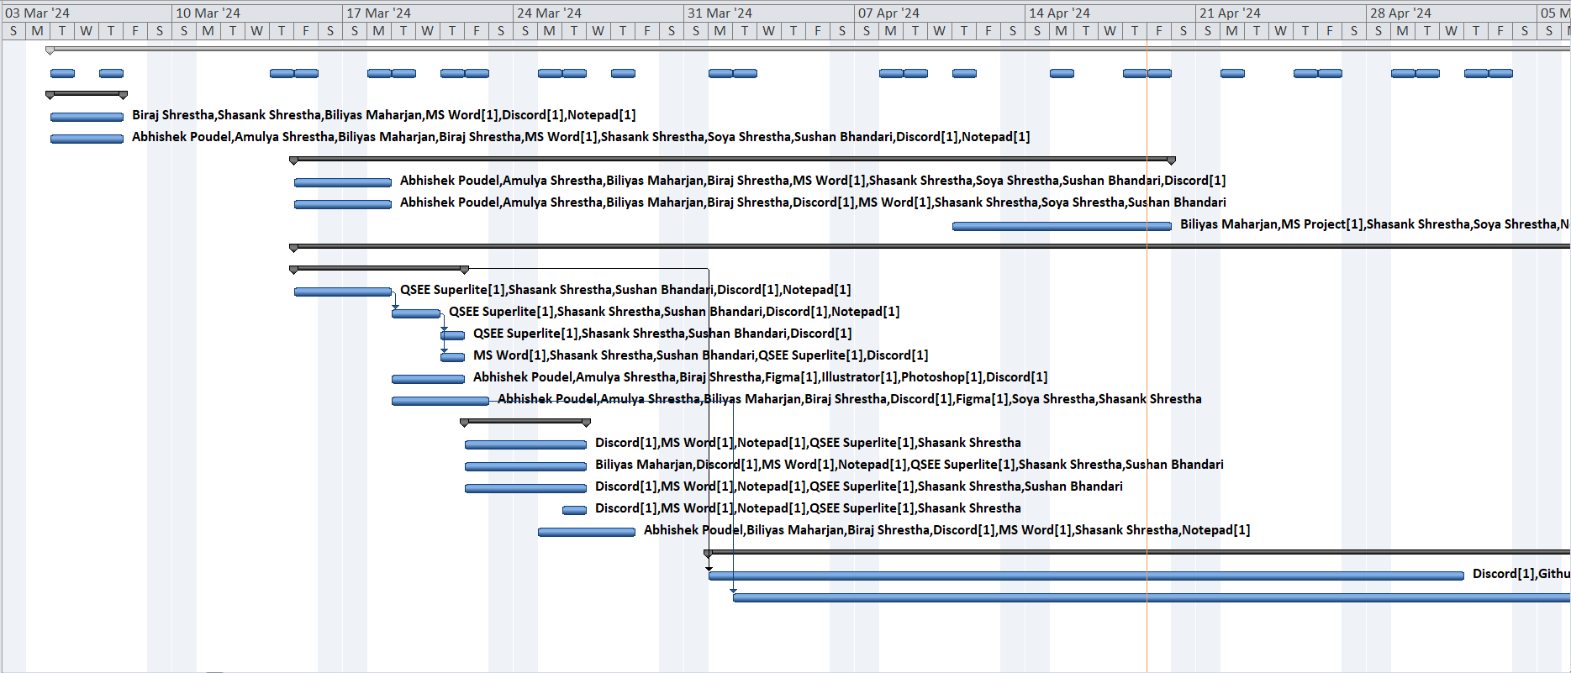

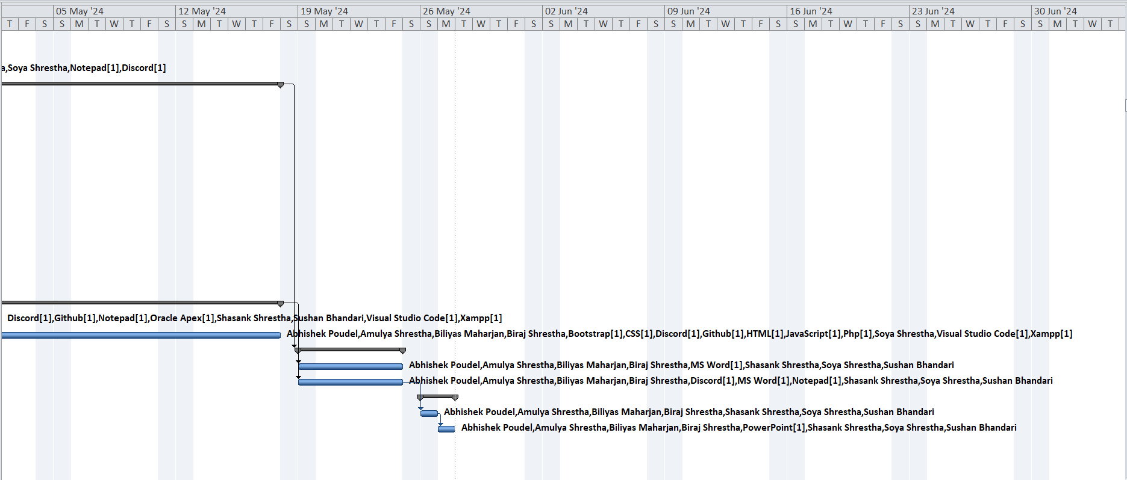

### II. Task Sheet

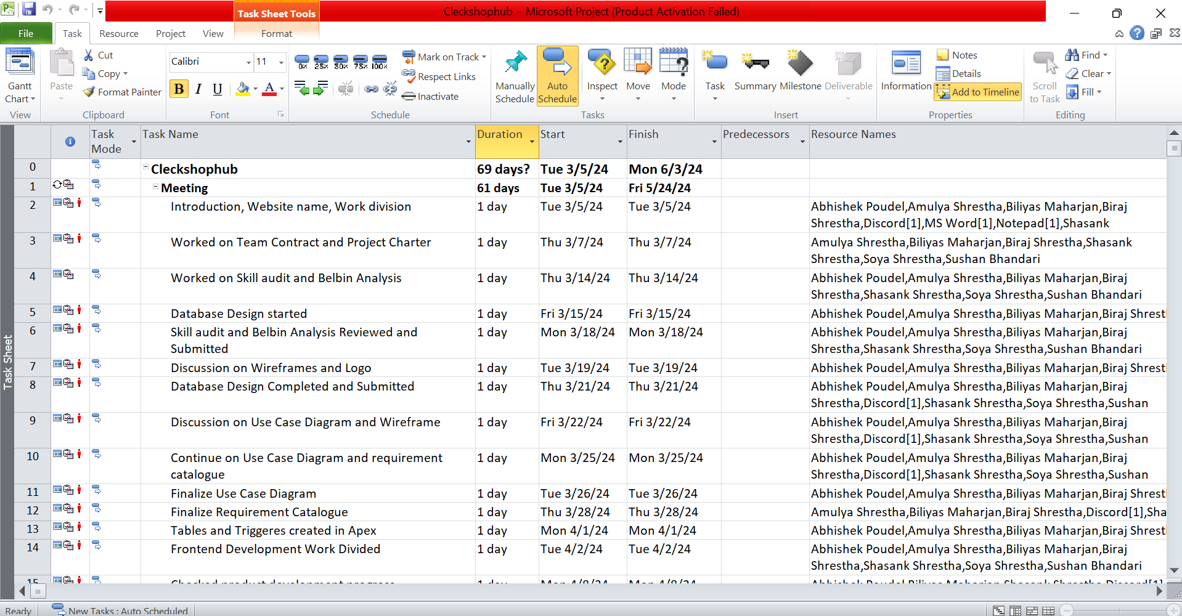

### 

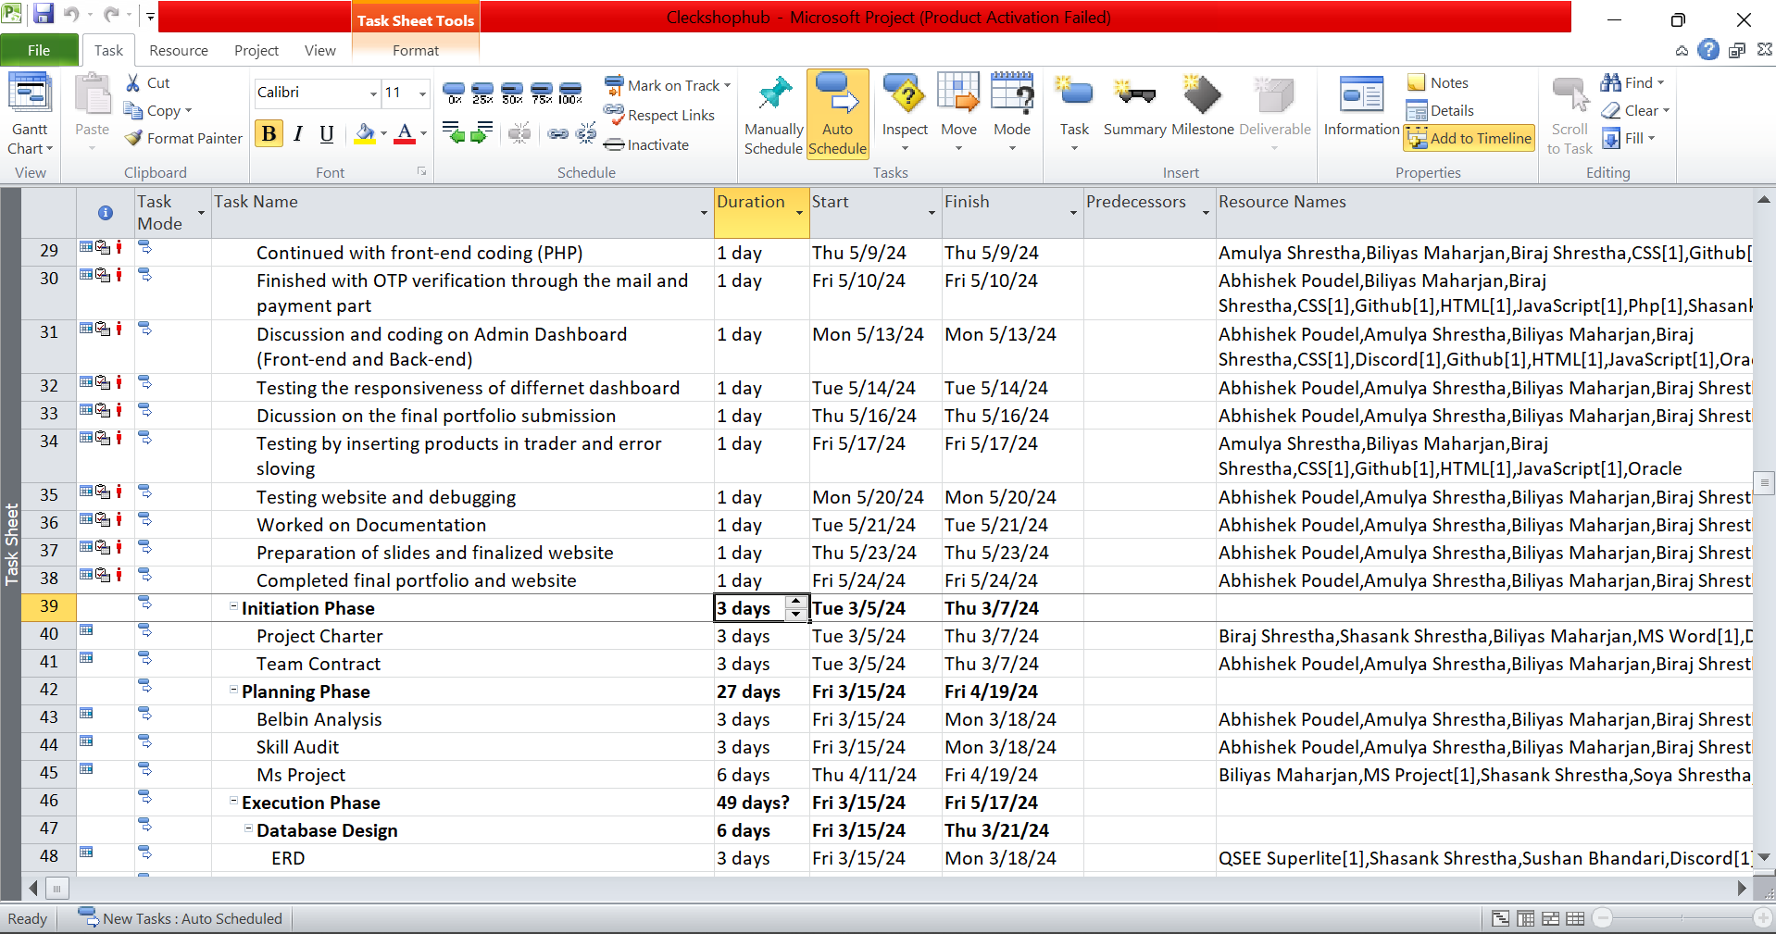

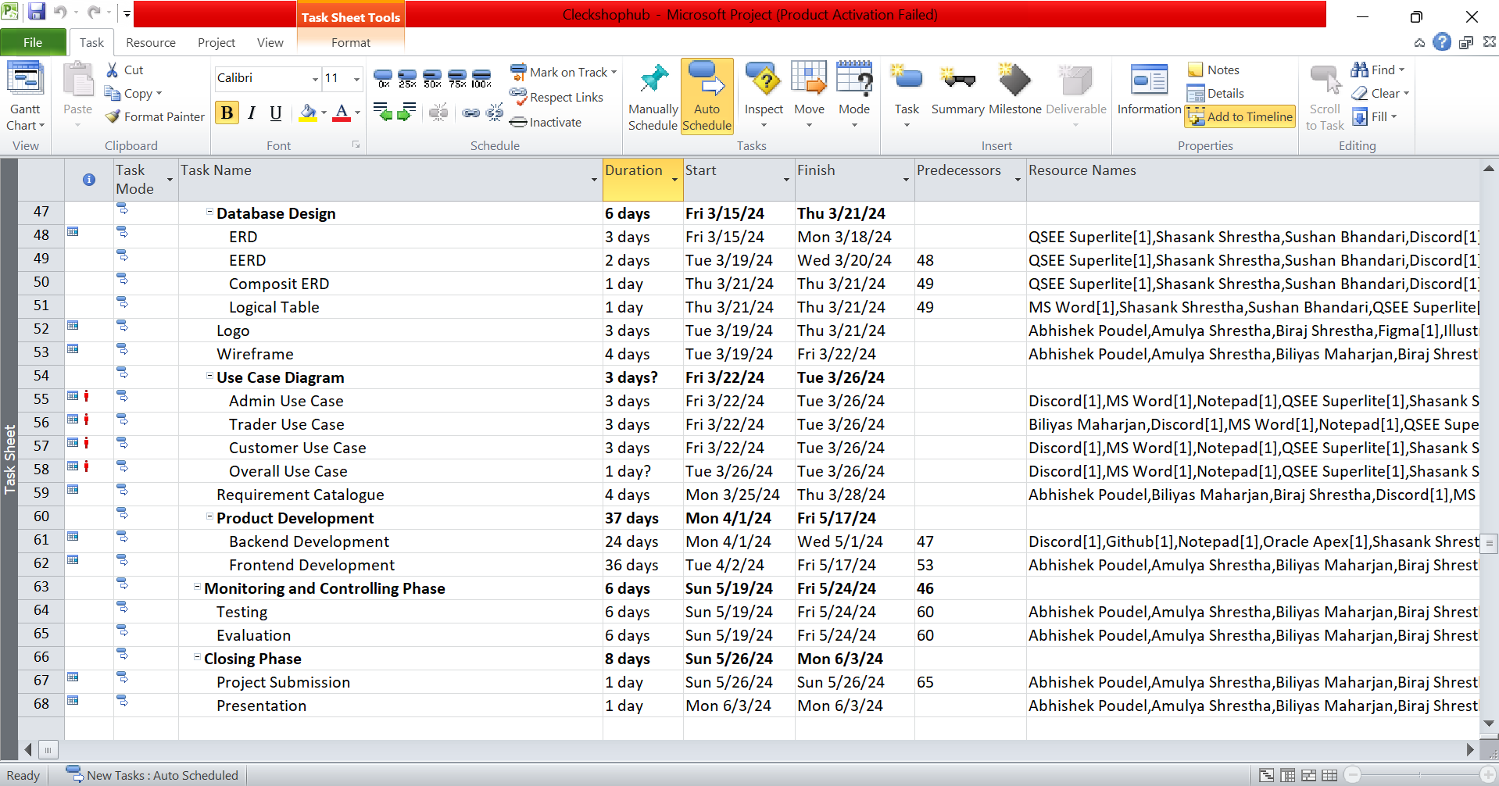

### III. Timeline

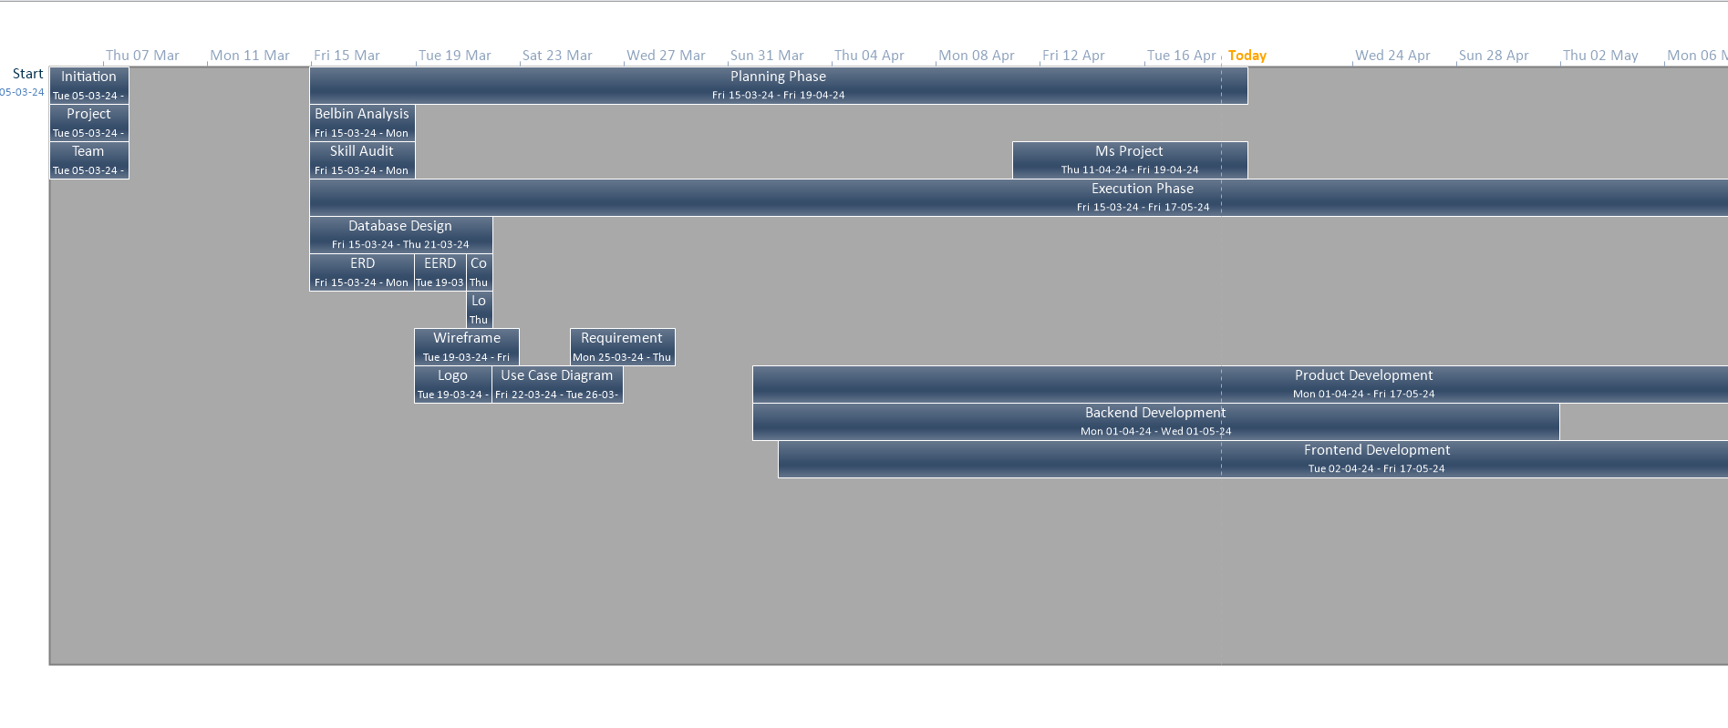

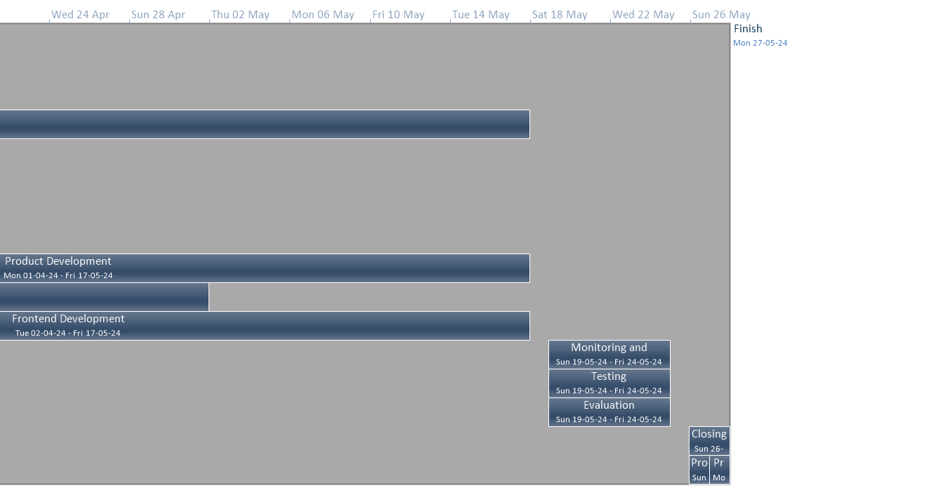

### IV. Resource Sheet

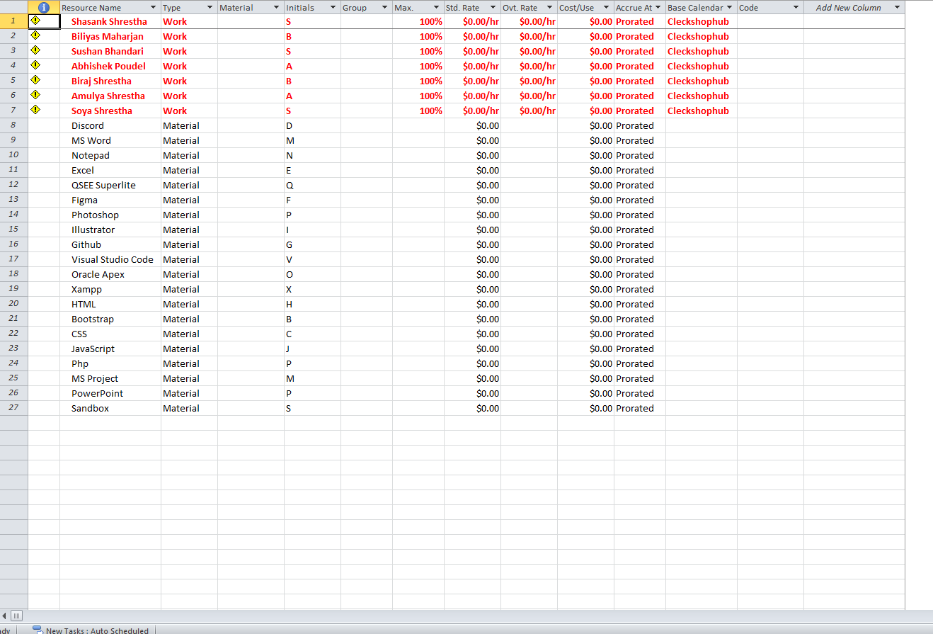

### V. Calendar

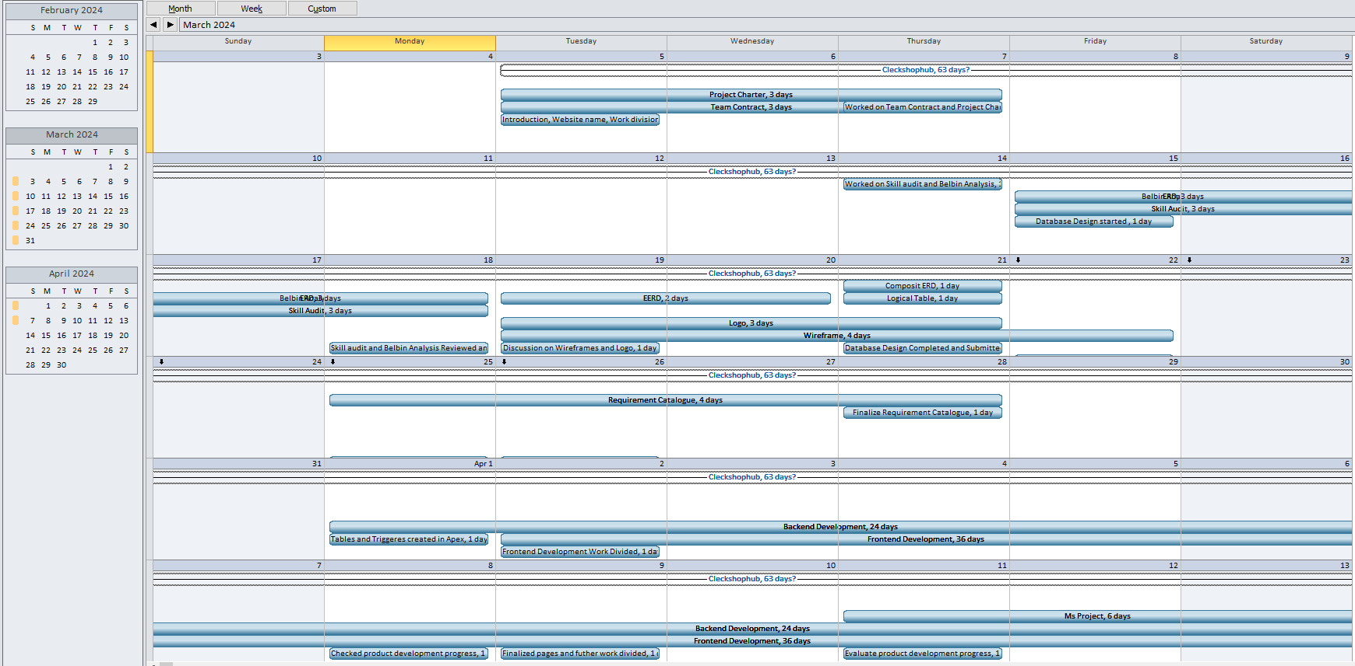

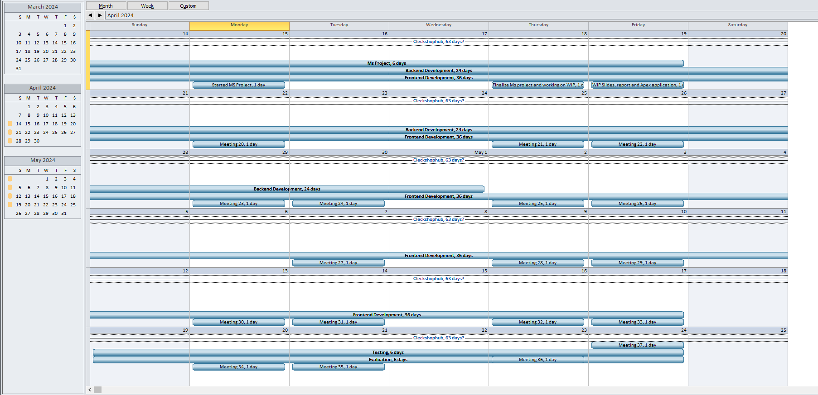

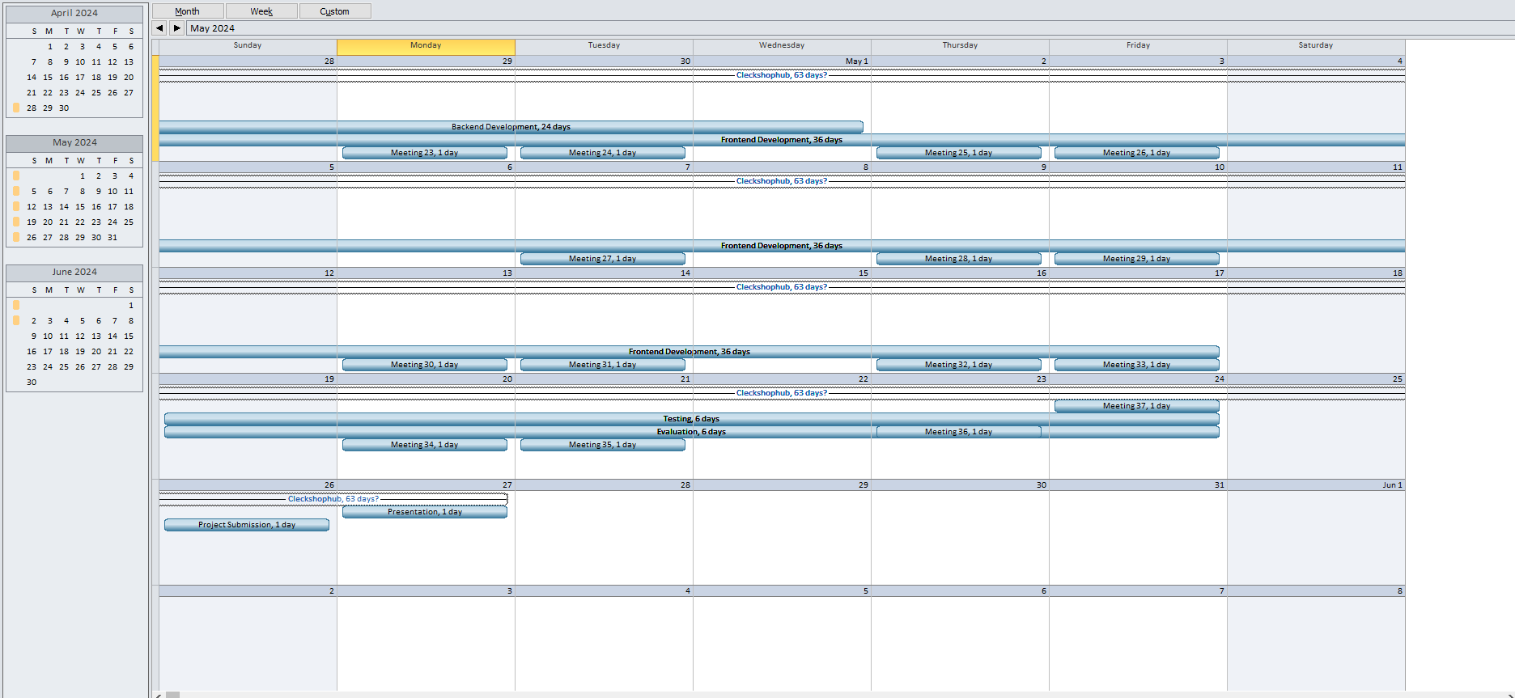

### VII. Change in Working Time

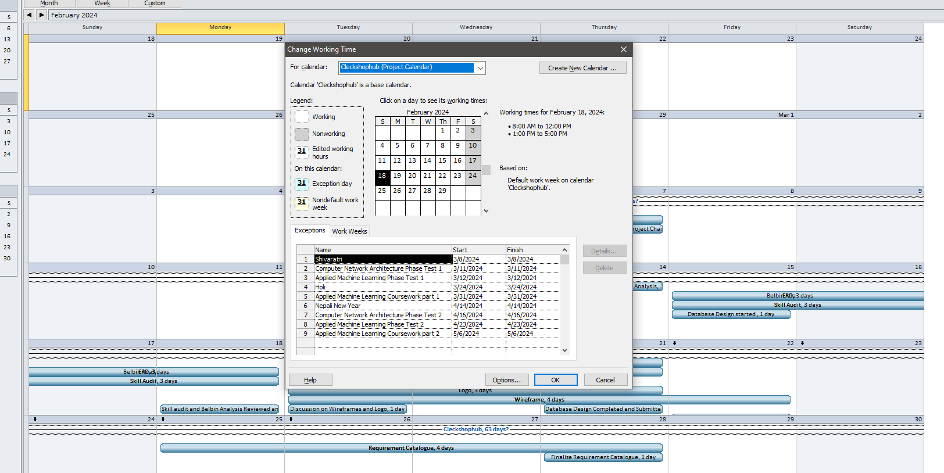

## f. Communication and collaboration tools

### I. Discord

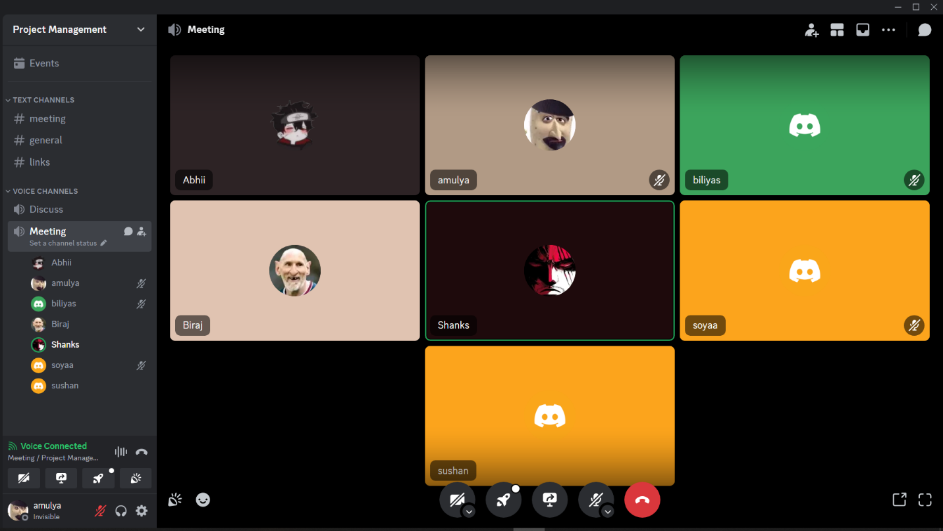

### II. Github

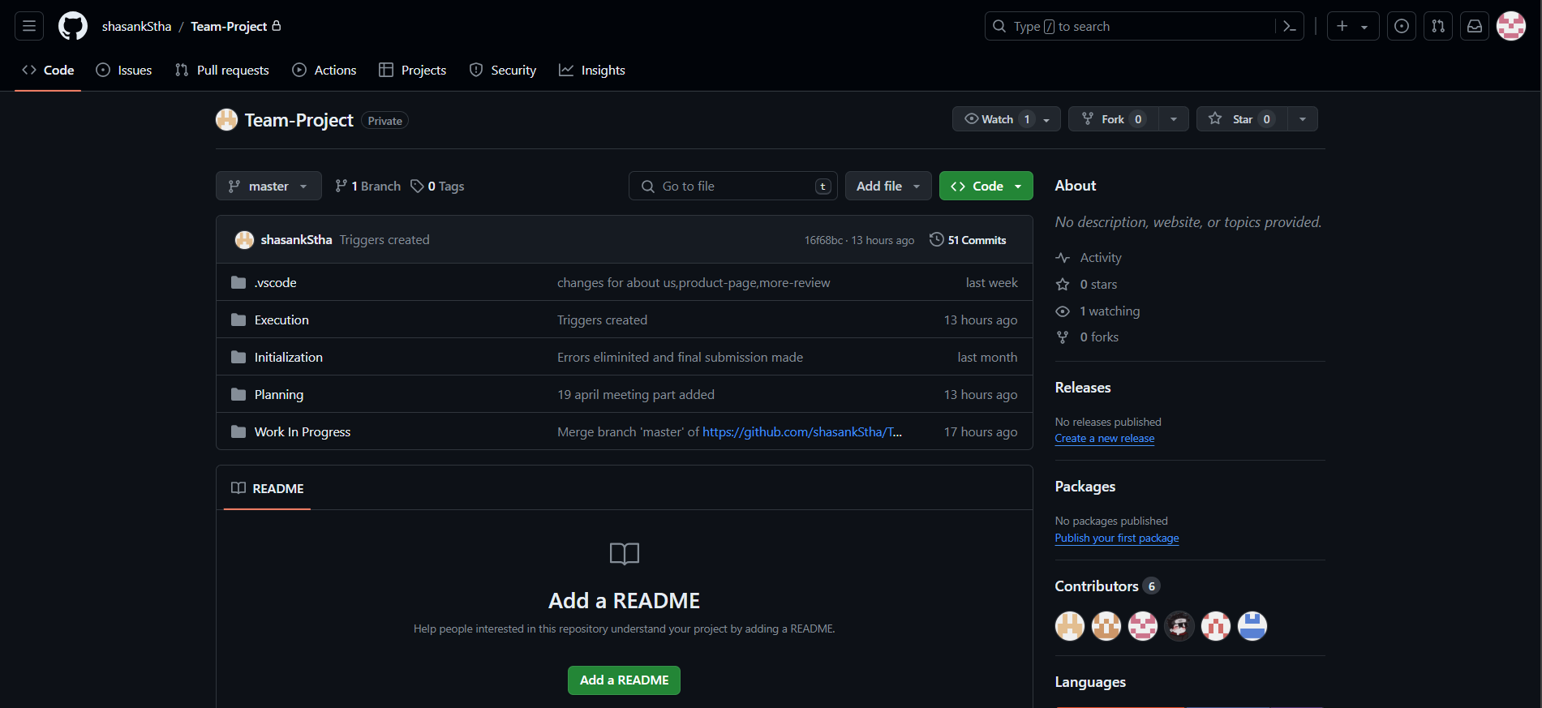

## g. Team Meetings

**Virtual Meeting:**

**Day 1(03/05/24): (Online)**

**Objectives:**

* Introduction of the team members
* Division of work among the team members.
* Website name decided (i.e. CleckShopHub).

**Day 2 (03/07/24): (Online)**

**Objectives:**

* Began with the contract work and project charter.
* Deliberation and agreement on the project contract.

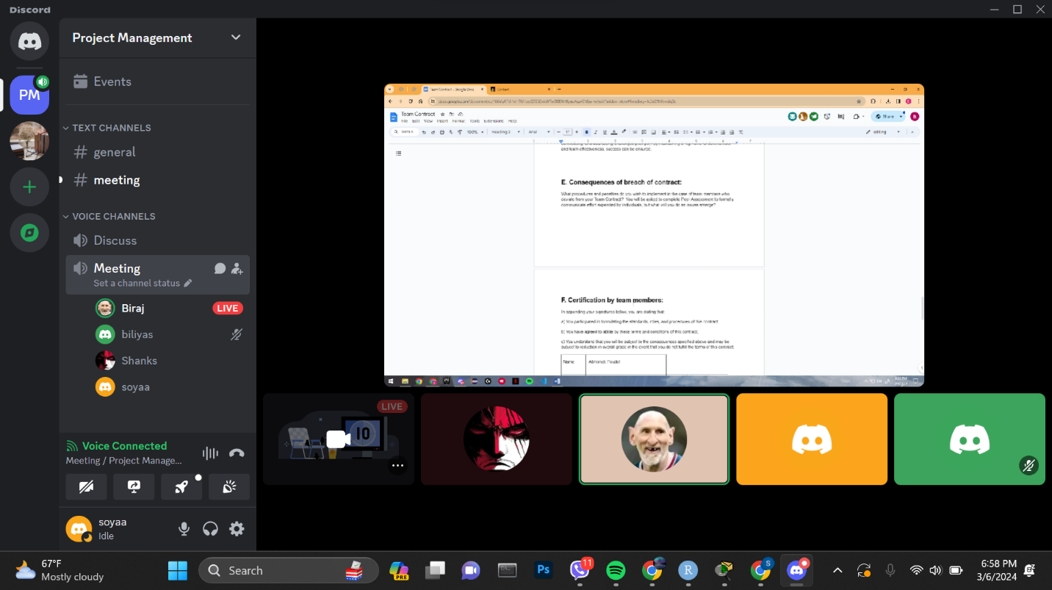

**Day 3 (03/14/24): (Online)**

**Objectives:**

* Reflected upon individual strengths and weaknesses for Skill audit.
* Decided and discussed suitable Belbin roles for each member.

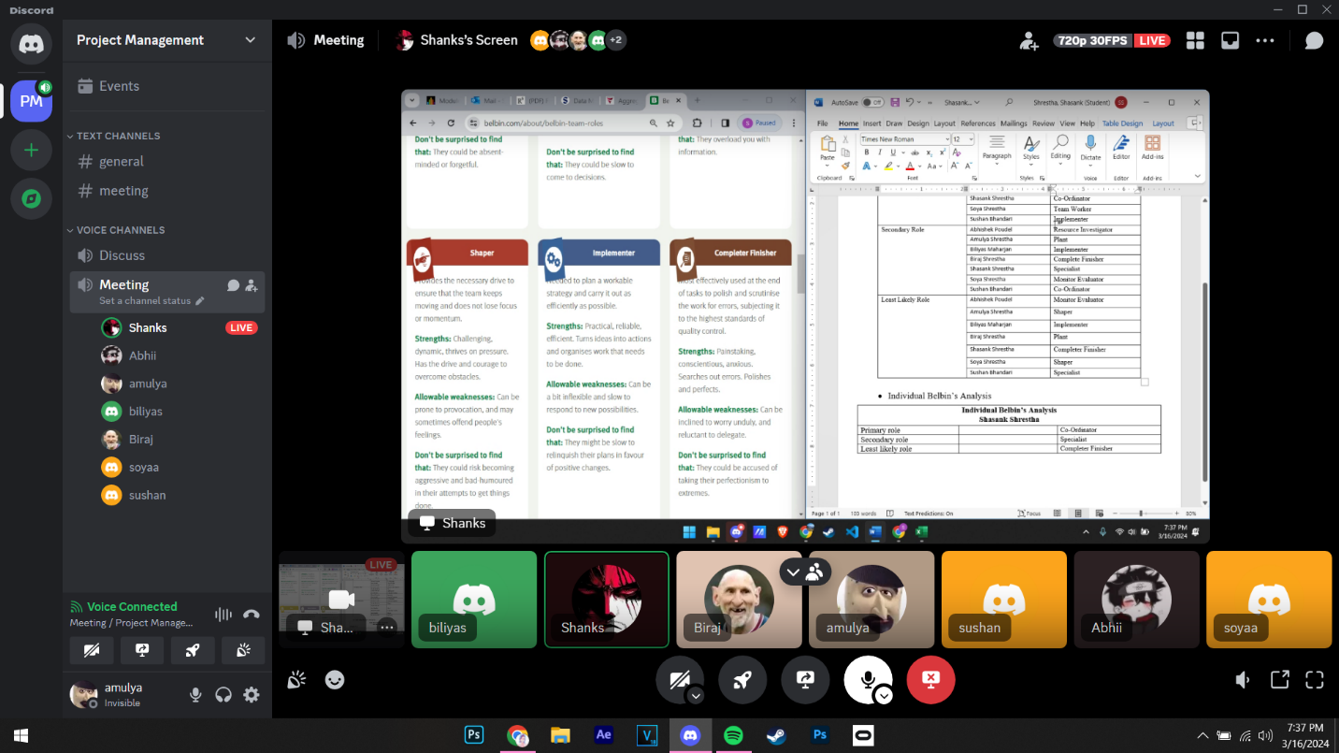

**Day 4(03/15/24): (Online)**

**Objectives:**

* Prepared ERD diagram to design database models used in our site.

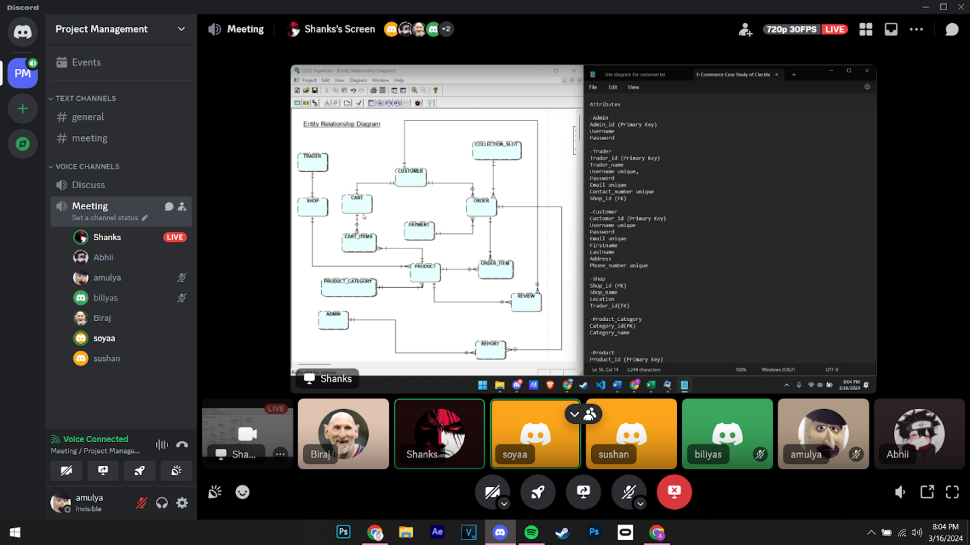

**Day 5(03/18/24): (Physical)**

**Objectives:**

* Began creating wireframes for web pages using Figma.
* Continued working on the ERD.
* Discussion on the logo.
* Started designing a website logo
* Commenced work on the wireframe.

**Day 6(03/19/24): (Physical)**

**Objectives:**

* Made various versions of logo

**Day 7(03/21/24): (Online)**

**Objectives:**

* EERD/ERD/Final Composite & Decomposition ERD/ Logical Table discussion and submission.
* Continued making wireframes.

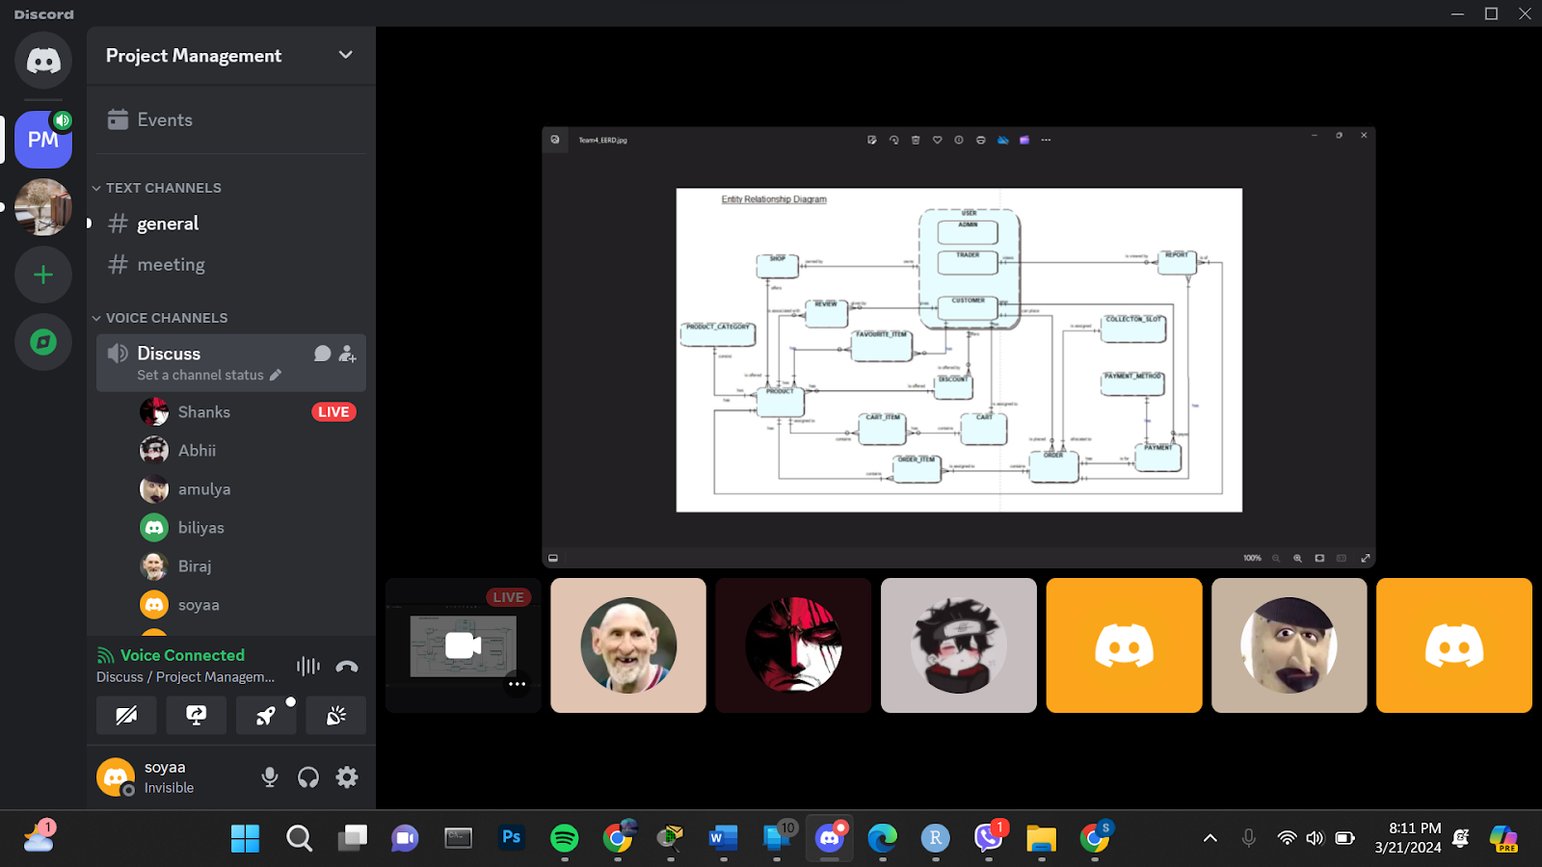

**Day 8(03/22/24):**

**Objectives:**

* Started working on Use Case Diagram
* Continued Wireframe.
* Started working on use case diagram
* Discussion on Functional and Non-Functional Requirements.

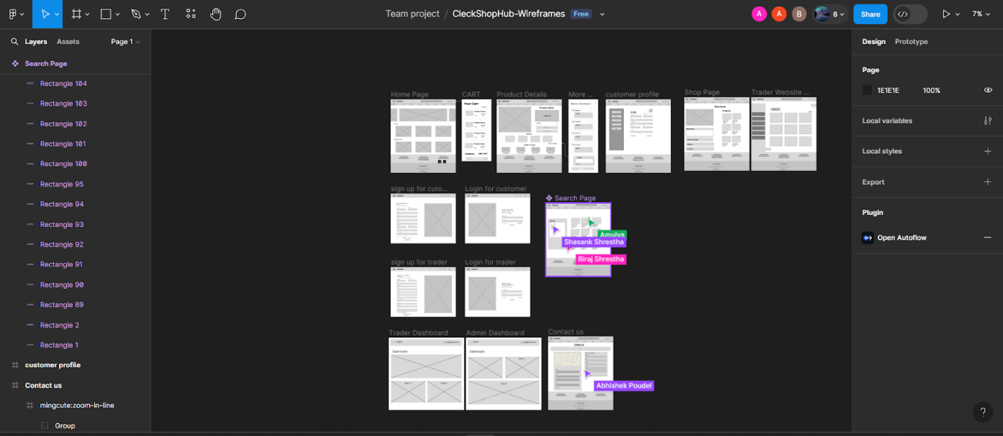

**Day 9(03/25/24):**

**Objectives:**

* Worked on Functional and non-functional requirements

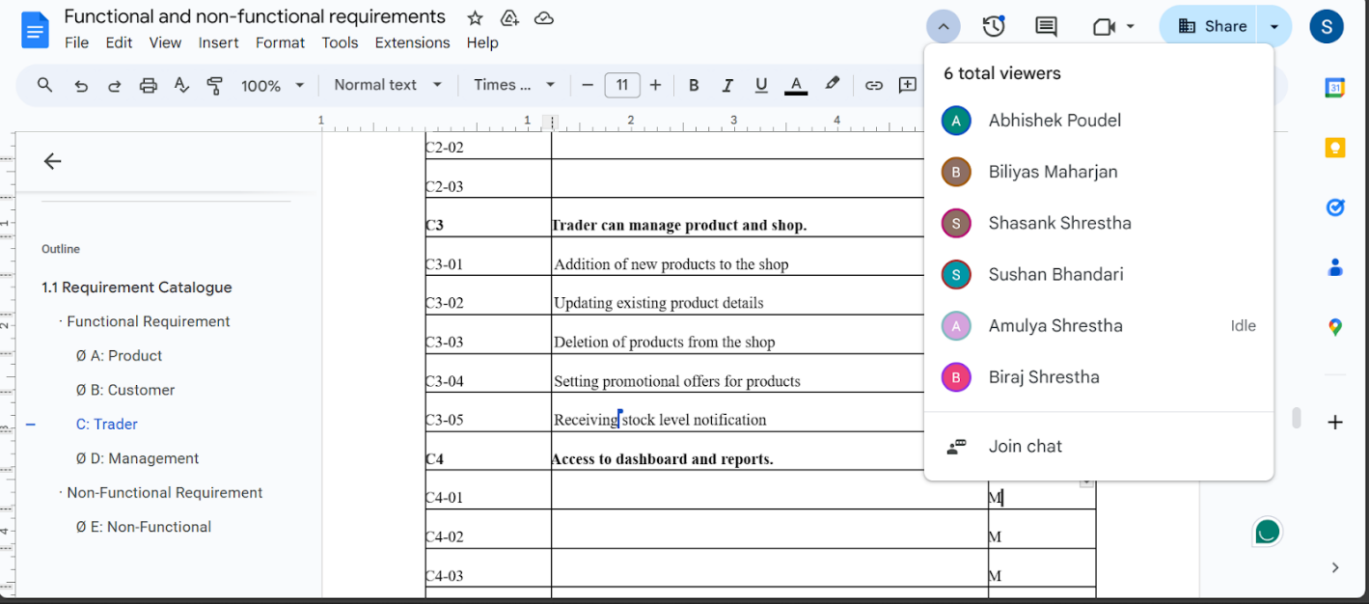

**Day 10(03/26/24): (Online)**

**Objectives:**

* Finalizing Use Case Diagram
* Discussion on Functional and Non-Functional Requirements.

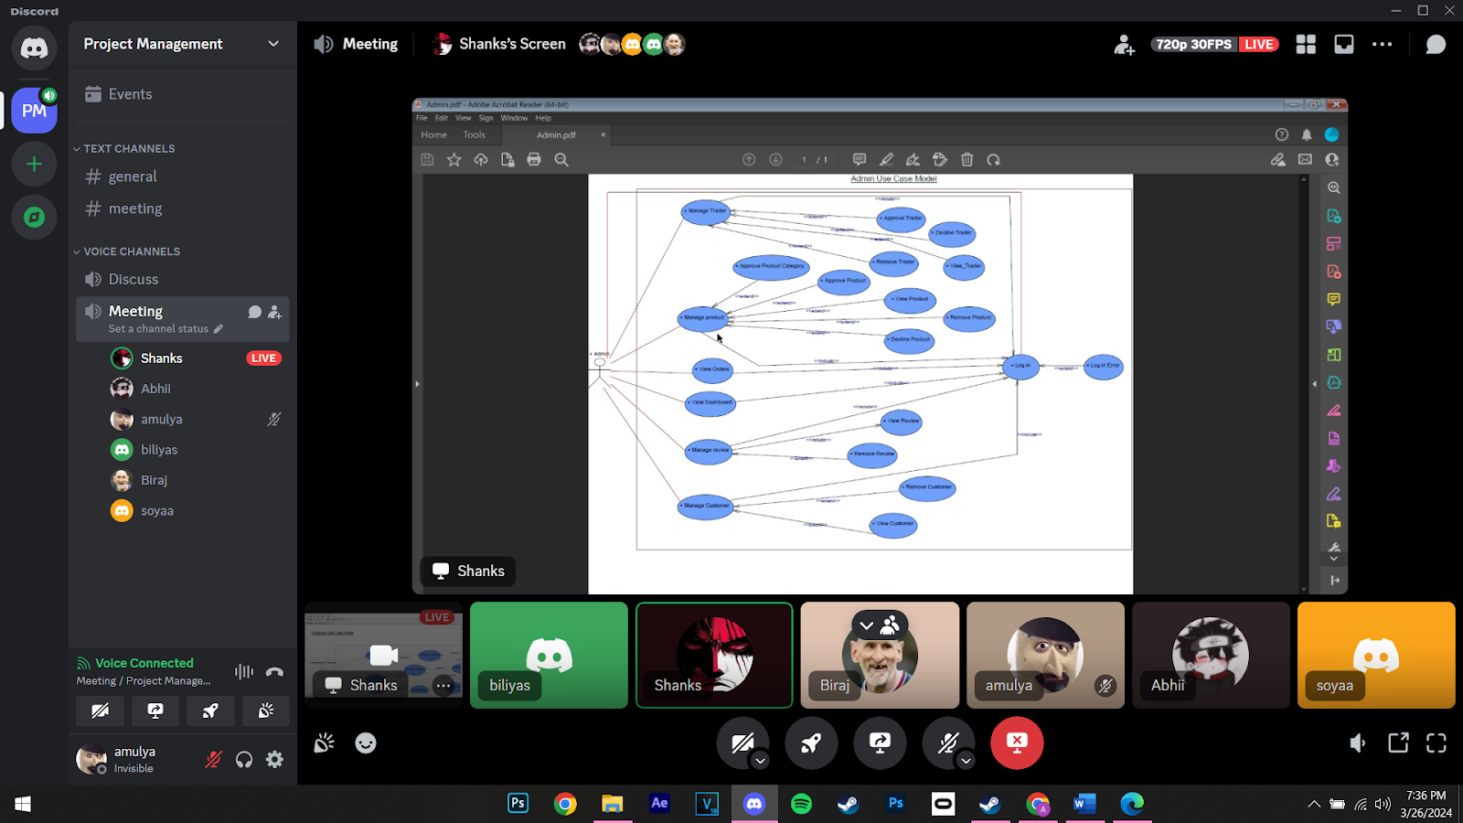

**Day 11(03/28/24): (Online)**

**Objectives:**

* Submission of Use case diagram and functional and non-functional requirements.

**Day 12(04/01/24): (Online)**

**Objectives:**

* Submission of Use case diagram and functional and non-functional requirements.
* Commenced making tables and triggers in Apex

**Day 13(04/02/24): (Physical)**

**Objectives:**

* Discussion on how to further proceed on the project
* Division on individual work (HTML, CSS)
* Table created in the database

**Day 14(04/08/24): (Physical)**

**Objectives:**

* Checked on individual progress.
* Discussion on what changes should be made in HTML and CSS
* Triggers were created in the database

**Day 15(04/09/24): (Physical)**

**Objectives:**

* Finalized the HTML and CSS work and decided how to combine individual works.
* Individual work was pushed, creating each folder in the GIT hub

**Day 16(04/11/24): (Physical)**

**Objectives:**

* Discussion on work progress and how to further proceed with the project

**Day 17(04/15/24): (Online)**

**Objectives:**

* Started maintaining schedules on MS Project

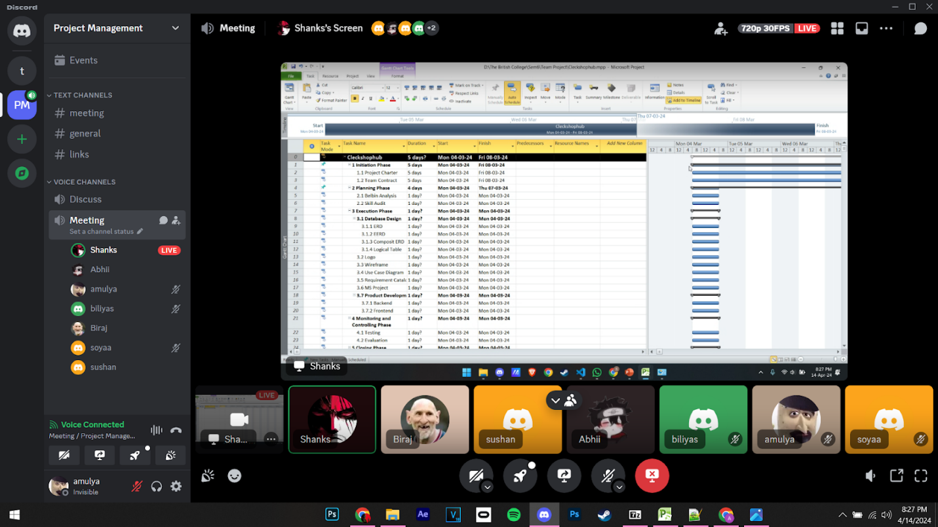

**Day 18(04/18/24): (Online)**

**Objectives:**

* Finalized ms project
* Made necessary changes in slides and word file for wip

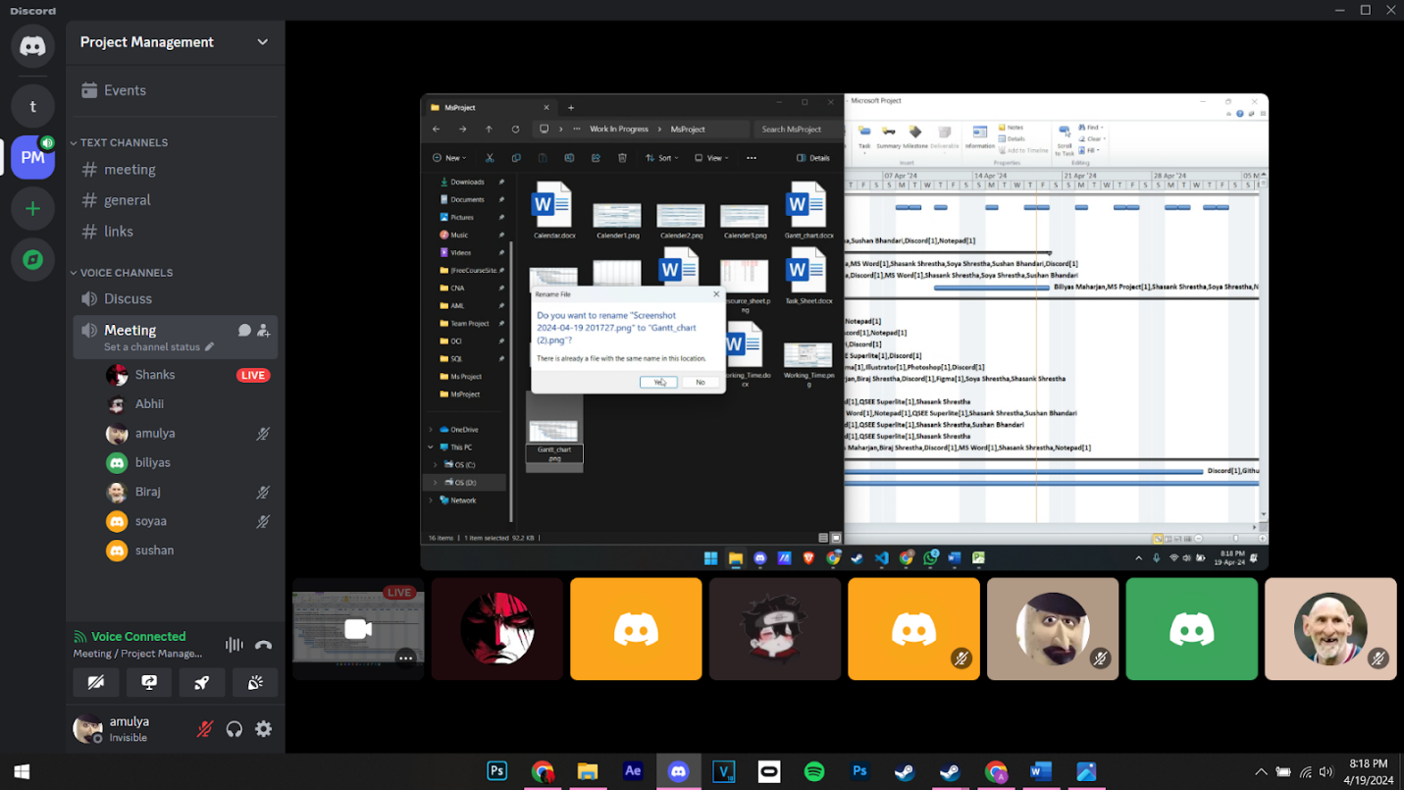

**Day 19(04/19/24): (Physical)**

**Objectives:**

* Finalized ms project
* Made necessary changes in slides and word file for wip

**Day 20(04/22/24): (Physical)**

**Objectives:**

* Finalized and submitted WIP Files

**Day 21(04/25/24): (Physical)**

**Objectives:**

* Troubleshooted OCI Connection

**Day 22(04/26/24): (Physical)**

**Objectives:**

* Prepared for WIP presentation

**Day 23(04/29/24): (Physical)**

**Objectives:**

* Practiced for WIP presentation also continuing front-end coding

**Day 24(04/30/24): (Physical)**

**Objectives:**

Continued practising for WIP presentation

**Day 25(05/02/24): (Physical)**

**Objectives:**

* Demo presentation before WIP presentation

**Day 26(05/03/24): (Physical)**

**Objectives:**

* Division of front-end part among team members

**Day 27(05/07/24): (Physical)**

**Objectives:**

* Discussion on the progress of front-end and back-end coding

**Day 28(05/09/24): (Physical)**

**Objectives:**

* Continued with front-end coding (PHP)

**Day 29(05/10/24): (Physical)**

**Objectives:**

* Finished with OTP verification through the mail and payment part

**Day 30(05/13/24): (Physical)**

**Objectives:**

* Discussion and coding on Admin Dashboard (Front-end and Back-end)

**Day 31(05/14/24): (Physical)**

**Objectives:**

* Testing the responsiveness of differnet dashboard

**Day 32(05/16/24): (Physical)**

**Objectives:**

* Dicussion on the final portfolio submission

**Day 33(05/17/24): (Physical)**

**Objectives:**

* Testing by inserting products in trader and error solving

**Day 34(05/20/24): (Physical)**

**Objectives:**

* Testing website and debugging

**Day 35(05/21/24): (Physical)**

**Objectives:**

* Worked on Documentation

**Day 36(05/23/24): (Physical)**

**Objectives:**

* Preparation of slides and finalized website

**Day 37(05/24/24): (Physical)**

**Objectives:**

* Completed final portfolio and website

# 2. Product Designing

# a. EERD

## I. ERD

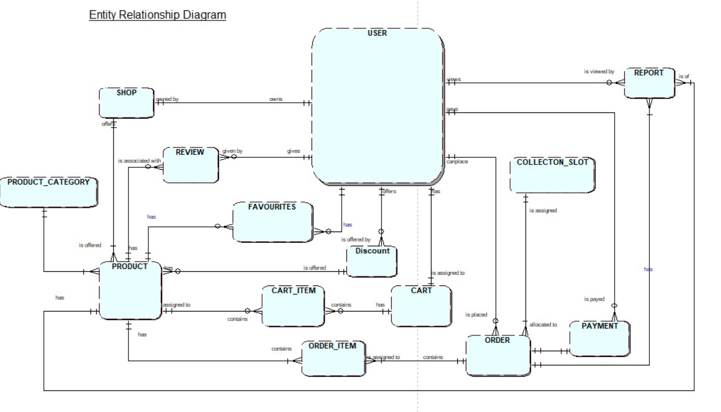

## II. EERD

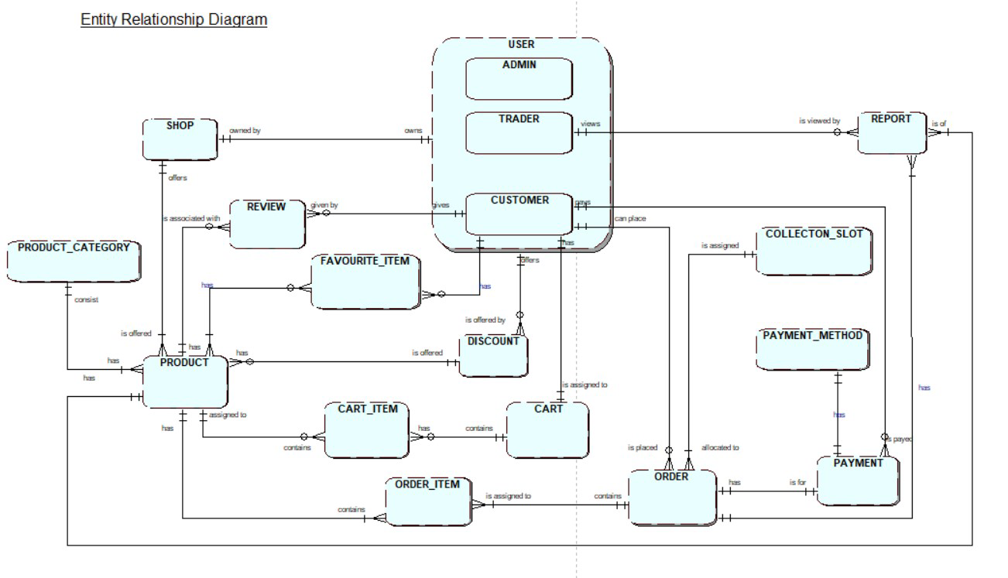

## III. Composite EERD

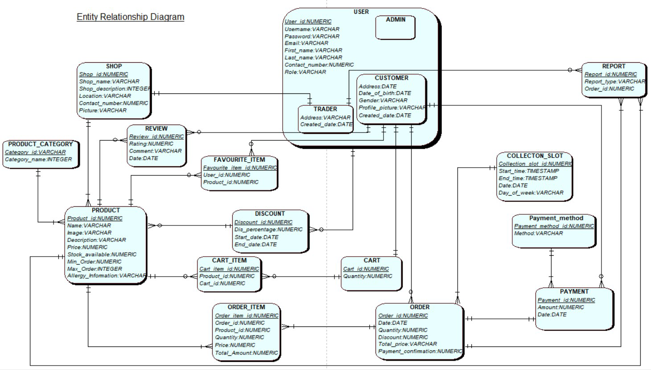

## IV.Logical Table

1. USER(**User_id**, Username, Password, Email, First_name, Last_name, Contact_number, Role)
2. ADMIN(***User_id***)
3. TRADER(***User_id***, Address, Created_date, Last_loggedin_date)
4. CUSTOMER(***User_id,*** Address, Date_of_birth, Gender, Profile_picture, Created_date, Last_loggedin_date)
5. SHOP(**Shop_id**, Shop_name, Location,Shop_Description, Picture, Contact_number, *User_id*)
6. PRODUCT(**Product_id**, Name, Image, Description, Price, Stock_Available, Min_Order, Max_Order, Allergy_Information, *Shop_id, Category_id,Discount_id)*
7. PRODUCT_CATEGORY(**Category_id**, Category_name)
8. REVIEW(**Review_id**, Rating, Comment, Date, *Product_id, User_id)*
9. FAVOURITE_ITEM(**Favourite_item_id**, *User_id*, *Product_id*)
10. DISCOUNT(**Discount_id**, Dis_percentage, Start_data, End_date, *User_id*)
11. CART(**Cart_id**, Quantity, *User_id*)
12. CART_ITEM(**Cart_item_id**, *Cart_id, Product_id)*
13. ORDER(**Order_id**, Date, Quantity, Discount, Total_price, Payment_confirmation, *User_id, Collection_Slot_id)*
14. ORDER_ITEM(**Order_item_id**, Quantity, Price, Discount, Total_Amount, *Order_id, Product_id*)
15. COLLECTION_SLOT(**Collection_slot_id**, Start_time, End_time, Date, Day_of_week)
16. PAYMENT(**Payment_id**, Amount, Date, *User_id, Order_id, Payment_method_id*)
17. PAYMENT_METHOD(**Payment_method_id**, Method)
18. REPORT(**Report_id**, Date, Report_type, *User_id, Order_id, Product_id)*

## b. Use Case Diagram

### I. Overall Use Case Diagram

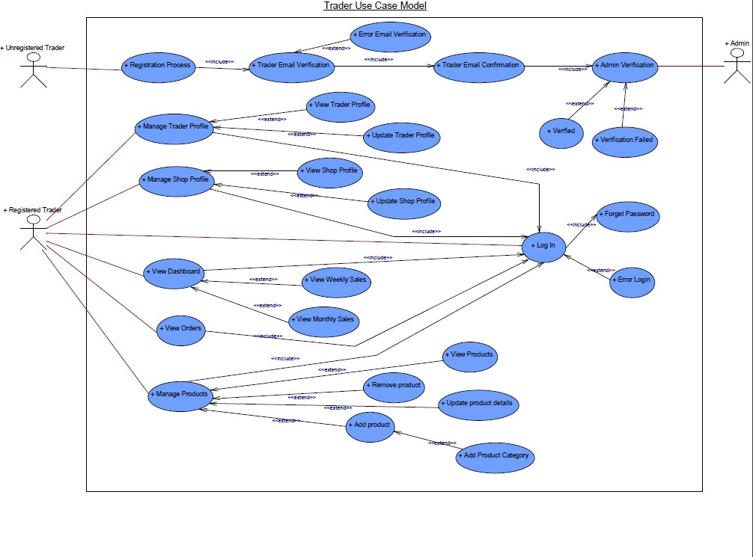

Figure : Overall Use Case Diagram

### II. Customer Use Case Diagram

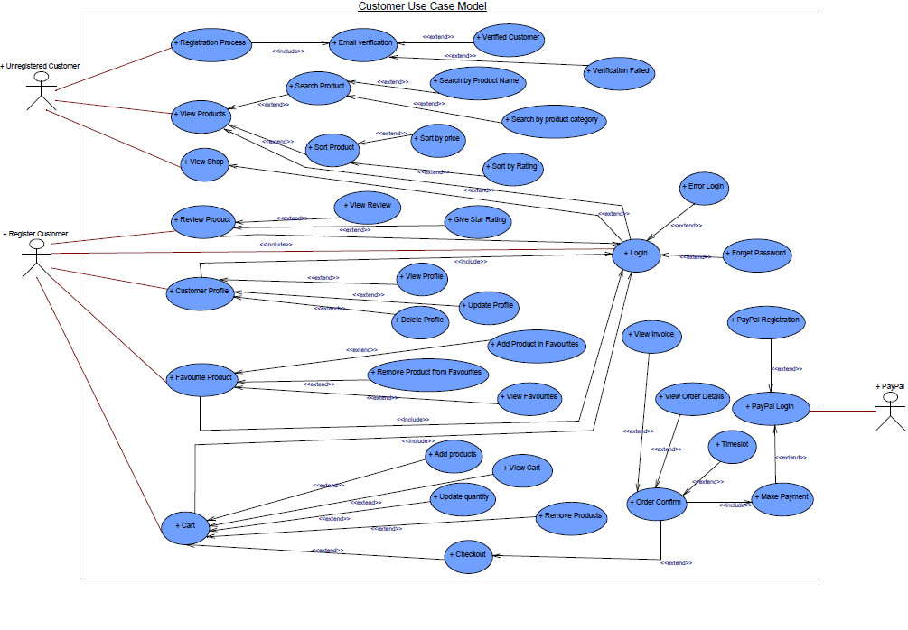

Figure : Customer Use Case Diagram

### III. Trader Use Case Diagram

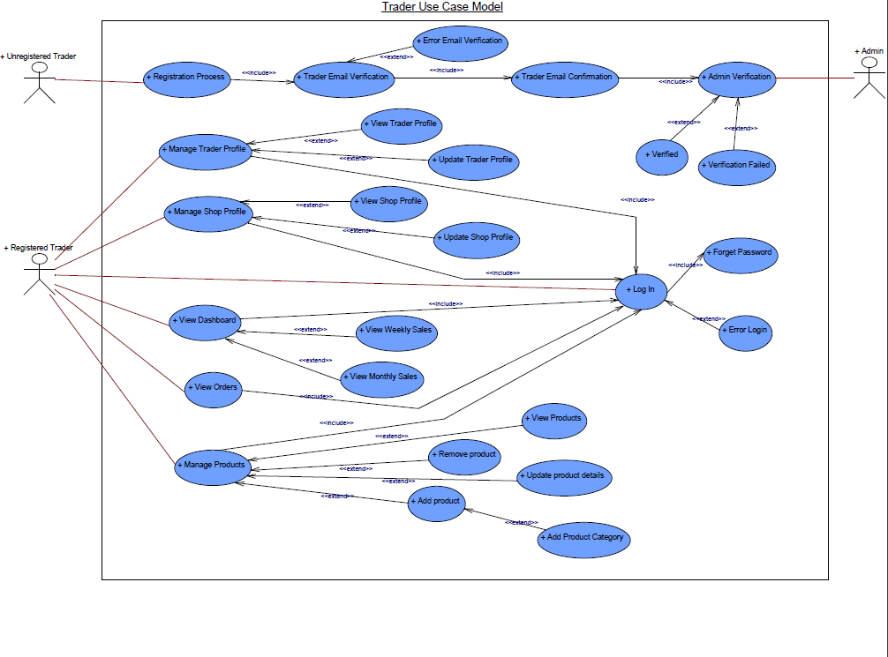

### IV.Admin Use Case Diagram

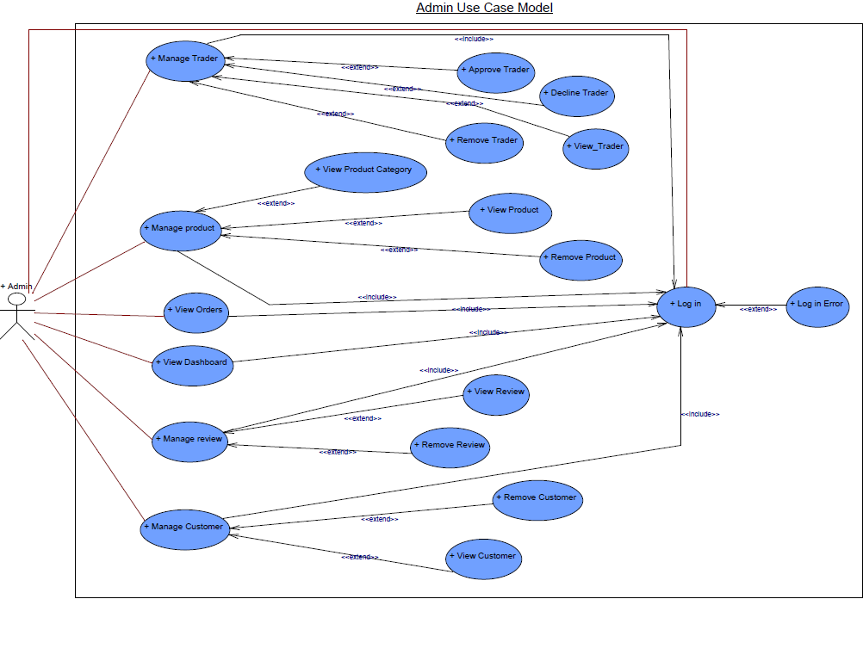

## c.Requirement Catalogue

### I. Functional Requirement

* A: Product

|  |  |  |
| --- | --- | --- |
| **Requirement ID** | **Description** | **MoSCoW** |
| **A1** | **All products need details.** |  |
| A1-01 | Each product should have their name, price, stock information, minimum order, and maximum order. | M |
| A1-02 | Products should be associated with a specific shop. | M |
| A1-03 | Product should have a product category. | M |
| A1-04 | Product should have image and allergy information. | S |
| A1-05 | Product should display average rating and review count. | S |
| A1-06 | Products can have discount applied to them. | C |
| **A2** | **An interface to navigate product and shop.** |  |
| A2-01 | Users should be able to see shop details like name, location, description etc. | M |
| A2-02 | Users should be able to search products by product name or product category. | M |
| A2-03 | Users should be able to search for products by shop. | S |
| A2-04 | Users should be able to filter products based on price and rating. | S |
| **A3** | **An interface to add products in cart and wish list.** |  |
| A3-01 | Users should be logged in to add products to their cart. | M |
| A3-02 | Users should be able to add up to 20 different items in the cart at a time. | M |
| A3-03 | Users should be able to view items in their cart. | M |
| A3-04 | Users should be able to add/ remove product from their wish list or favorites list. | S |
| A3-05 | Users should be able to increase or decrease the quantity of products from the cart. | C |
| **A4** | **An interface for review and rating for product.** |  |
| A4-01 | Users should be able to leave a textual review of the product. | S |
| A4-02 | Users should be able to give star ratings to a product. | S |
| A4-03 | Products should have a date of reviewed. | C |

* B: Customer

|  |  |  |
| --- | --- | --- |
| **Requirement ID** | **Description** | **MoSCoW** |
| **B1** | **An interface to register for new user.** |  |
| B1-01 | User should provide all required details i.e. name, address, contact number etc. to register. | M |
| B1-02 | Email verification should be required during registration. | M |
| B1-03 | Password should be 8 to 32 characters long. | S |
| B1-04 | Password should contain an uppercase, number and a special character. | C |
| **B2** | **An interface for user login.** |  |
| B2-01 | User should be able to log in using their registered credentials. | M |
| B2-02 | User should be able to reset their password via web interface. | S |
| B2-03 | User should be able to reset their password via email verification if he/she forgets. | C |
| **B3** | **An interface to view and update profile.** |  |
| B3-01 | User should be able to view and update their profile information. | M |
| B3-02 | User should be able to change their password. | S |
| B3-03 | User should be able to upload or remove profile picture. | C |
| **B4** | **Customer should be able to view product.** |  |
| B4-01 | Customer should be able to search and browse products. | M |
| B4-02 | Customers should be able to view product details. | M |
| B4-03 | Customer should be able to sort and filter products. | S |
| B4-04 | Customers should be able to view product review and ratings | S |
| B4-05 | Customers should be able to view related products. | S |
| B4-06 | Customers should be able to view product availability. | C |
| **B5** | **Customer has access to cart.** |  |
| B5-01 | Customer should be logged in to access cart. | M |
| B5-02 | Customers should be able to view the total cost of items in their cart. | M |
| B5-03 | Customers should be able to remove all the products from cart using “Clear All” button. | S |
| B5-04 | Customers should be able to increase or decrease the quantity of product in the cart. | S |
| B5-05 | Customer should be able to save their cart for later. | C |
| **B6** | **Customer has wish list.** |  |
| B6-01 | Customers can add or remove product from their wish list. | C |
| **B7** | **An interface to place order.** |  |
| B7-01 | Customer should be able to select a collection time slot while placing order. | M |
| B7-02 | Customer should be able to pay through PayPal. | M |
| B7-03 | Customer should get a notification about order confirmation. | S |
| B7-04 | Customer should be able to cancel their order. | C |
| **B8** | **An interface to review product.** |  |
| B8-01 | Customer should be able to leave a review and star rating on the product they have purchased. | M |
| B8-02 | Customer should be able to edit their review and ratings. | C |
| **B9** | **An interface to view order details.** |  |
| B9-01 | Customer should be able to view their order details. | M |
| B9-02 | Customer should be able to view their order history. | C |

C: Trader

|  |  |  |
| --- | --- | --- |
| **Requirement ID** | **Description** | **MoSCoW** |
| **C1** | **An interface for trader registration and login.** |  |
| C1-01 | Trader should be able to register with their shop information. | M |
| C1-02 | Traders should be able to log in using their registered credentials. | M |
| C1-03 | Traders should be able to reset their passwords via email verification if they forget their passwords. | S |
| C1-04 | The registration and login forms should have proper validations. | C |
| C2 | **An interface to view and update profile.** |  |
| C2-01 | Traders should be able to view and update their profile via web interface. | M |
| C2-02 | Traders can view and update their shop information, including descriptions and contact details. | M |
| C2-03 | Traders should be able to change their passwords. | S |
| **C3** | **Trader can manage product and shop.** |  |
| C3-01 | Traders should be able to add new products to their shop. | M |
| C3-02 | Traders should be able to update stock information of the product. | M |
| C3-03 | Traders should be able to update shop information. | M |
| C3-04 | Traders should be able to remove the product. | S |
| C3-05 | Traders should be able to set discounts on their products. | C |
| **C4** | **Access to dashboard and reports.** |  |
| C4-01 | Traders should be able to access the dashboard via website or apex. | M |
| C4-02 | Traders can view details of daily orders. | M |
| C4-03 | Traders can view daily, weekly, and monthly reports. | M |
| C4-04 | Traders can view weekly financial reports. | S |
| C4-05 | Traders can filter reports based on date. | S |
| C4-06 | Traders should be able to export reports in various formats. | C |

* D: Management

|  |  |  |
| --- | --- | --- |
| **Requirement ID** | **Description** | **MoSCoW** |
| **D1** | **An apex login interface.** |  |
| D1-01 | The administrator should be able to log in via both website and apex. | M |
| **D2** | **Manage trader and user.** |  |
| D2-01 | Admin should be able to view traders. | M |
| D2-02 | Admin should be able to view customers. | M |
| D2-03 | Admin should be able to approve or decline a trader register request. | M |
| D2-04 | Admin should be able to remove a trader or customer account. | M |
| D2-05 | Admin should be able to remove a review written by a user. | M |
| D2-06 | Admin should be able to send notifications to traders and users. | C |
| **D3** | **Management reports** |  |
| D3-01 | Admin should have access to various management reports and analytics. | M |
| **D4** | **Payment** |  |
| D4-01 | The system should support integration with payment gateways like PayPal and Stripe. | C |

1. Non-Functional Requirement

* E: Non-Functional

|  |  |
| --- | --- |
| **Requirement ID** | **Description** |
| E1 | The website should respond within an acceptable timeframe to user actions. |
| E2 | The website should be able to handle increasing loads of users and data without sacrificing performance. |
| E3 | User’s accounts should be securely stored and protected against unauthorized access or data breaches. |
| E4 | Properly authenticating users and authorizing access to different parts of the website based on their roles and permission. |
| E5 | Encryption protocols to protect sensitive data such as payment information and personal details. |
| E6 | Websites should run smoothly across different devices and screen sizes. |
| E7 | Reliable backup and recovery procedures to protect against data loss and maintain operations during system failures. |
| E8 | Ensure users to leave feedback, ratings and reviews for products and services. |
| E9 | Recommend products and contents based on individual user preferences, browsing and payment history. |

# D. Logo Design

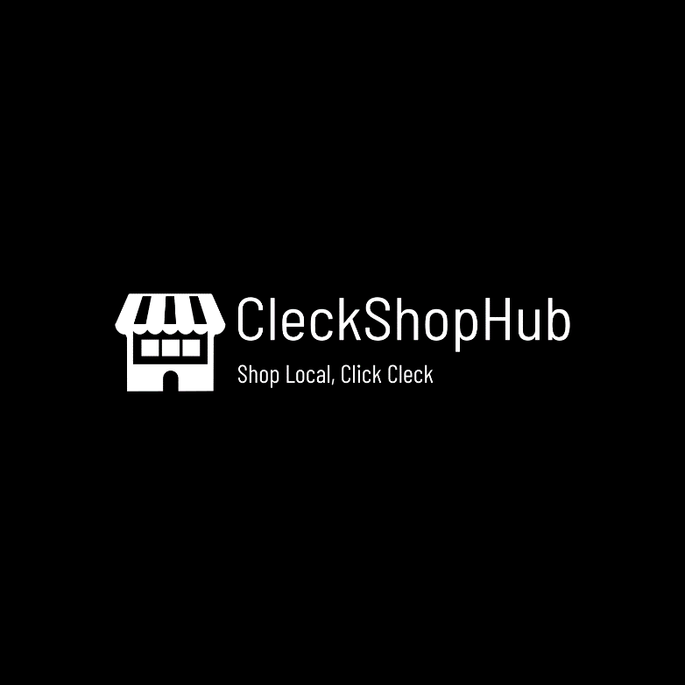



# E.Wireframe

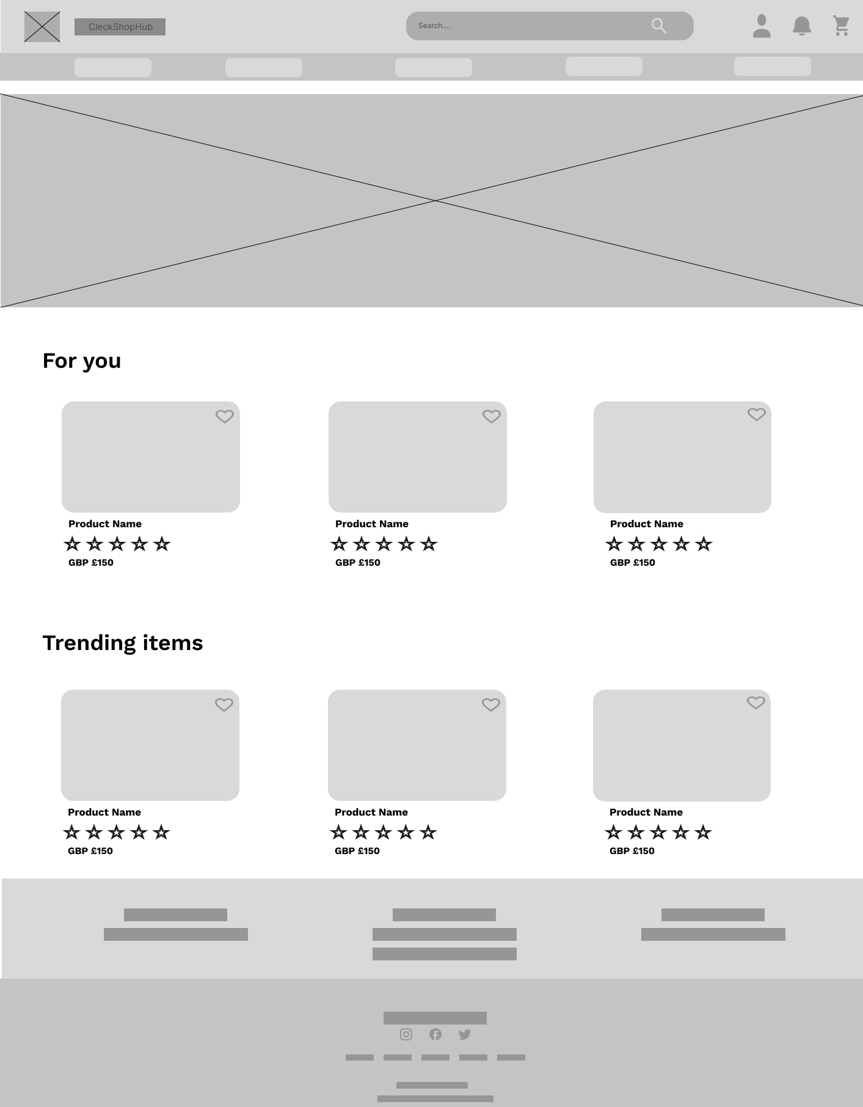

Figure :Home Page Wireframe

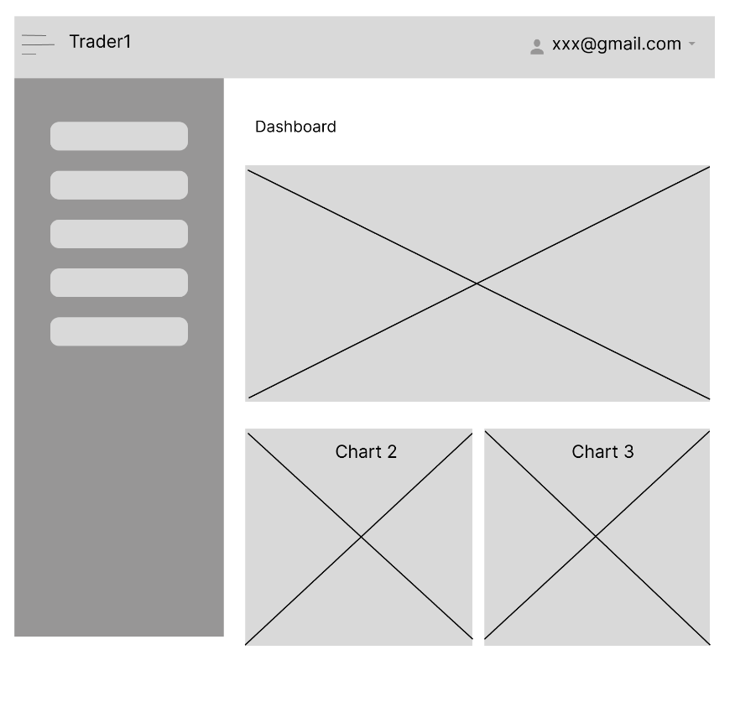

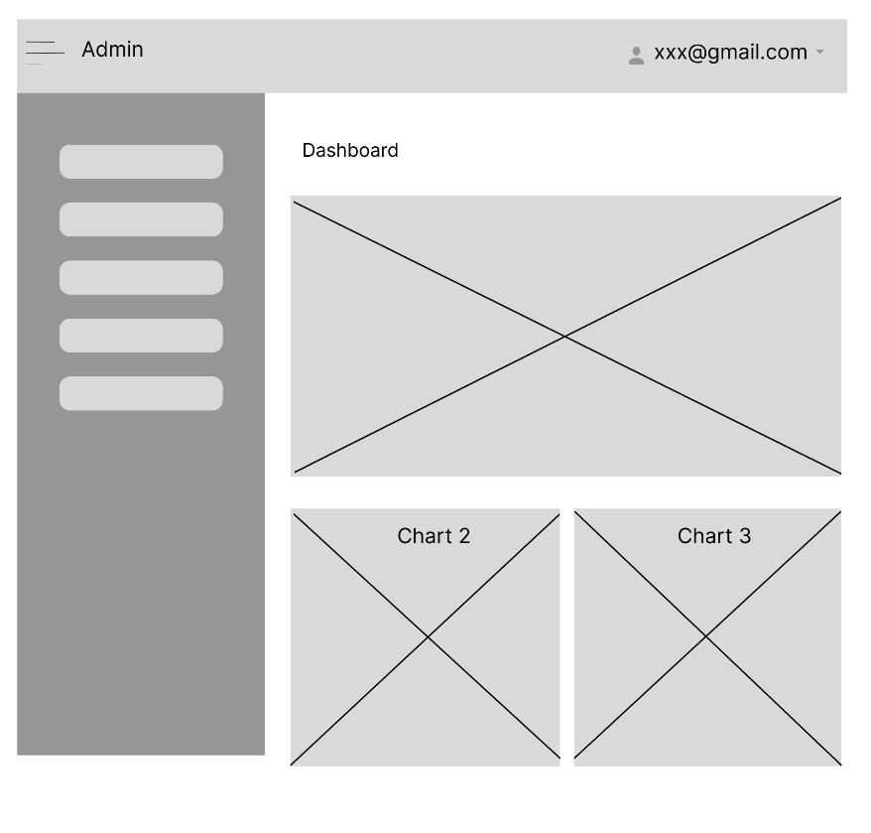

Figure 11: Trader CRUD

Figure 12: Admin CRUD

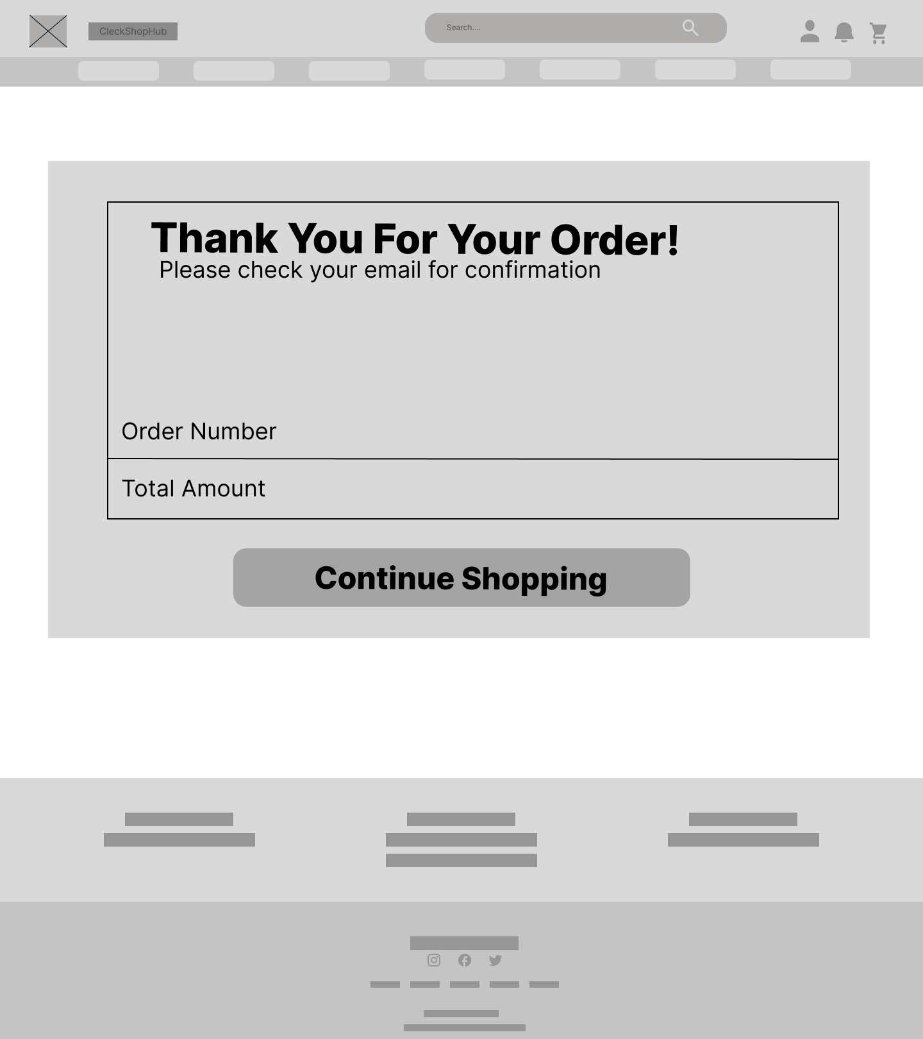

Figure 13: Invoice

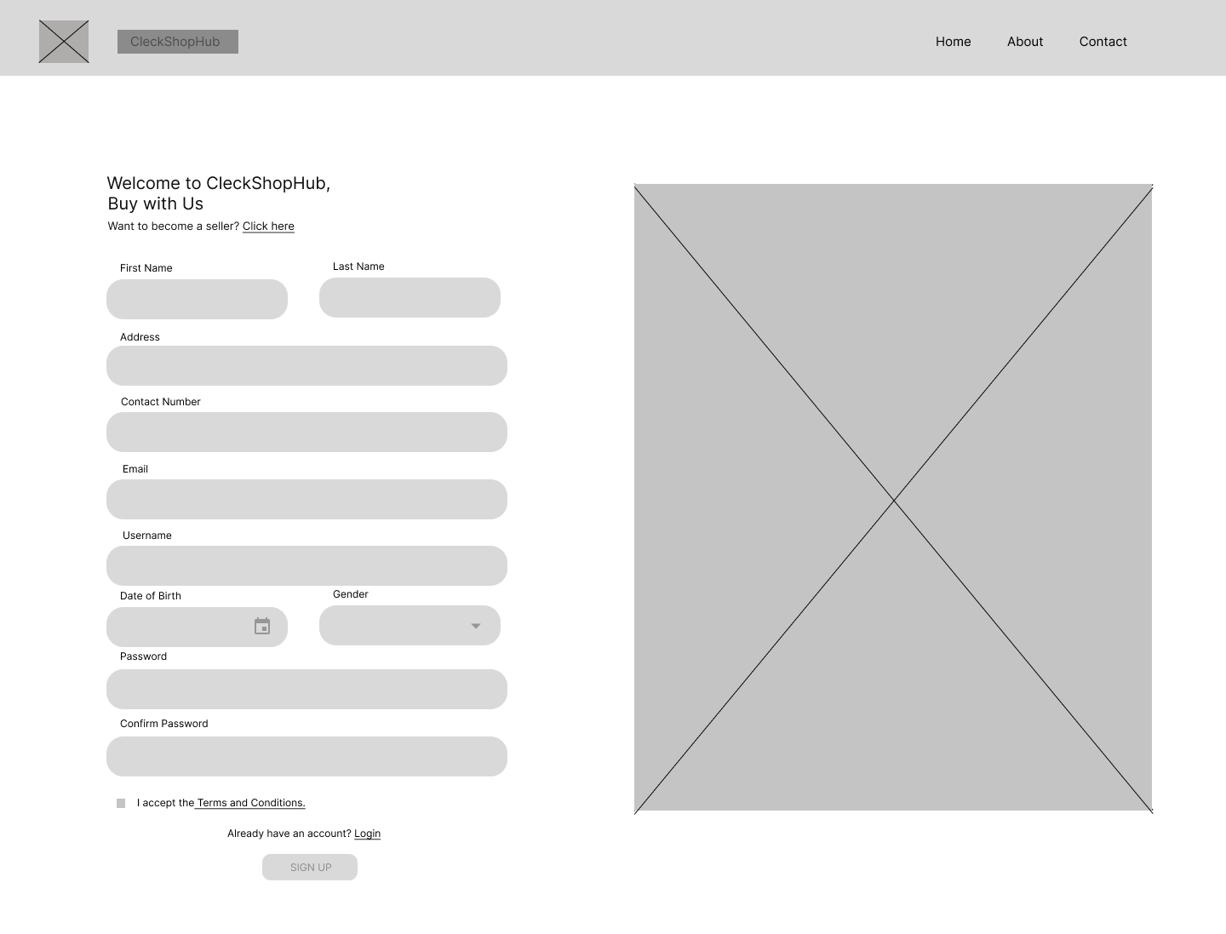

Figure 14: Register

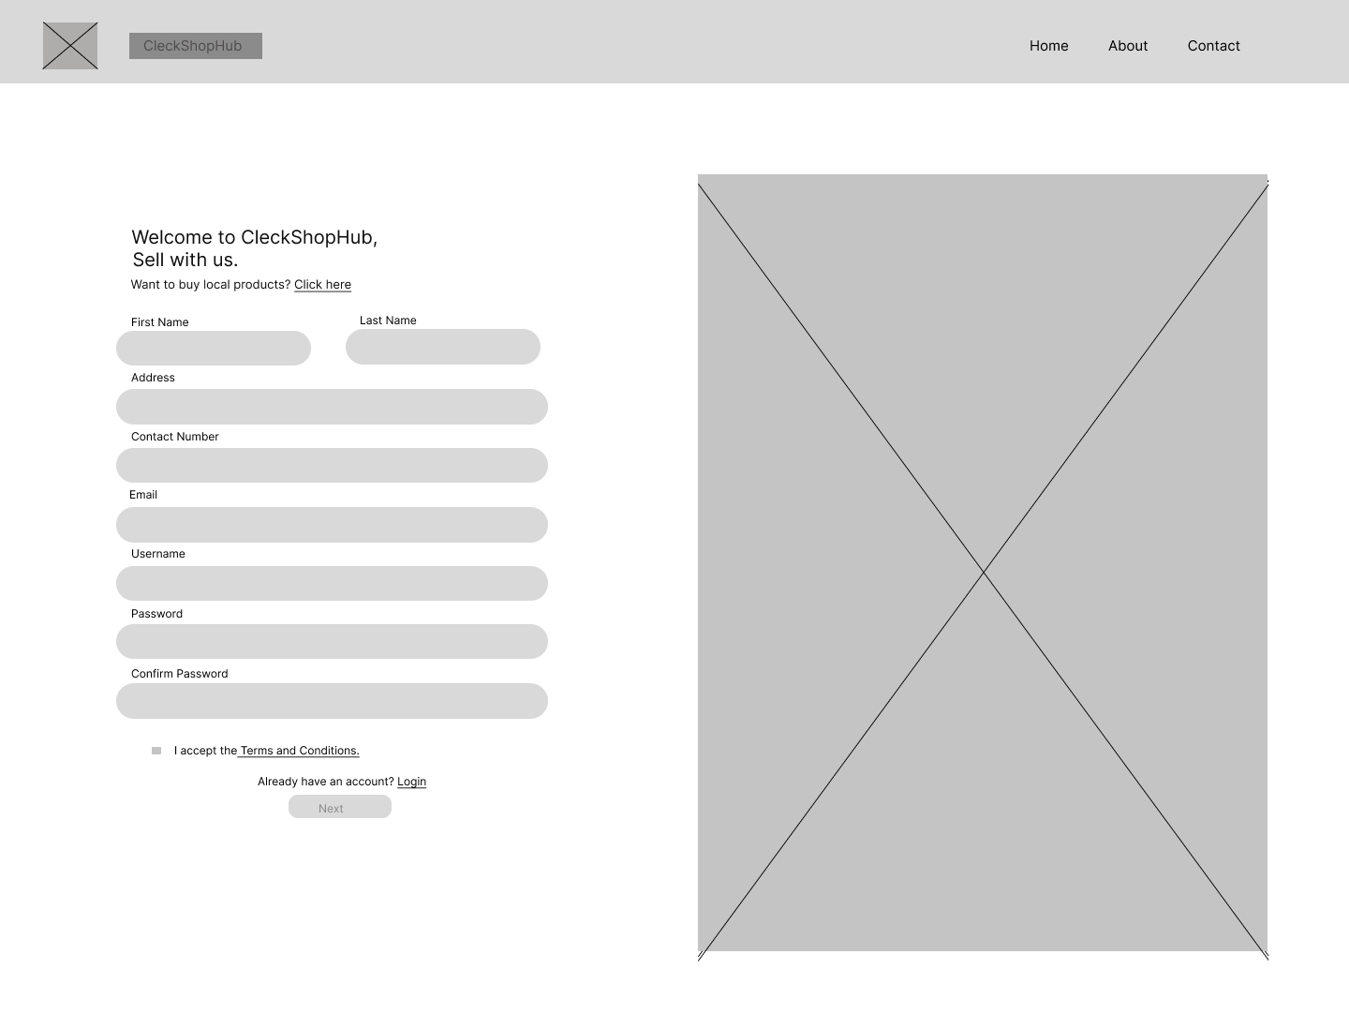

Figure : Register for Trader

Figure 15: Register for Trader

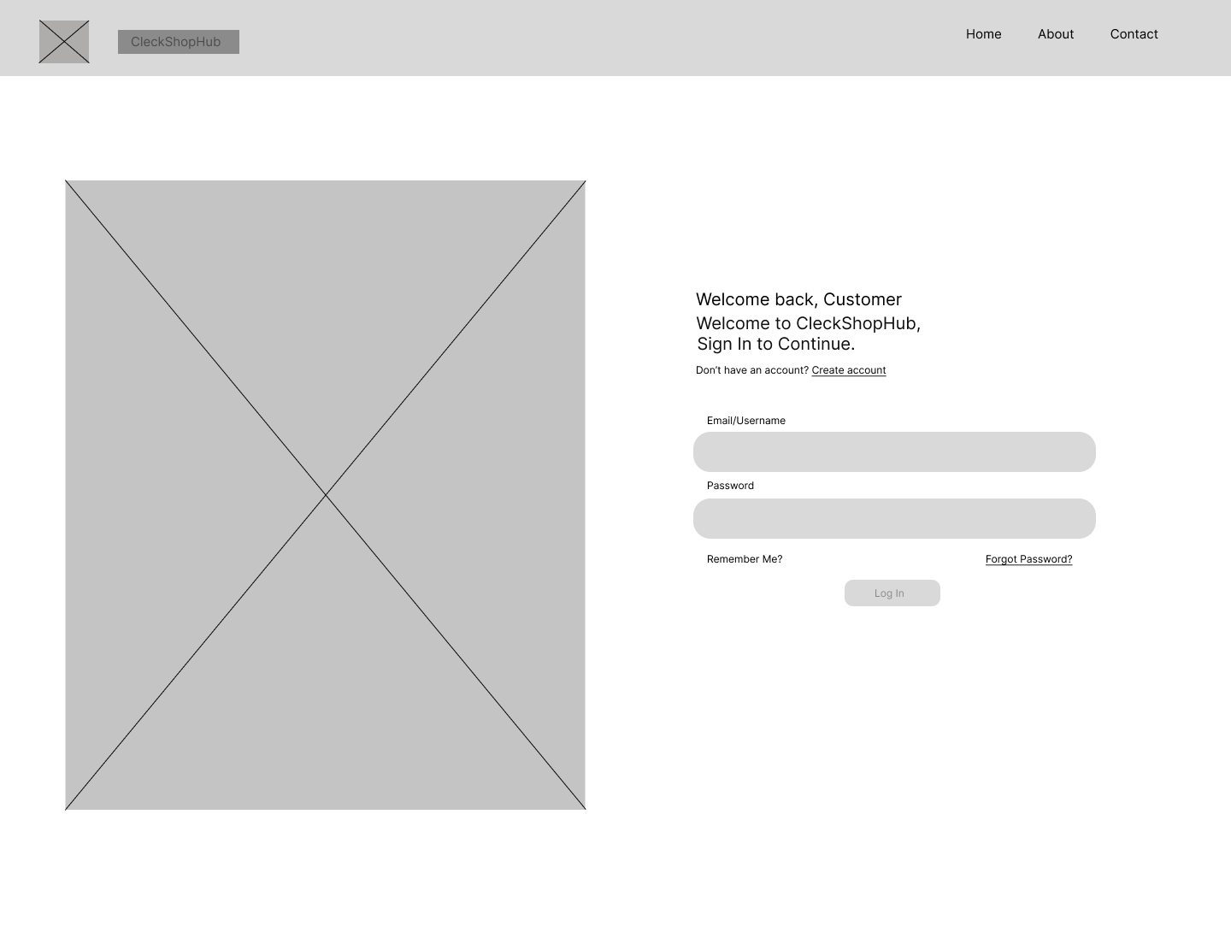

Figure 16: Login

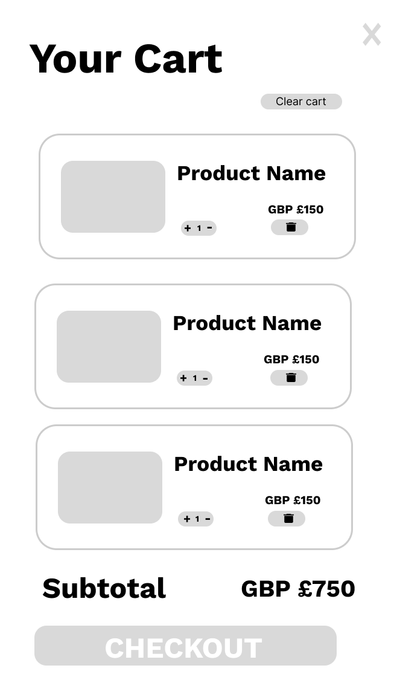

Figure 12: Cart

Figure 17: Cart

# 3. Product Development

1. Screenshots

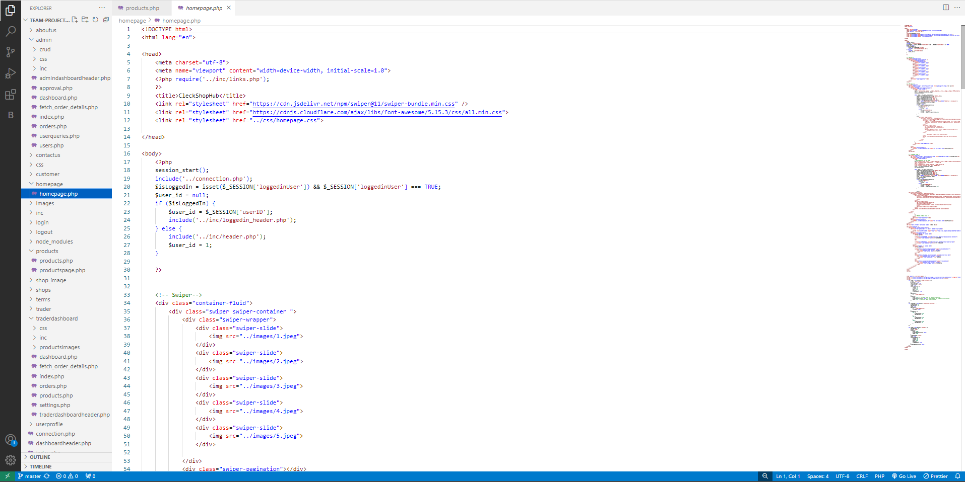Home Page Screenshot

Admin Dashboard

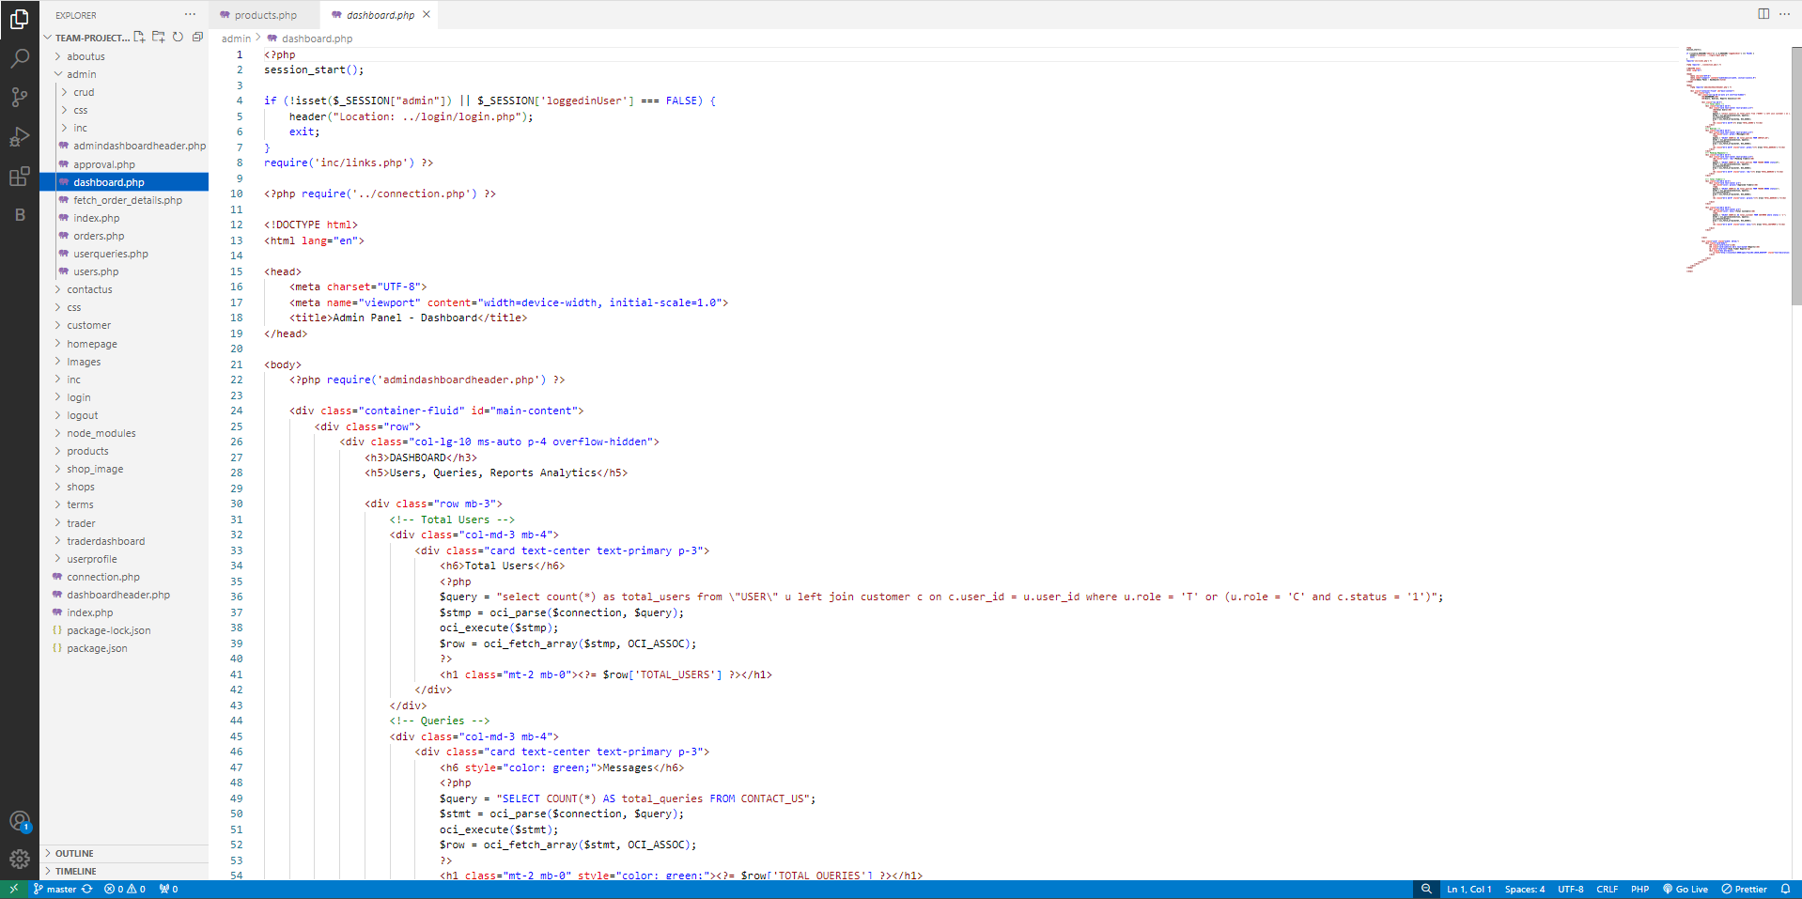

Customer Signup

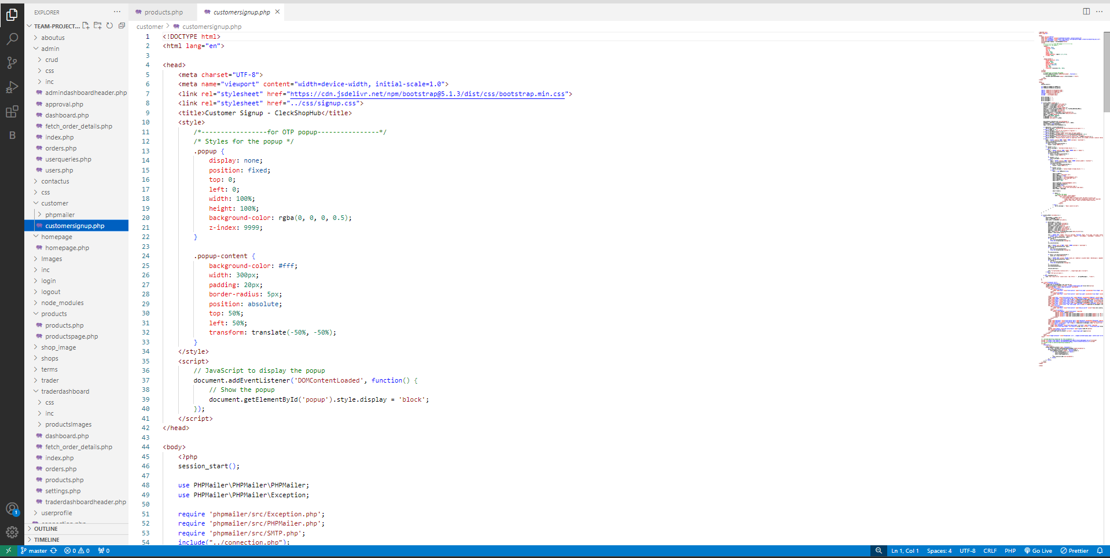

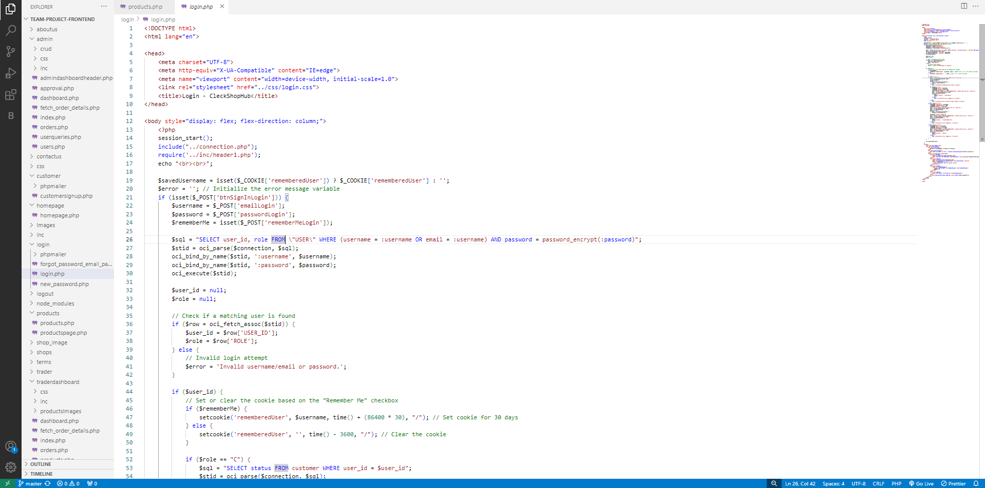Login Page

Products Page

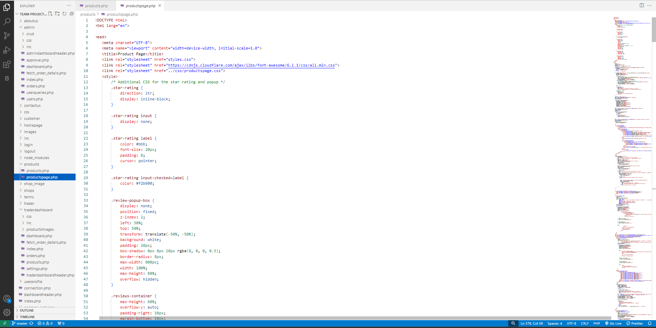

Trader Dashboard

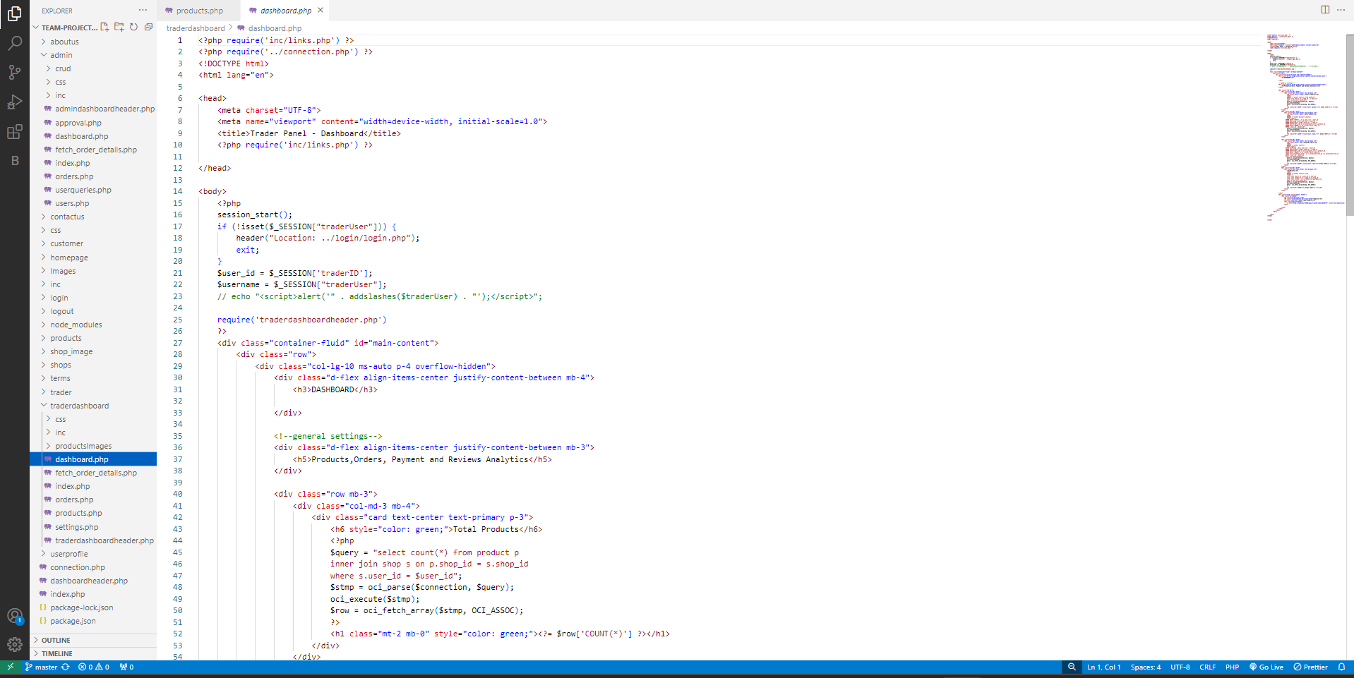

1. Website Homepage

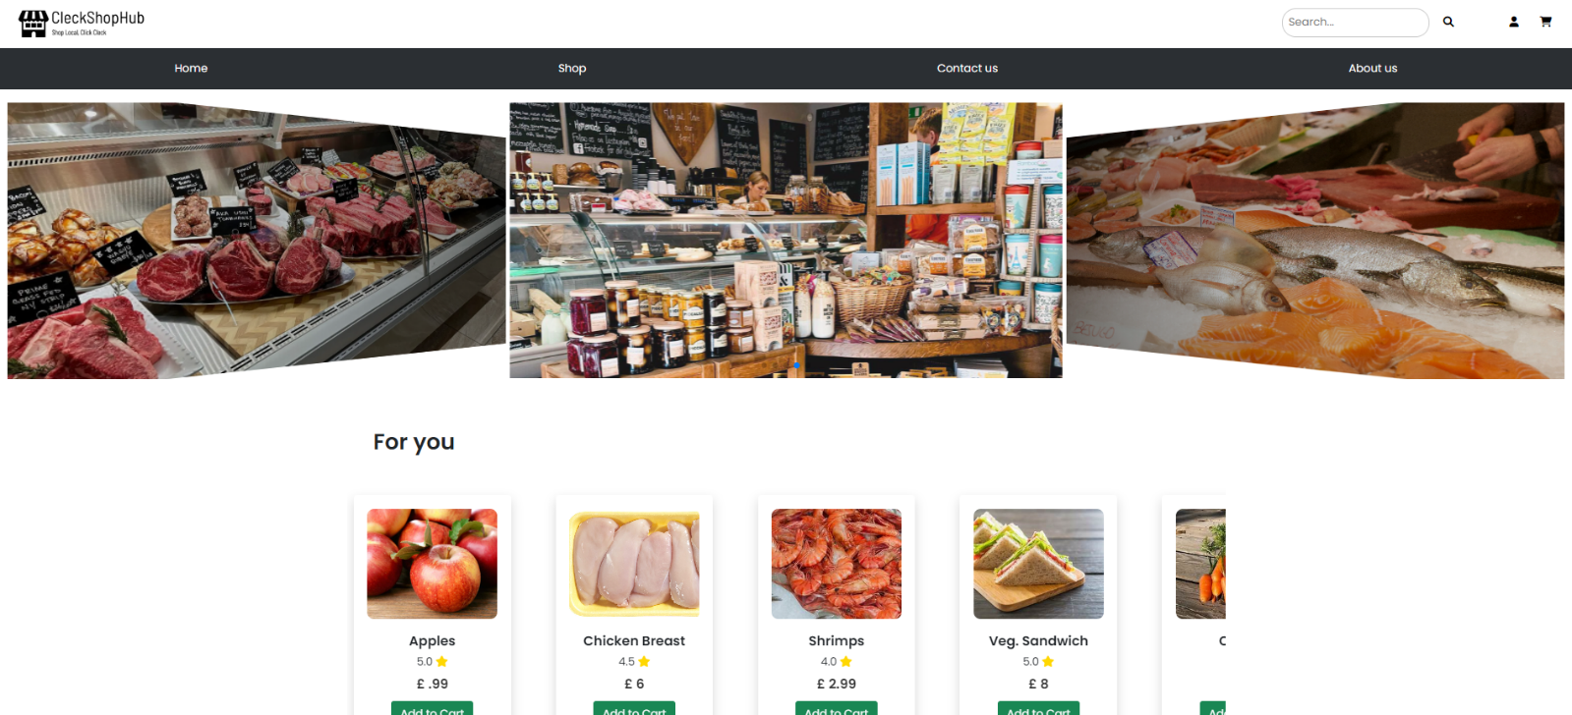

4. Product Testing

1. **CUSTOMER Interface Testing PHP**

* First, you need to go to the homepage of CleckShopHub, then click on the Login button from the top right of the navigation bar

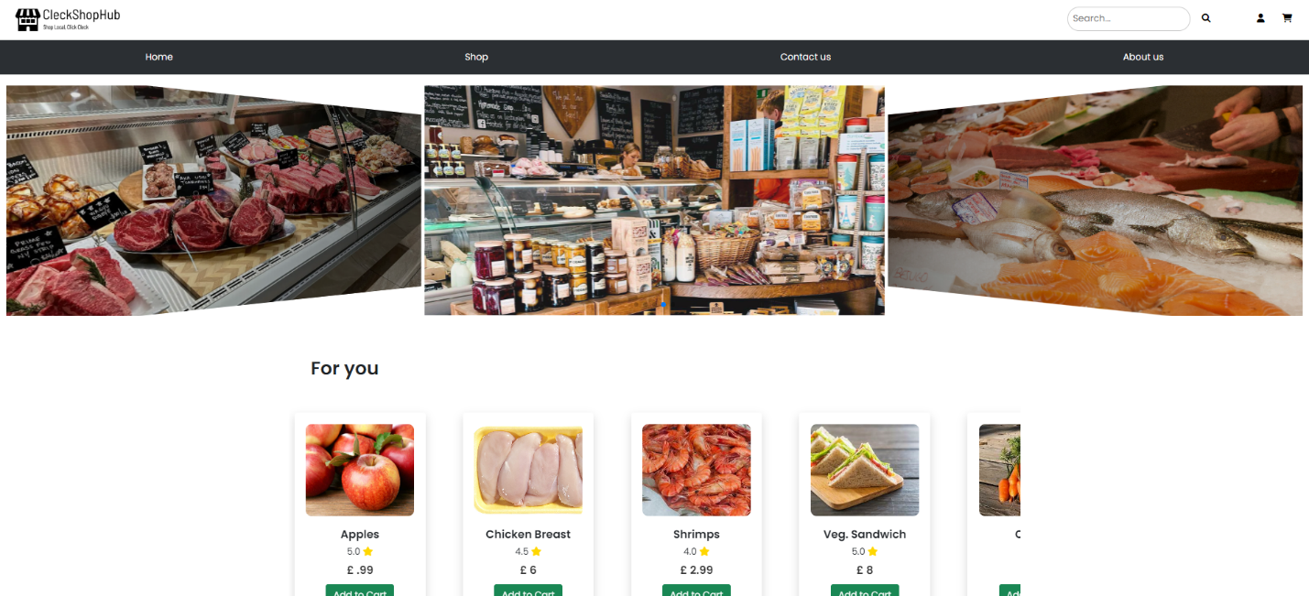

[Register Testing]

* If you click on Sign Up button without entering anything in the input fields then all the empty fields are highlighted in red

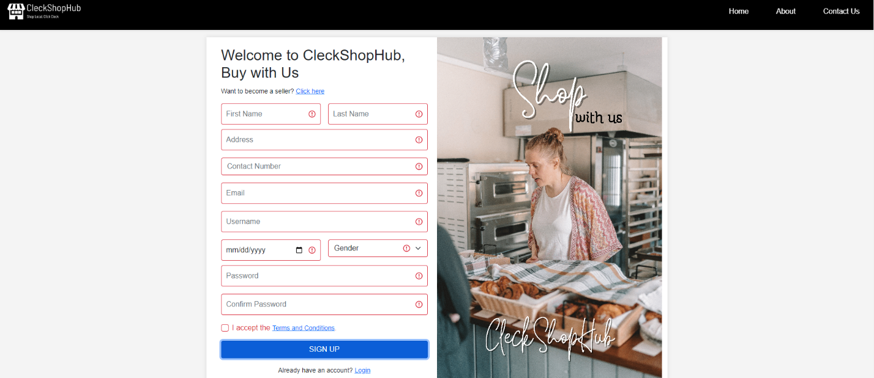

* If you input contact number which is lesser or greater than 10 digits then an error message will be highlighted instructing user to enter contact number that is exactly 10 digits long

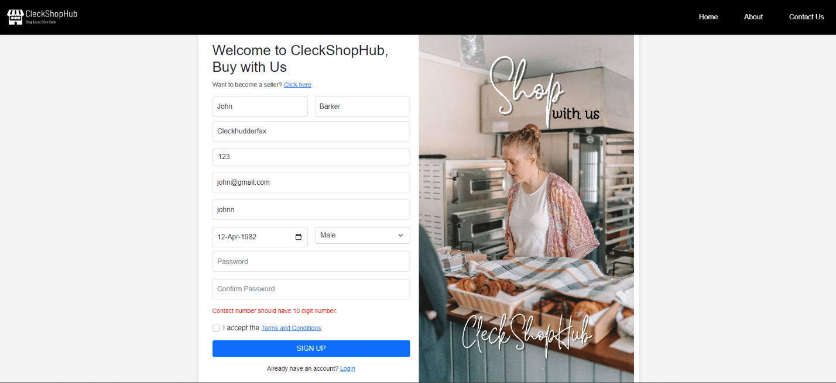

* If you enter a username which is already used by another existing user then a red error message will be displayed informing user that the username already exists

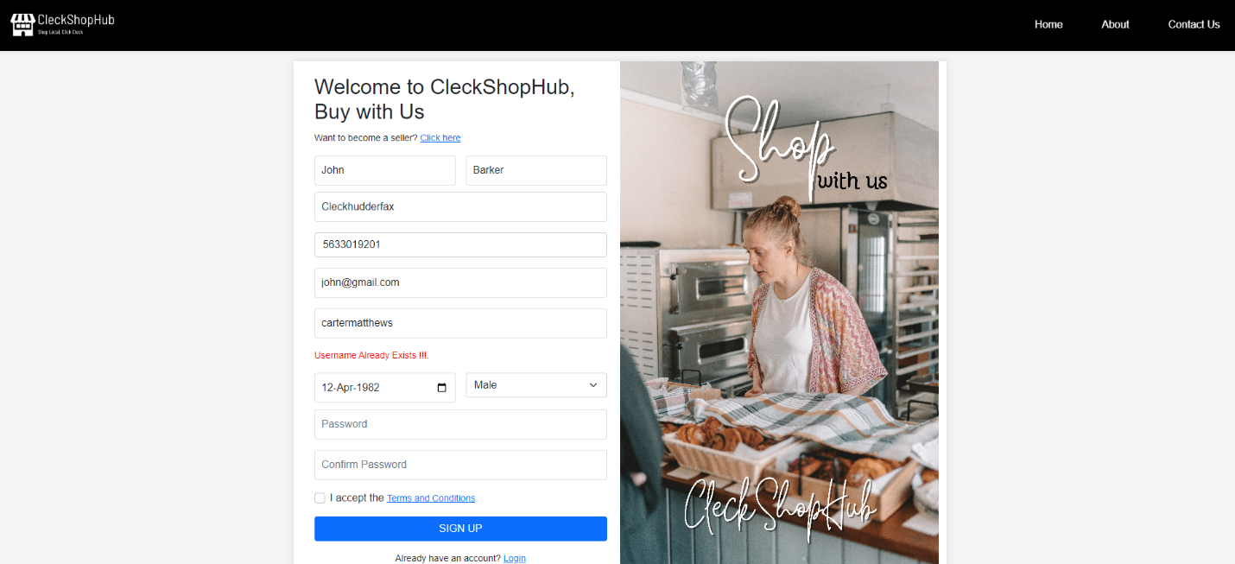

* If the user’s age is less than 12 after entering date of birth then red error message is displayed informing user that he/she is not able to register.
* If the user enters a contact number which is already used by another existing user then the following error is shown



* If the user provides an email address, which is not unique and used by another user then a red error is displayed informing user that the email already exists.

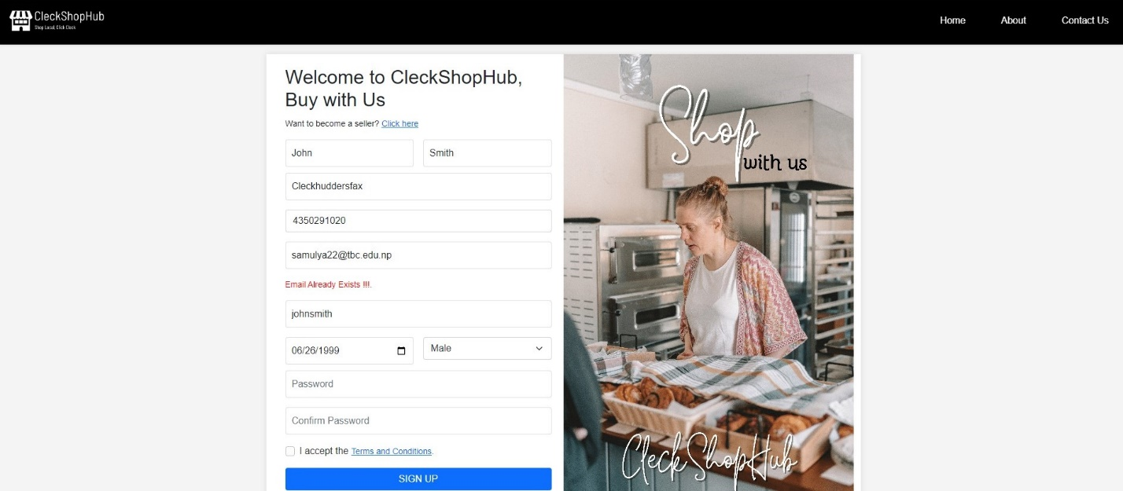

* If the user provides different password in Confirm Password and Password input field then a red error message is displayed informing user that the values doesn’t match

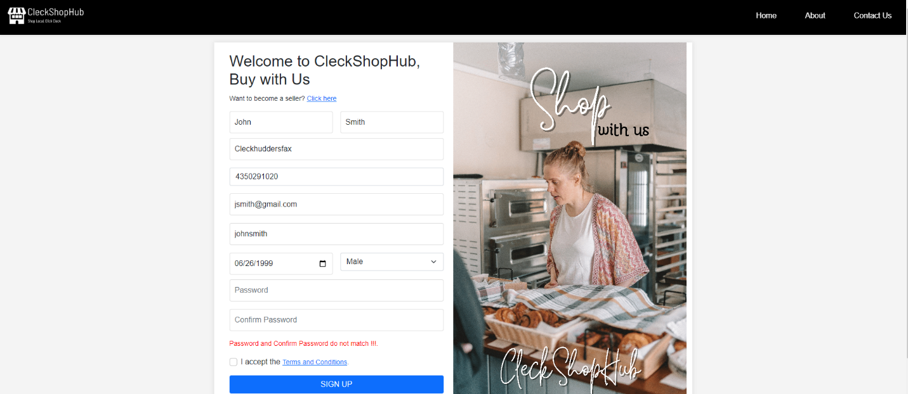

* If the user enters a password that is lesser than 8 or greater than 32 characters then a red error message is displayed asking user to enter a password that is between 8 and 32 characters

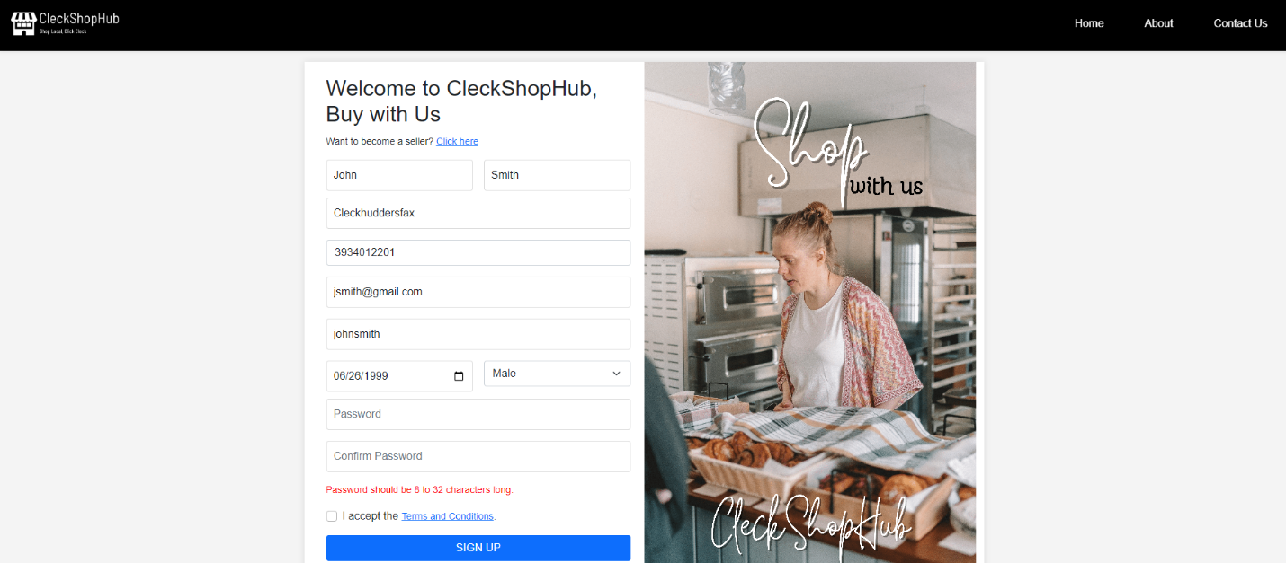

* If the user enters a password that does not contain an uppercase letter, or number or special character then the following error message is shown

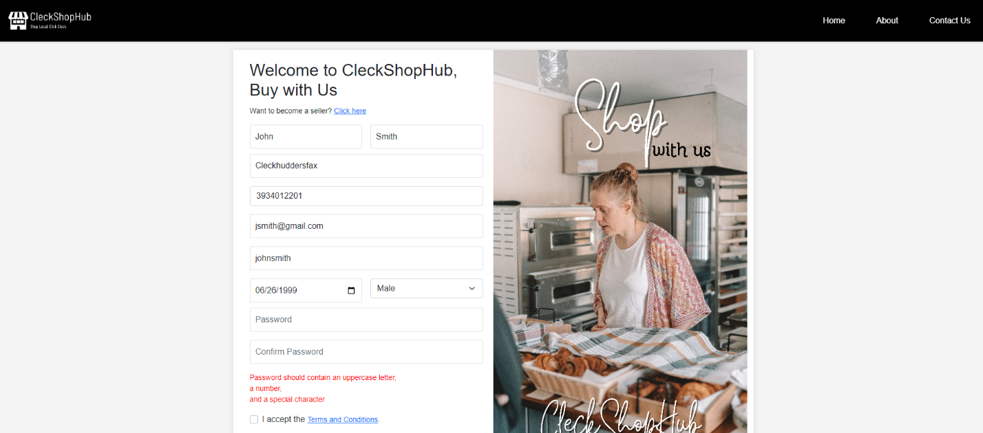

* After registering, the user is prompted to enter the One Time Validation(OTP) code which is sent to their email address

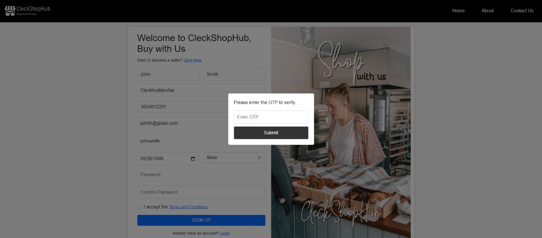

[Login Testing]

* If the user provides empty values in the input fields then the following message will be shown

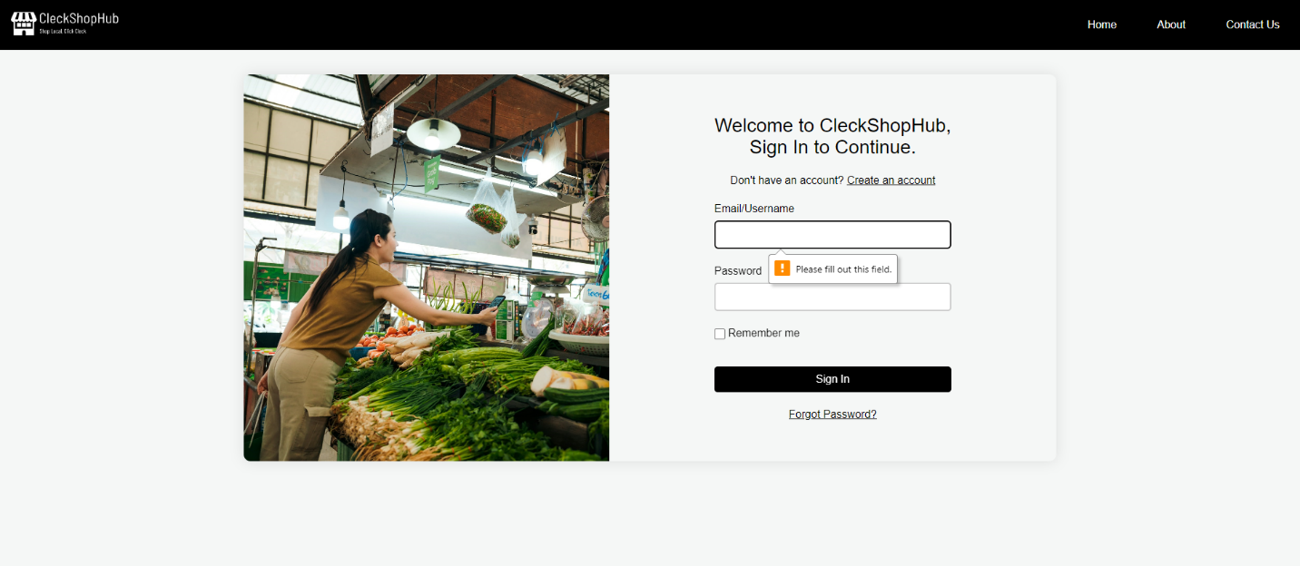

* If the user provides their invalid username or email address then the following error message is

displayed

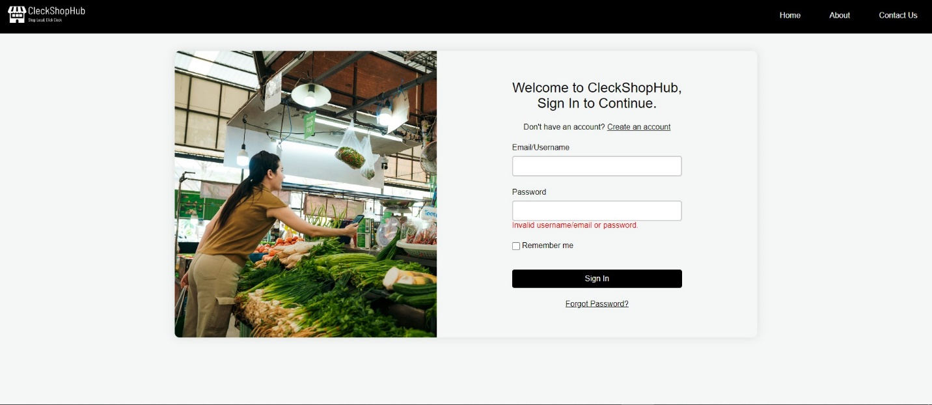

* If the user ticks the Remember Me checkbox, then the user is not required to enter their username or email details again

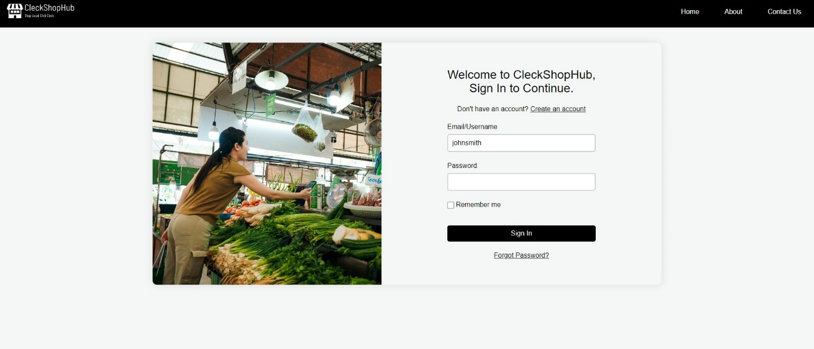

* If the user clicks on forgot password then the user is prompted to provide their email address to receive OTP code for validation and change their password by providing their old password.

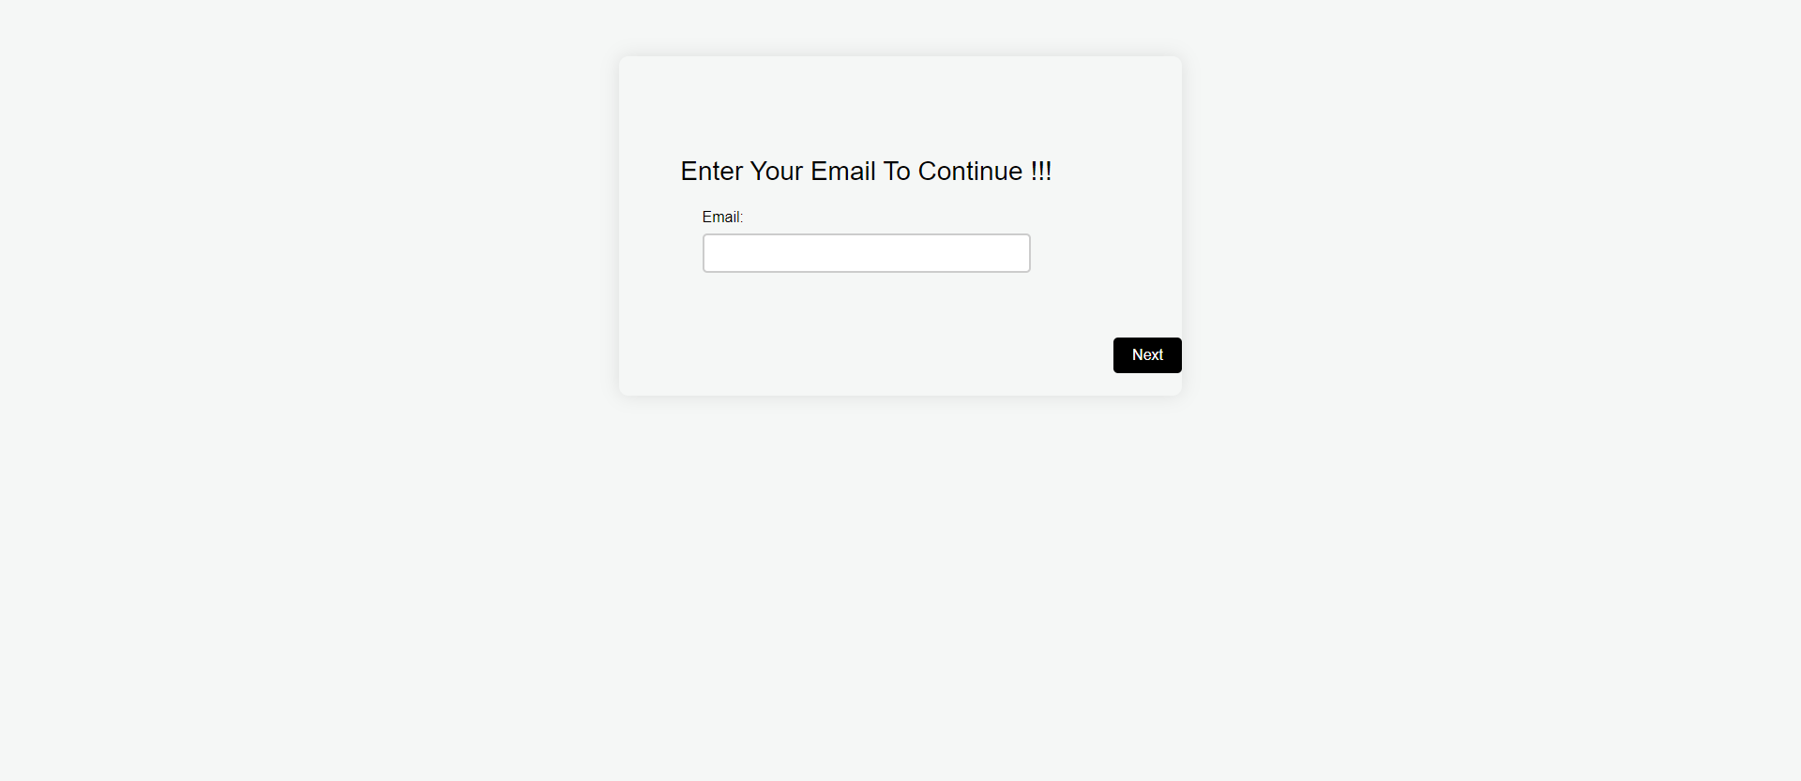

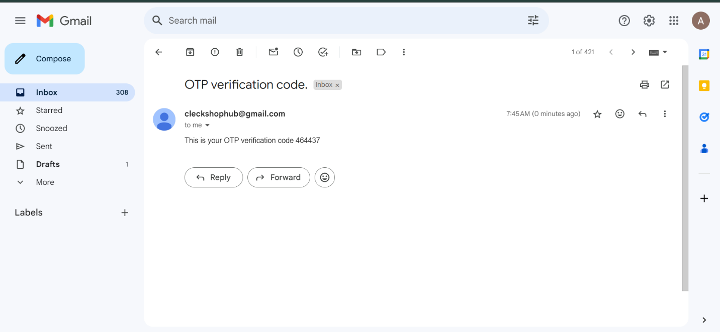

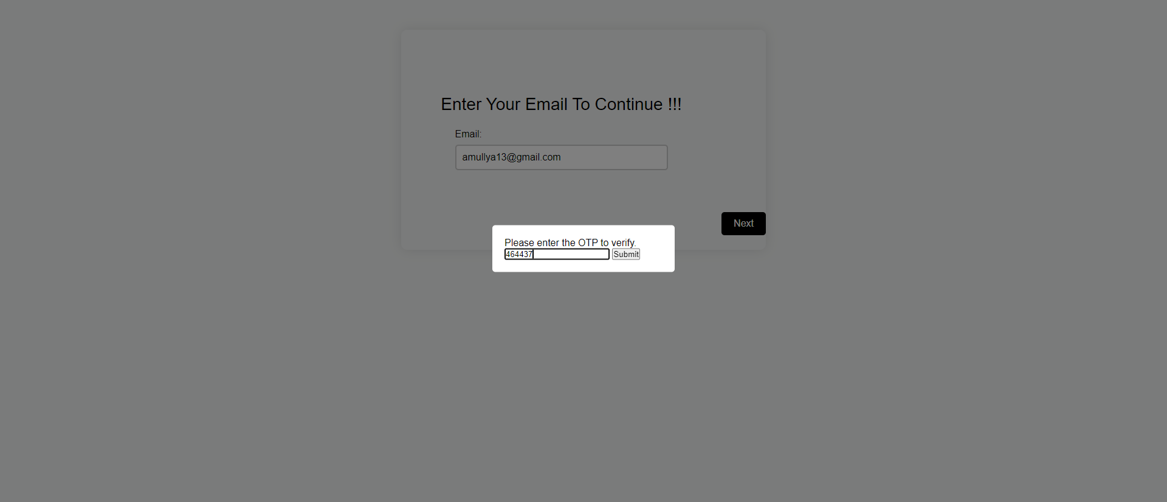

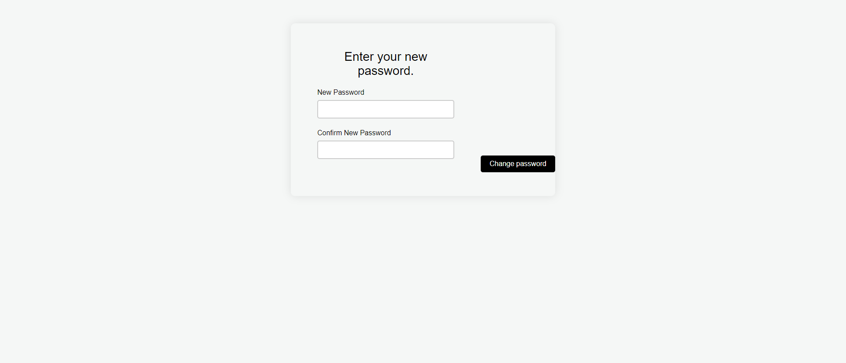

* After user successfully provides their correct username and password then they are directed to homepage.

**[Customer Testing]**

* Customer can view their profile by clicking on the profile icon on top right of the navigation bar

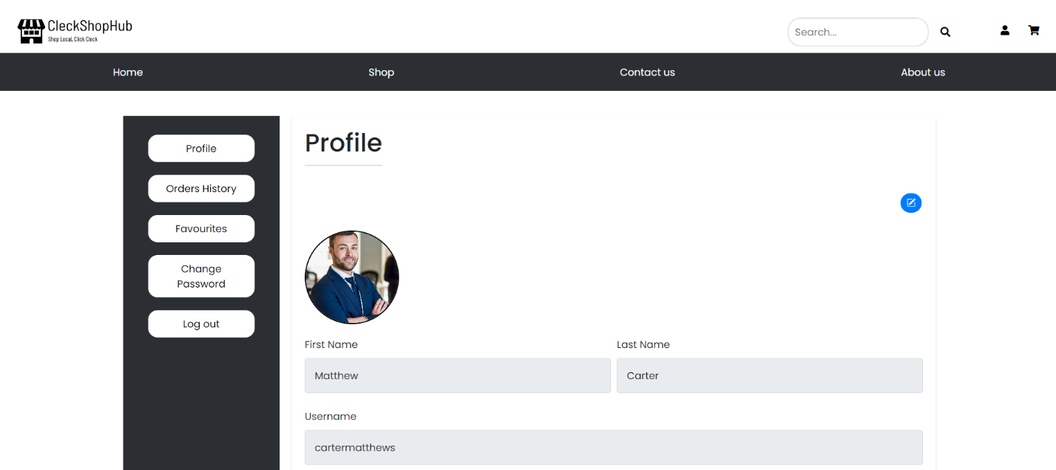

* Customer can update their profile picture by clicking on the blue edit label and upload their images from their system.

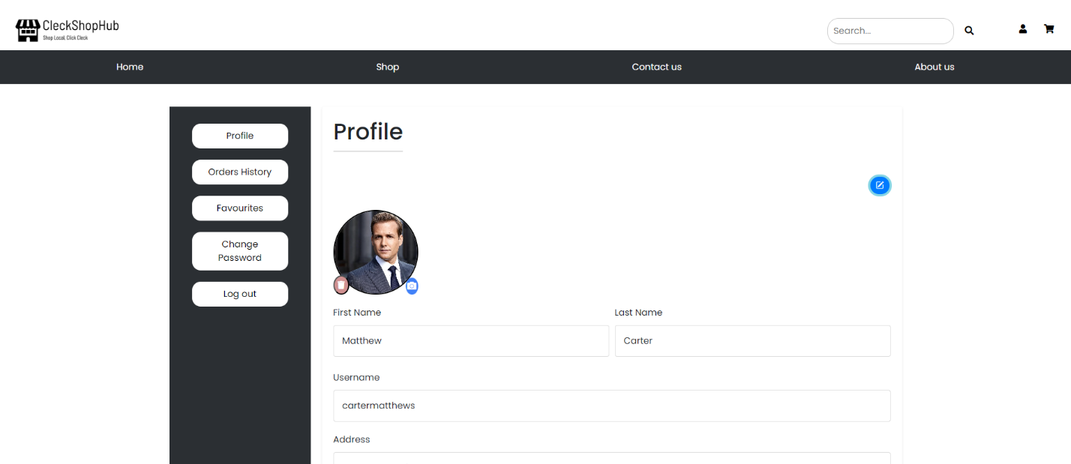

* Customer can check all the items they have favorited after clicking the Favorites tab.

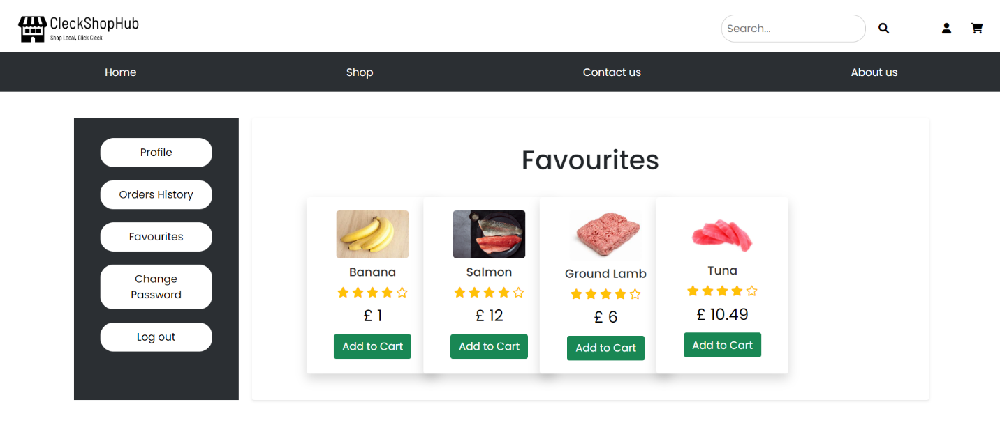

* Customer can check their order history by clicking on the Order History tab from the left side

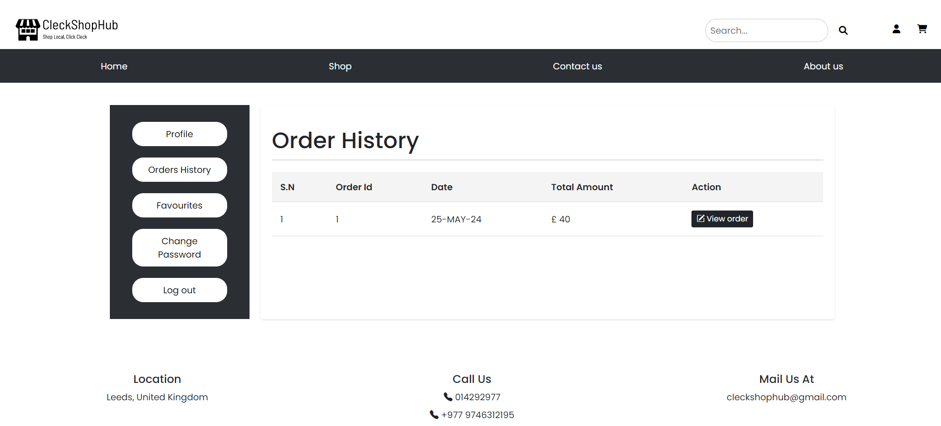

* Customer can change their password after clicking on change password tab

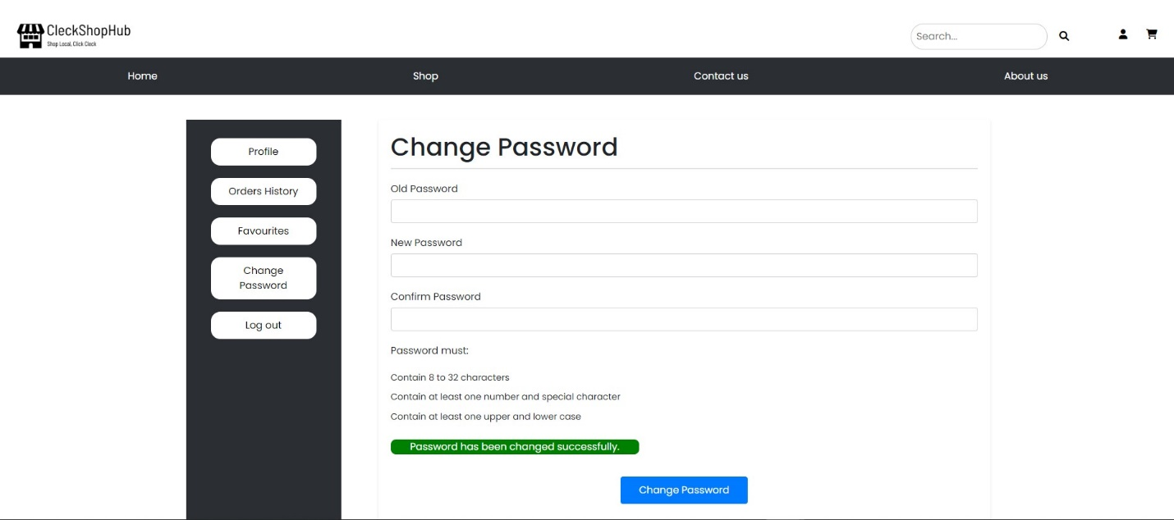

* Customer can log out after clicking on log out button on top right of the navigation bar and they are directed back into the homepage

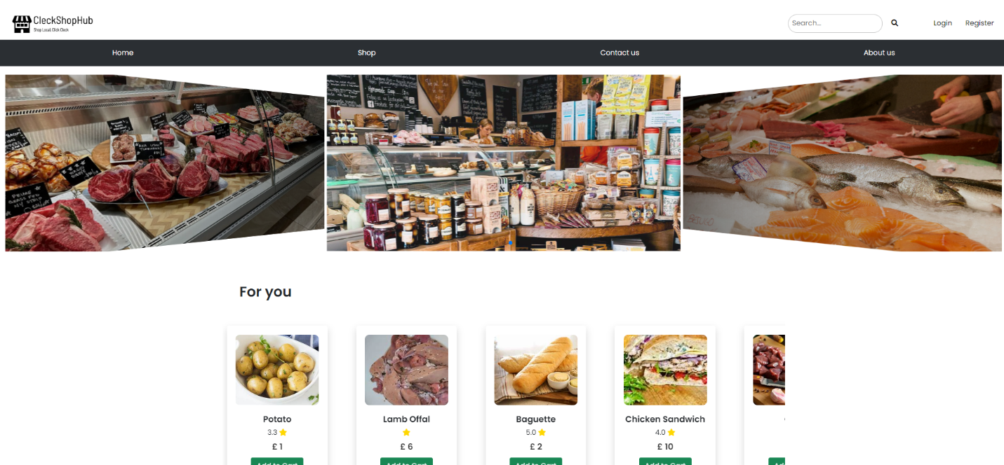

**[Product Testing]**

* Customer can search for a specific product in the search bar in the top of the navigation bar

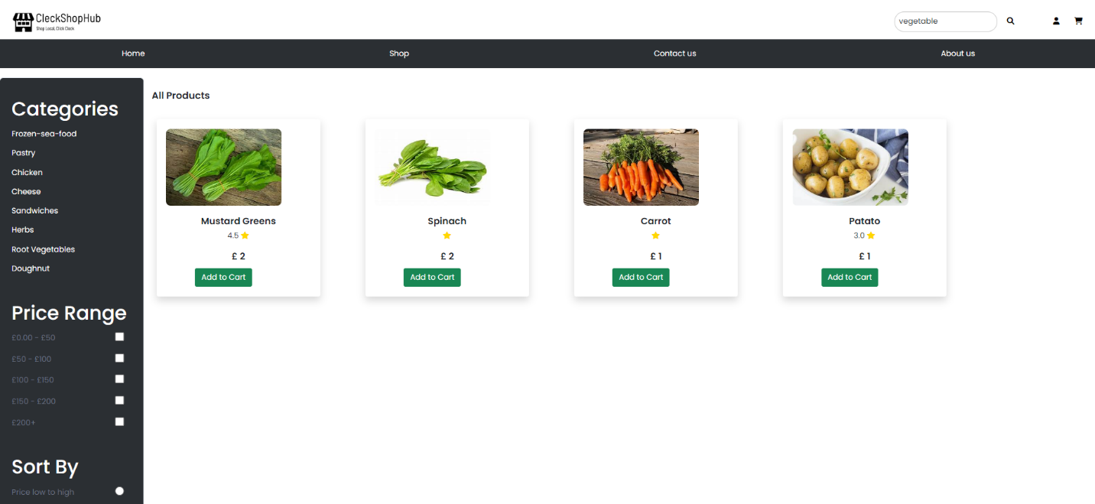

* Customer can add products to their cart after clicking on the add to cart button

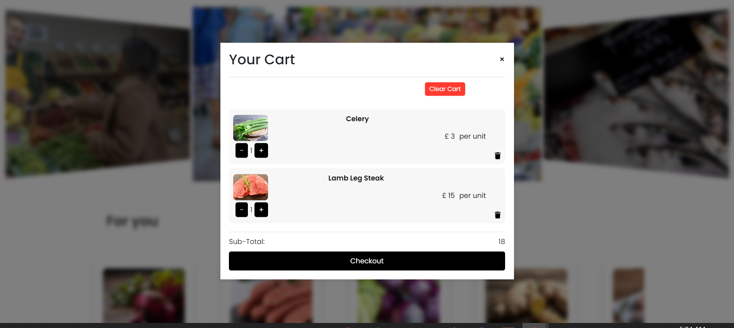

* Customer can add any product in their favorite list after clicking on the red “heart” labelled button

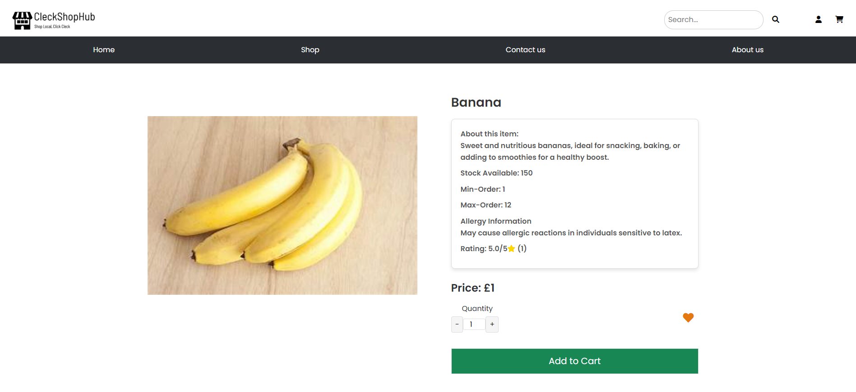

* Customer can check all the review a particular product has after clicking on the product

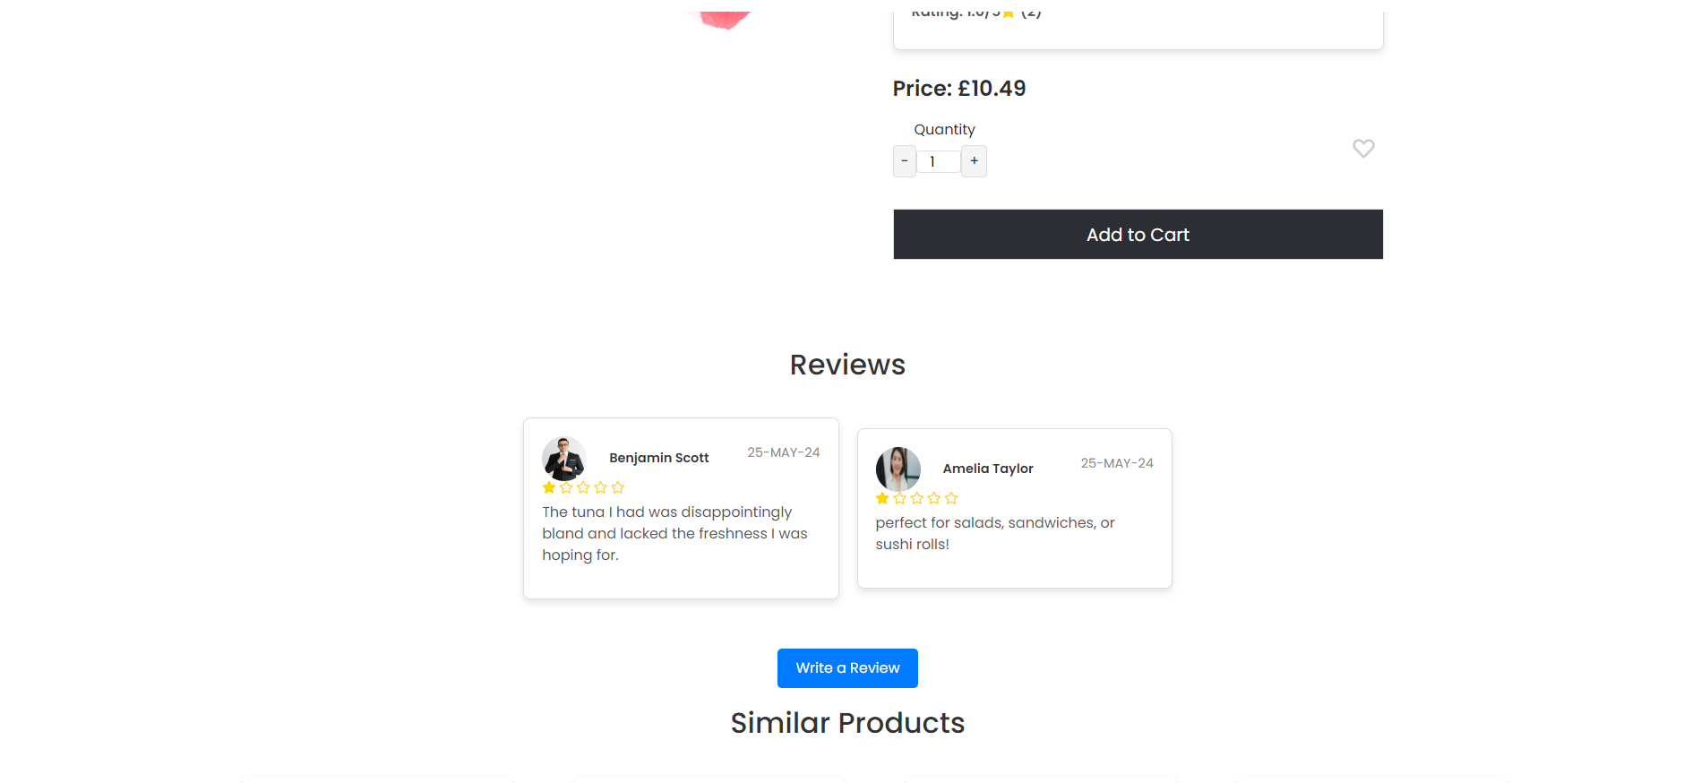

* Customer can check the product details after clicking on a specific product.

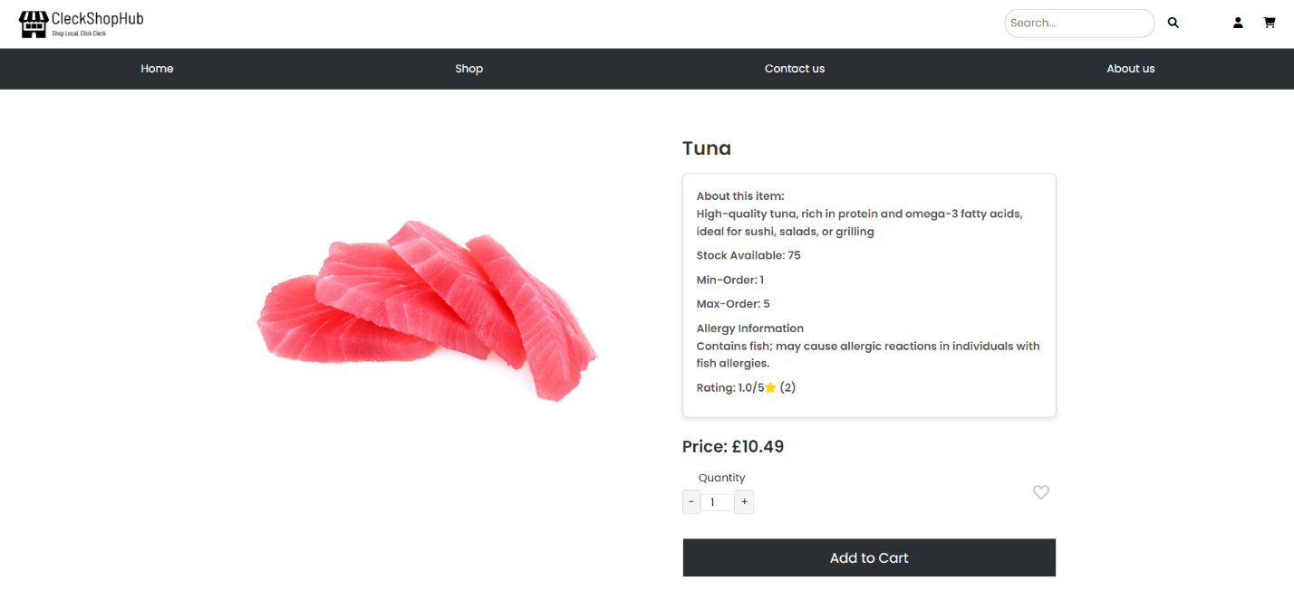

* Customer can write reviews about specific product after clicking on “write a review” labelled button

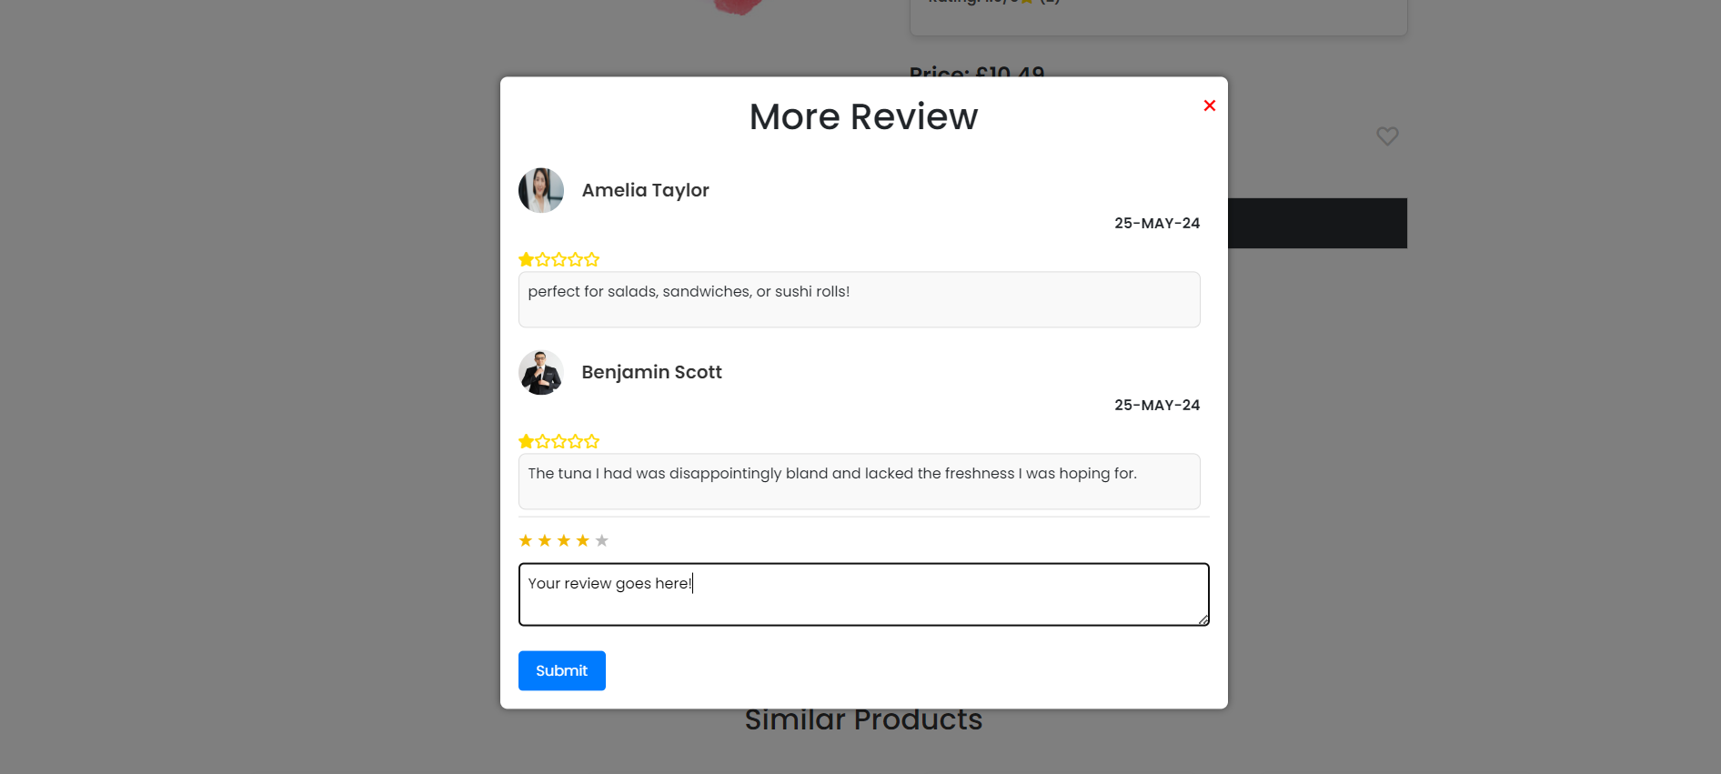

**[Cart Testing]**

* Customer can clear all the items from the cart after clicking on red clear cart labelled button

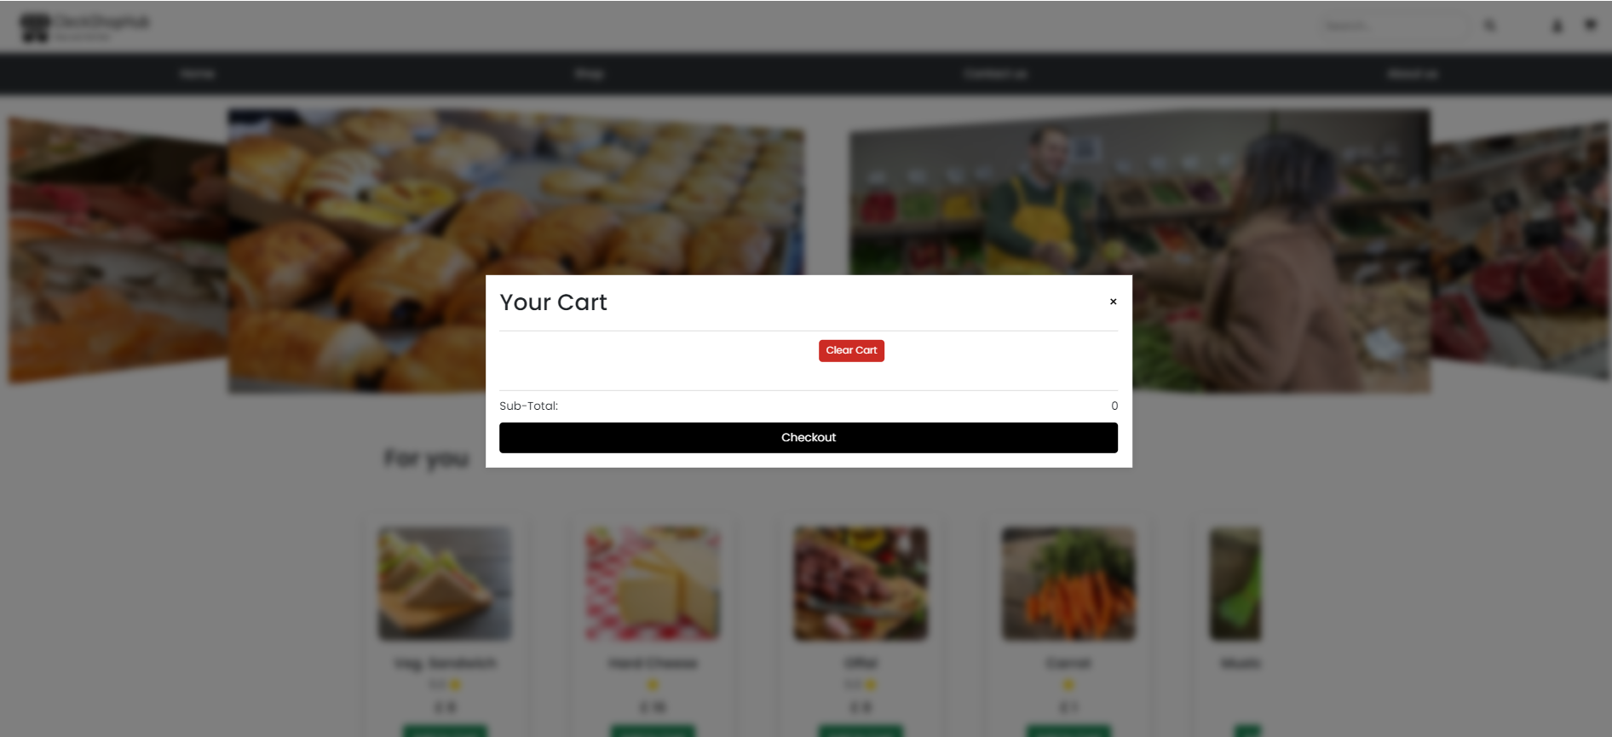

* Customer can increase or decrease the quantity of individual product by clicking on the “+” or “-“ labelled button

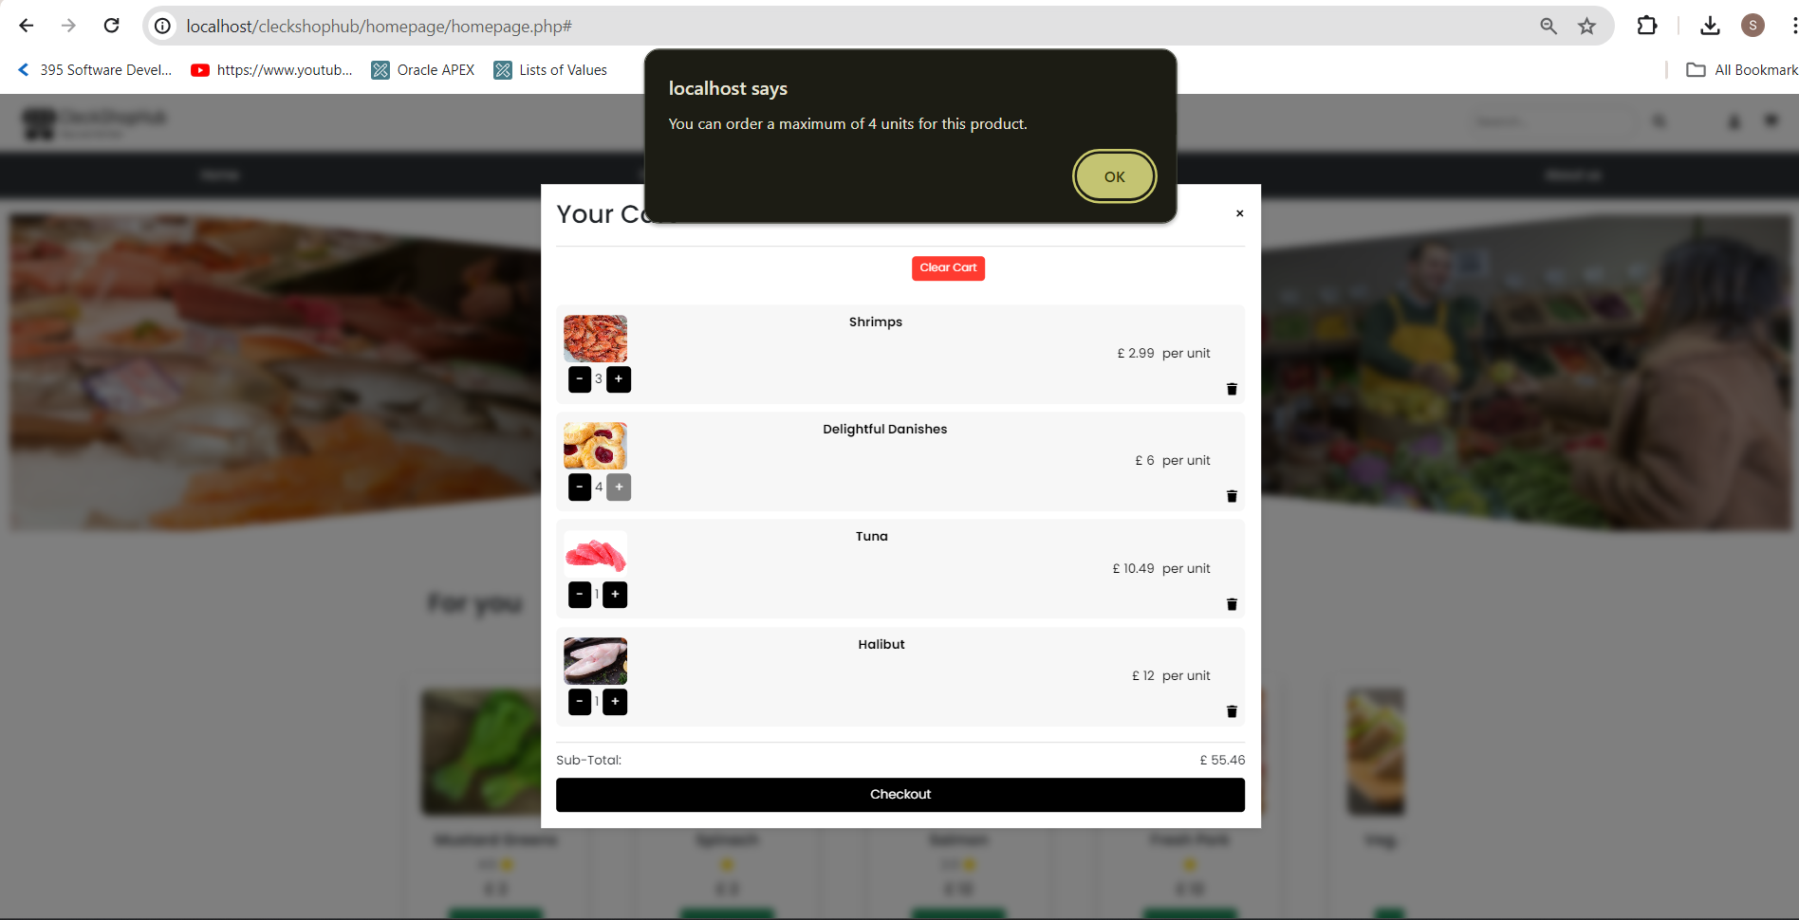

* Customer can know the subtotal of all the product which is displayed in the cart

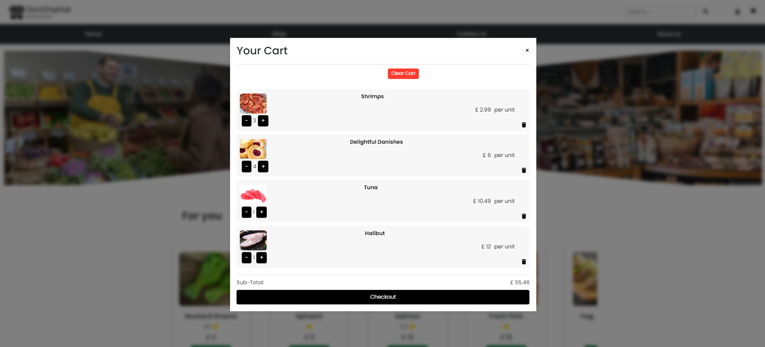

**[Checkout]**

* Customer can proceed to checkout after clicking on the checkout button

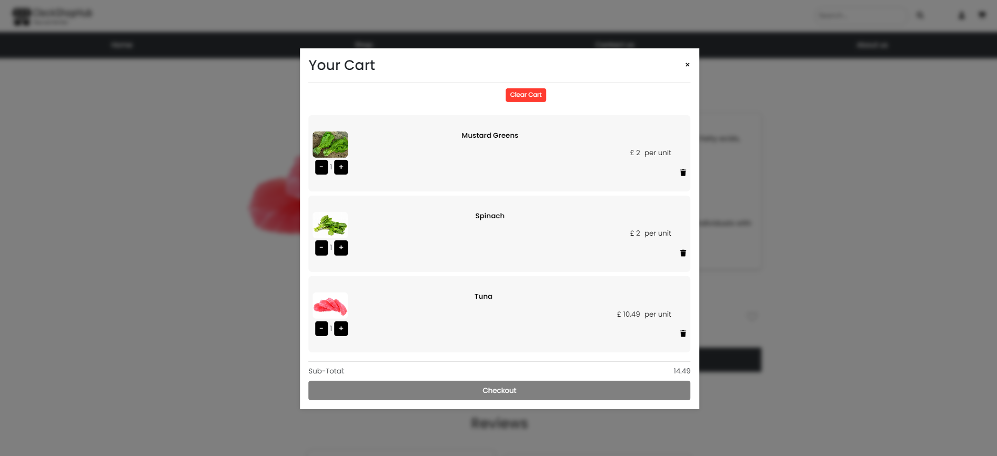

* Customer can select the collection slot during checkout

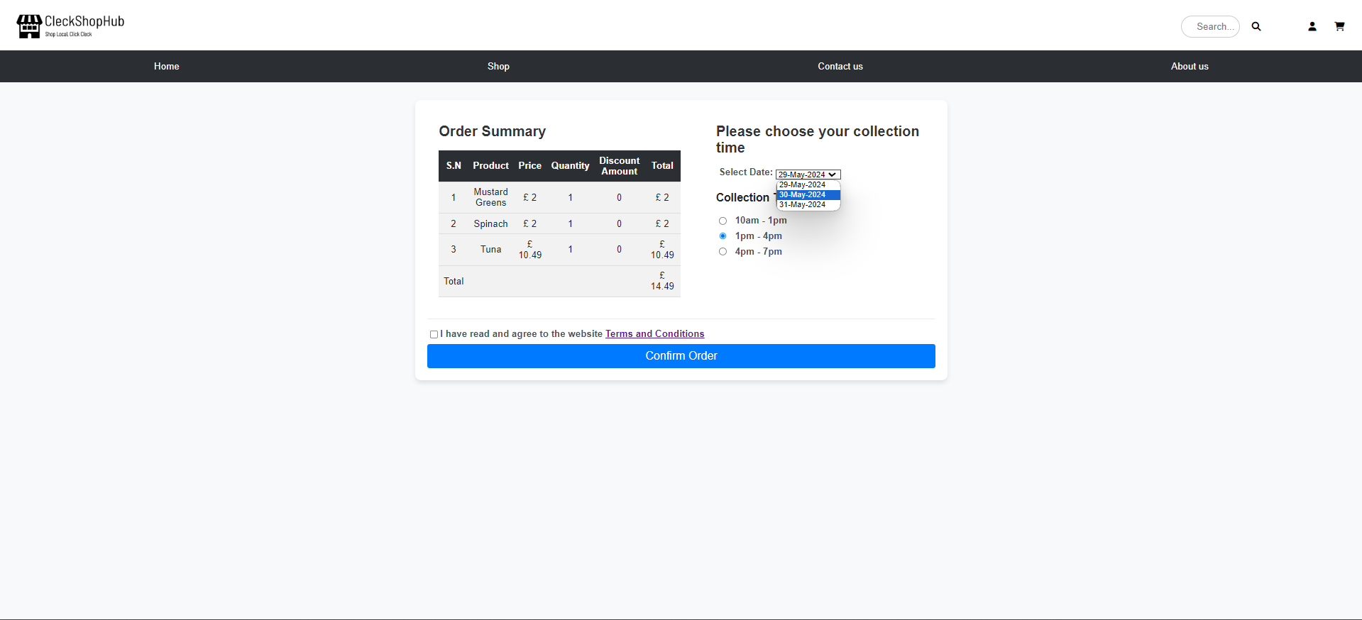

**[Payment]**

* Customer is directed to paypal after checking out

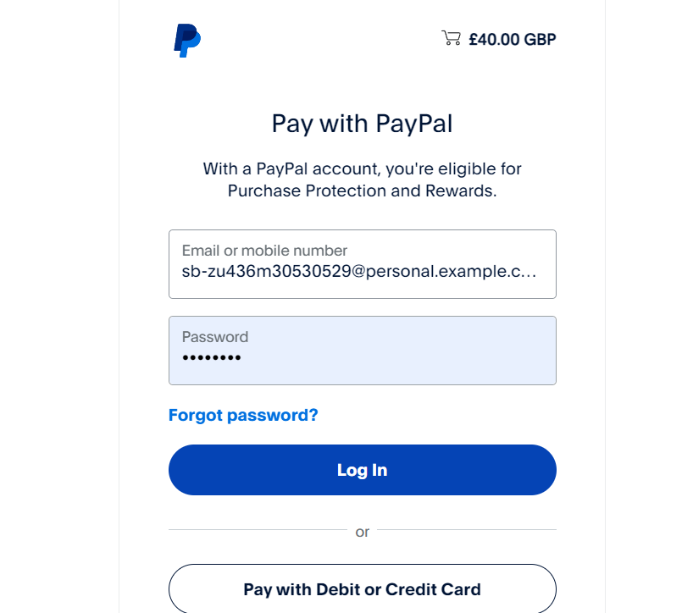

* Customer is prompted complete the payment after entering paypal details to complete the payment

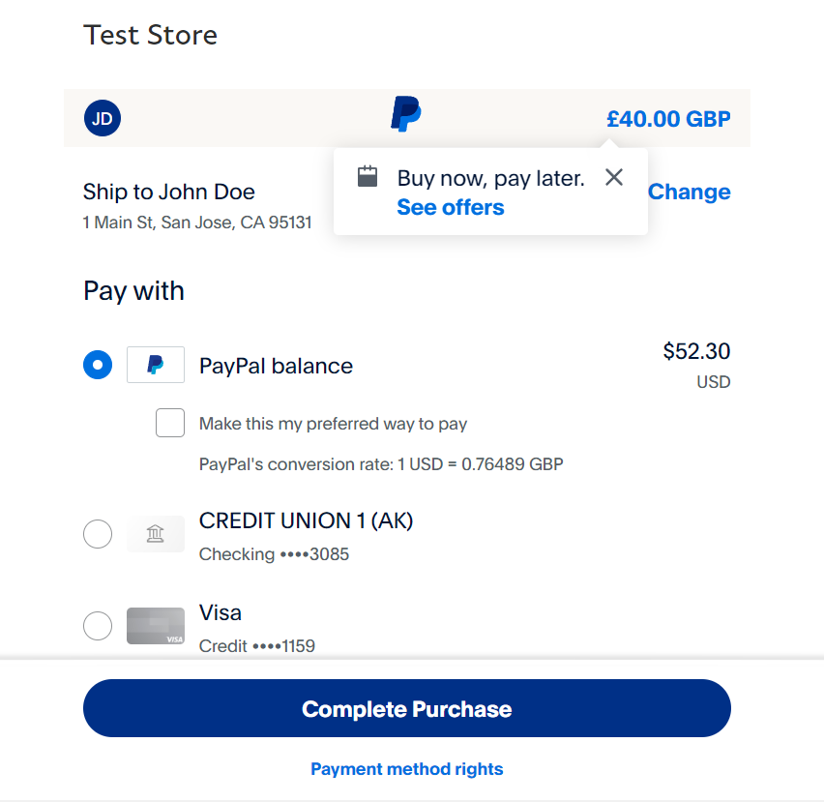

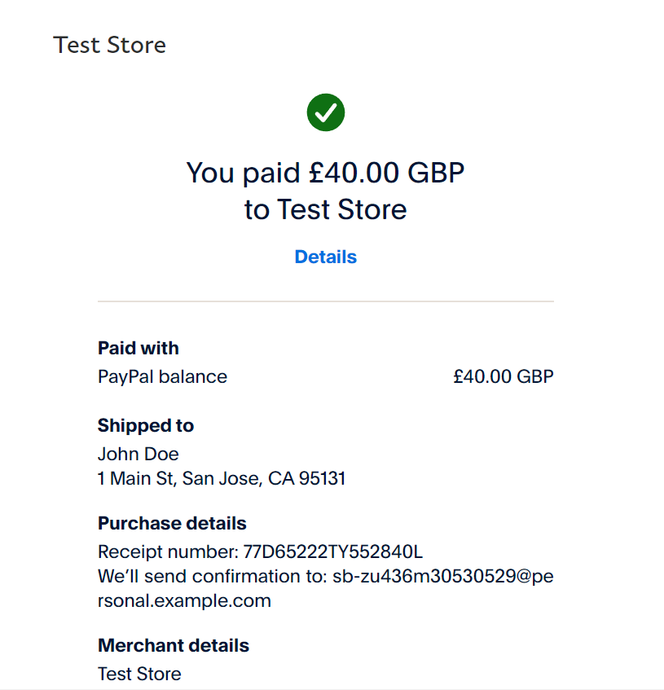

* Customer will receive invoice in their email after completing payment

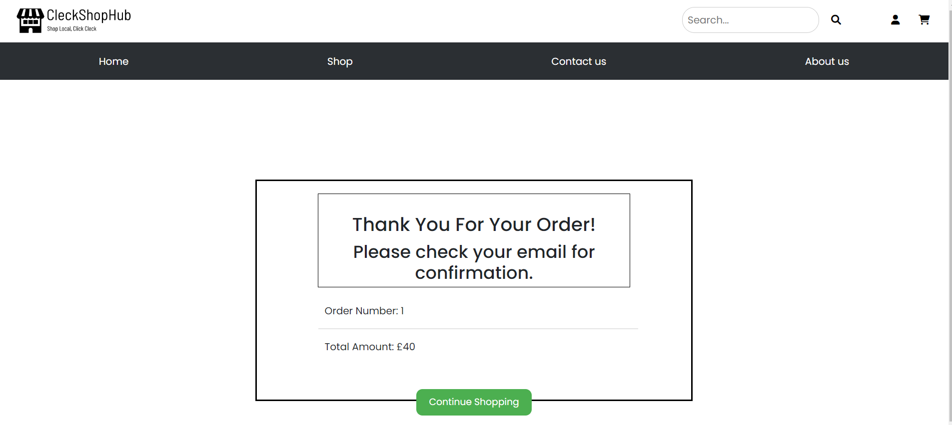

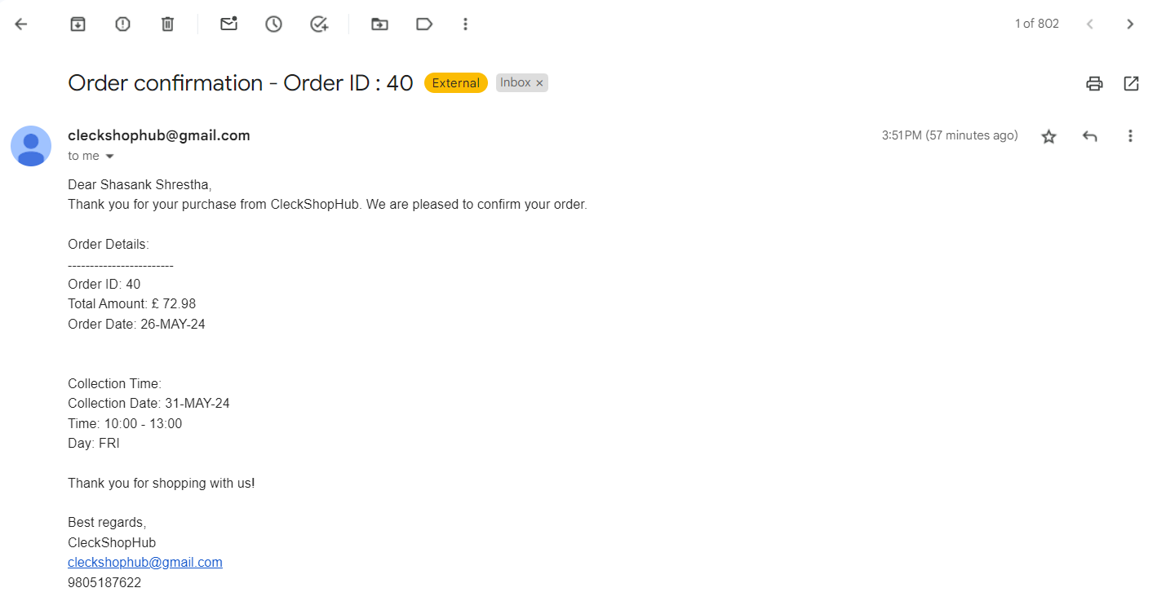

**[About Us]**

* Customer can know more about the website after clicking on the about us tab in the navigation bar

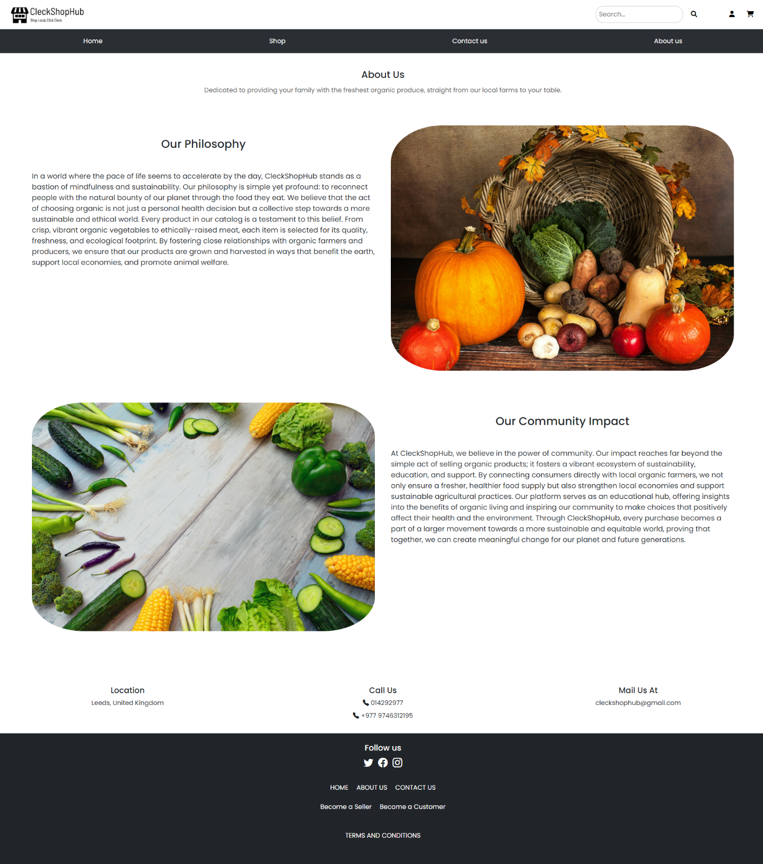

**[Contact Us]**

* Customer can send message or queries to admin, which is fetched to admin panel.

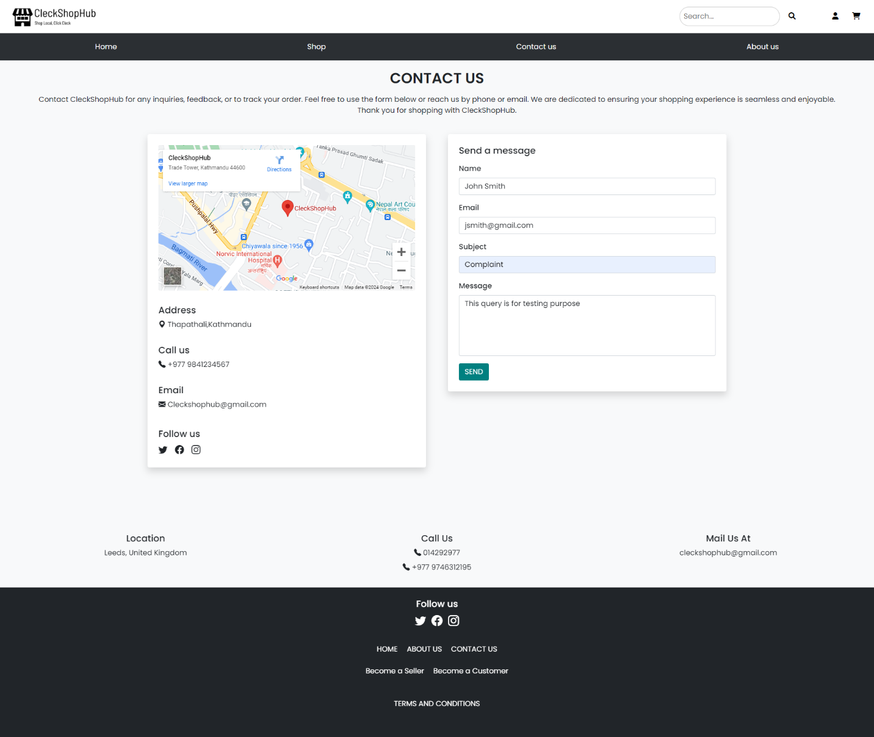

* Customer can check the shop location by interacting with Google Map

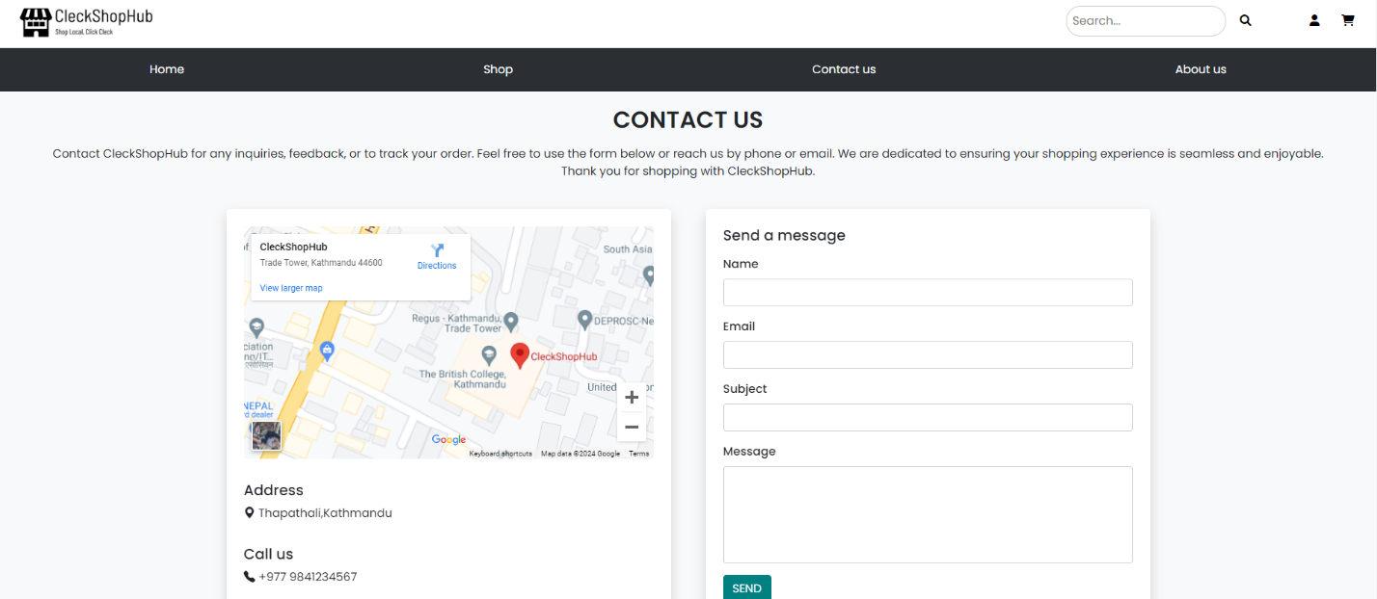

1. **TRADER interface testing PHP**

* First, you need to go to the homepage of CleckShopHub, then click on the Login button from the top right of the navigation bar

[Register Testing]

* If the trader clicks on Sign Up button without entering anything in the input fields then all the empty fields are highlighted in red

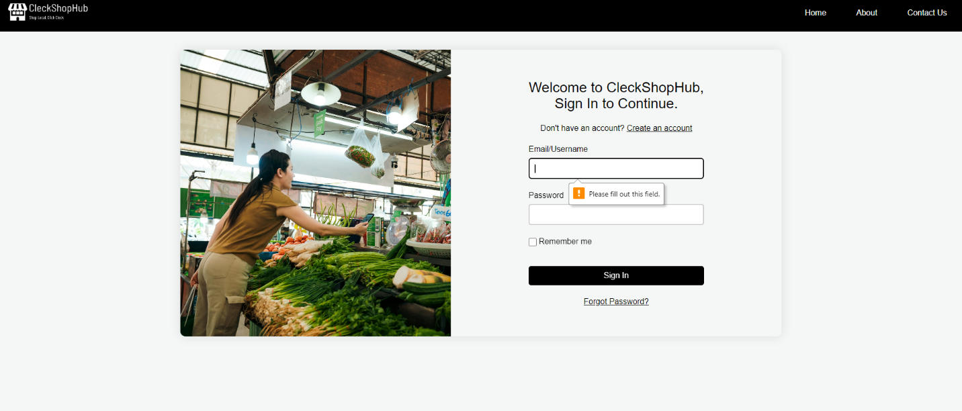

* If the trader provides a contact number that is less than or greater than 10 digits then following error message is shown

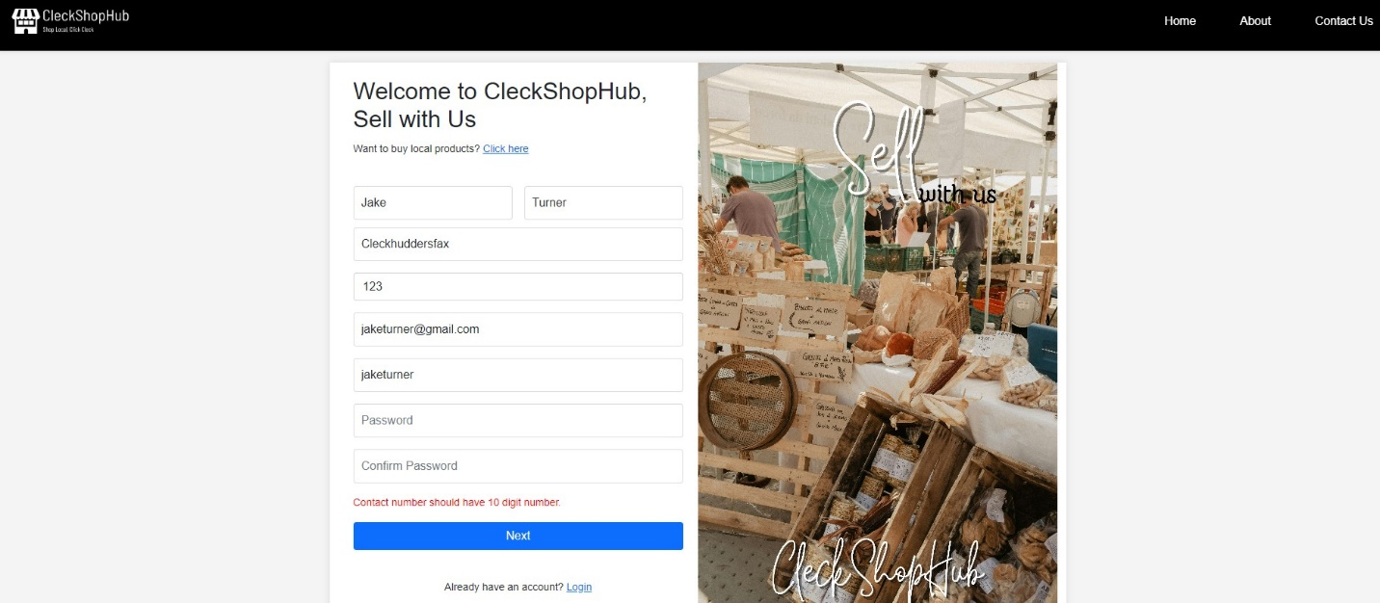

* If the trader provides a username that is already being used by an existing user then an red error message is shown

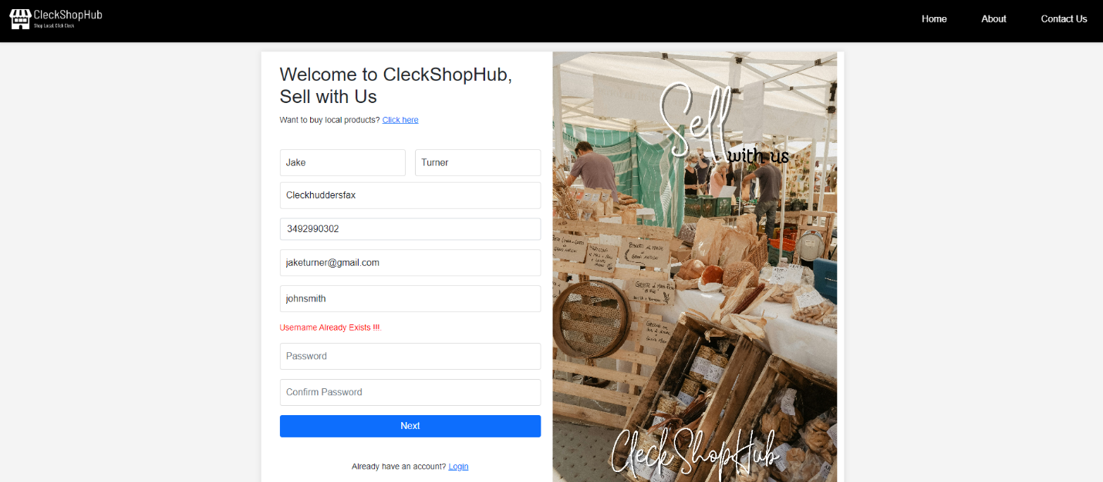

* If the trader provides a contact number that is already being used by another existing trader or customer then the following error message is displayed

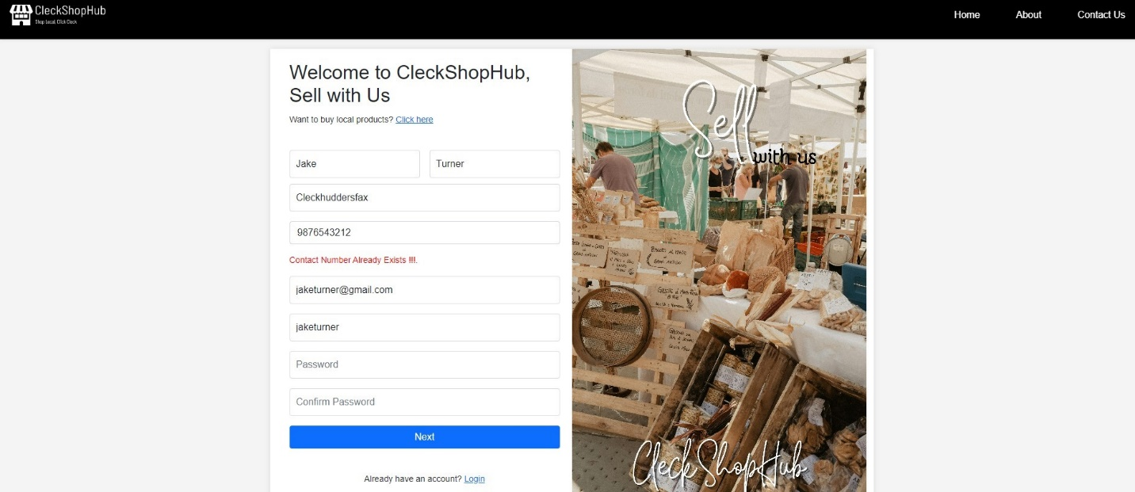

* If the trader’s password and confirm password input field values do not match then a red error message is displayed.

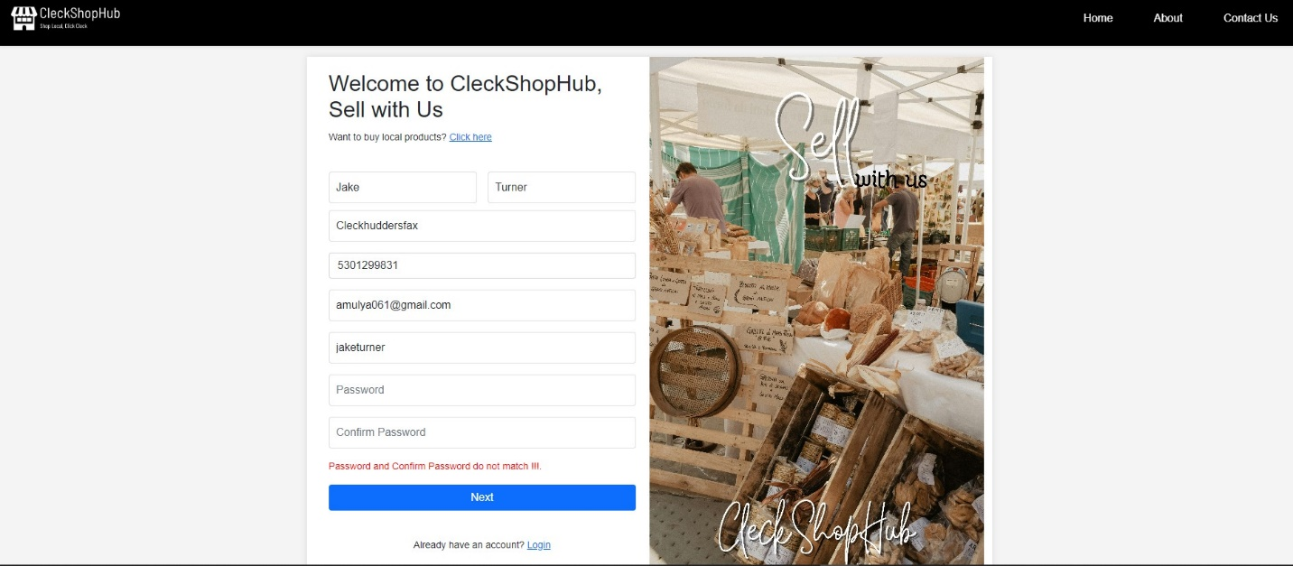

* If the trader inputs the password that is lesser than 8 or greater than 32 characters then the following error is shown

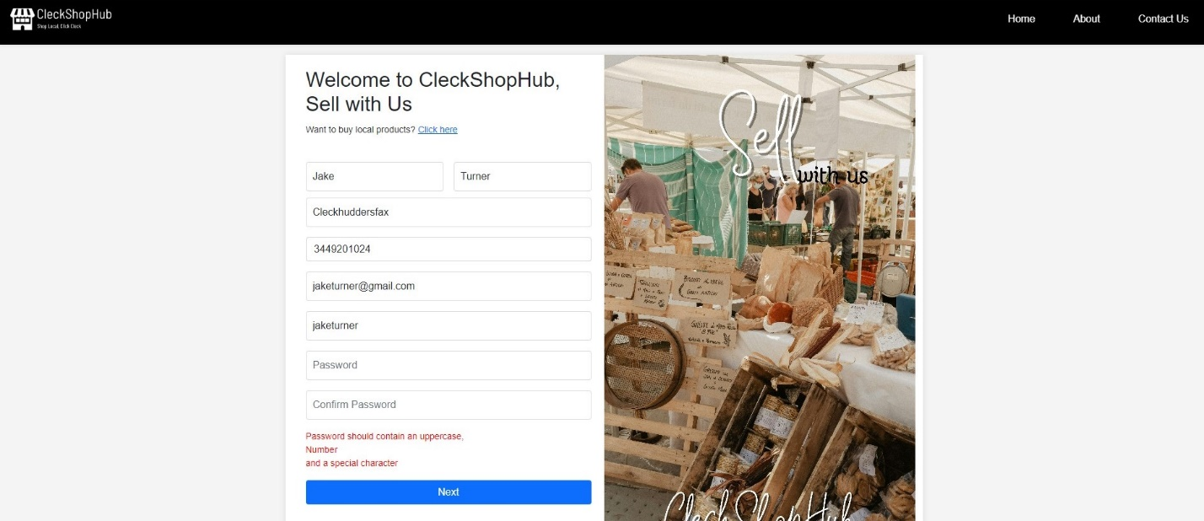

* If the trader provides a password with no uppercase letter or number or a special character then a red error message is displayed



* If the trader provides all the information that are valid then the trader is directed to shop details page where the trader can enter their shop details

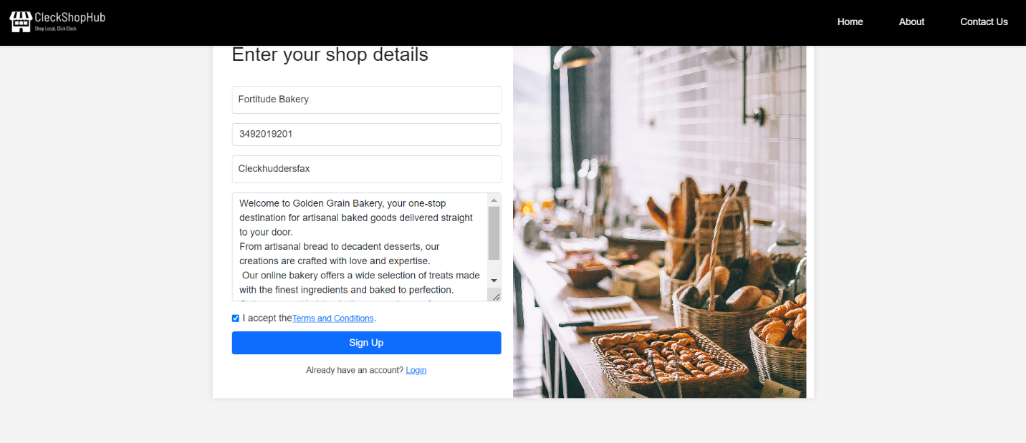

* After successfully registering, the trader gets an OTP validation code sent to their email address.

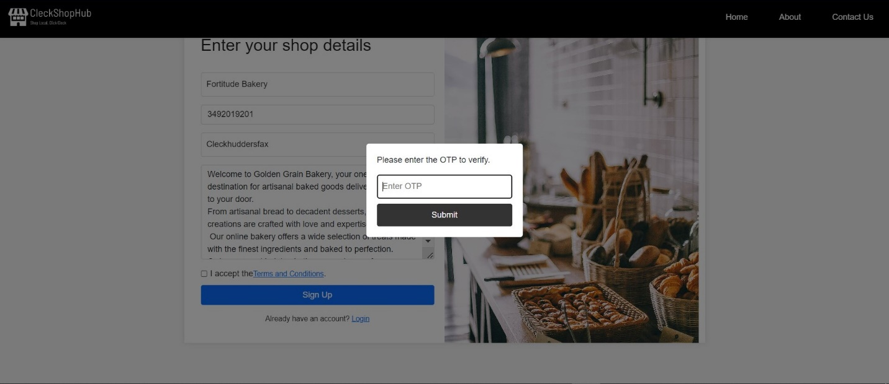

[Login Testing]

* If the trader provides valid details in the login page then the trader is directed to Trader panel.

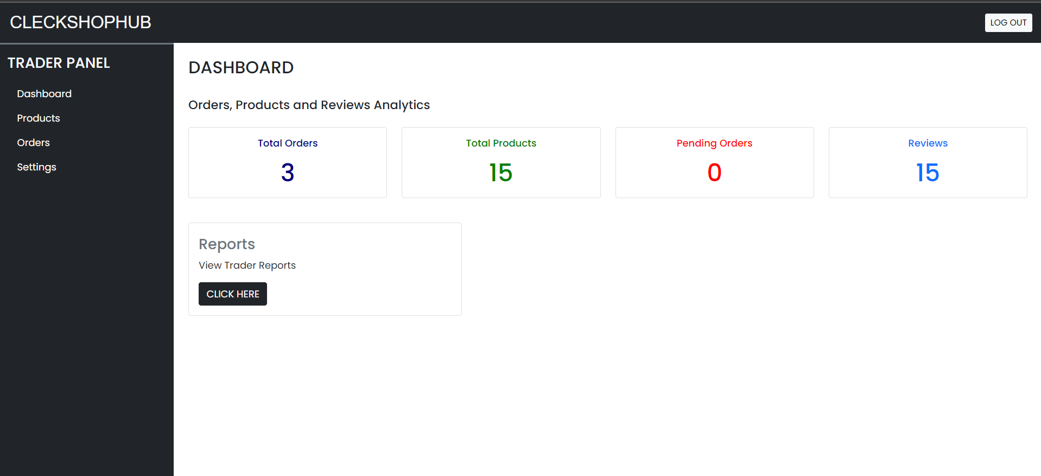

* If the trader provides invalid email or username or a password then a red error message is displayed informing the user that the entered email/username or password is not valid

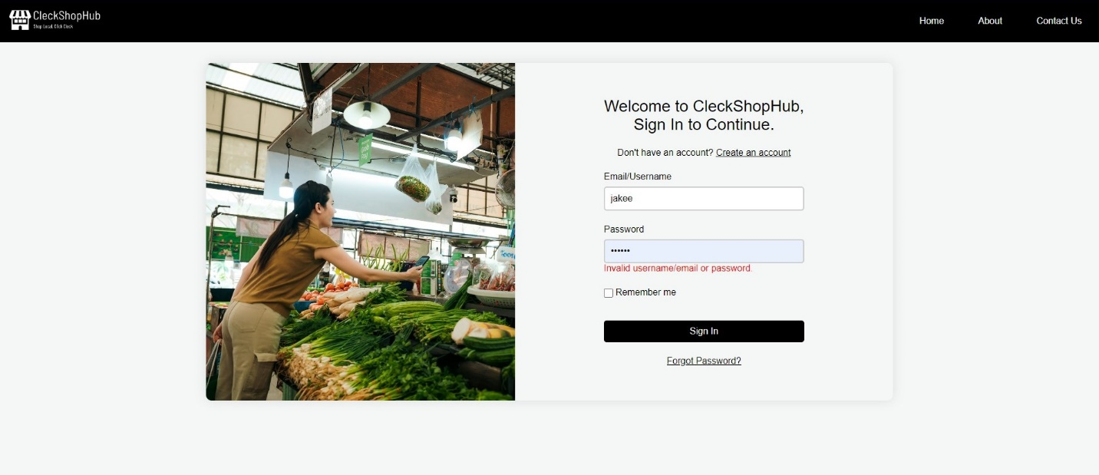

* If the trader ticks the Remember me checkbox then the trader is not required to enter their email or address details again



* If the trader clicks on the Forgot password link then the trader is instructed to provide their email address first, then the trader receives an OTP code sent to their email address and they can finally change their password.









* If the trader clicks on Sign In button without providing any details then a message is displayed prompting the trader to fill out the empty fields.



[Trader Panel Testing]

* If the trader clicks on “Click Here” on Report section then the trader is redirected to Oracle Apex Trader Report

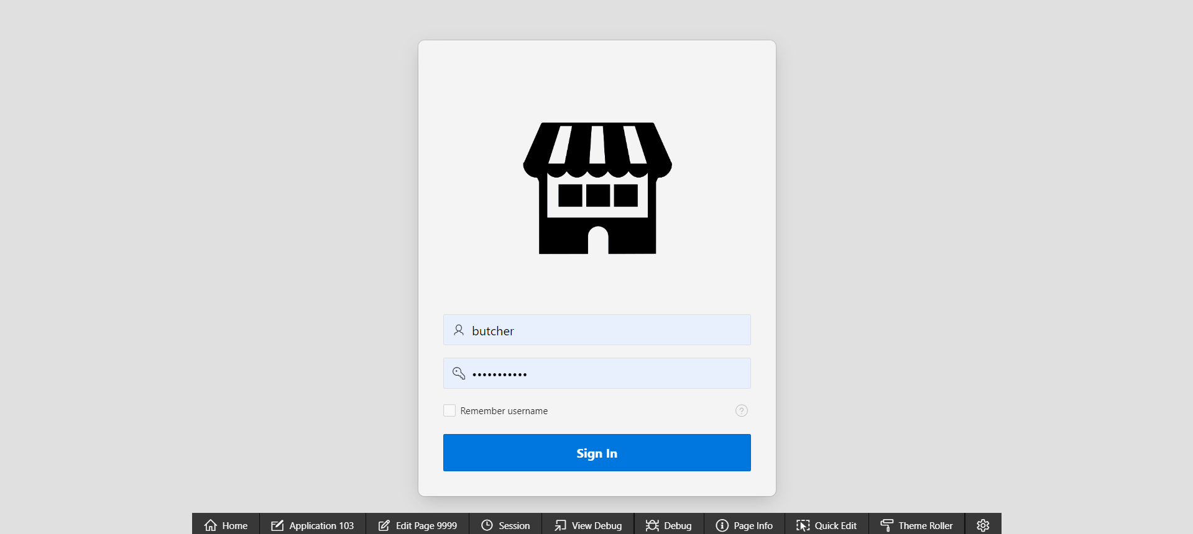

* If the trader clicks on “edit” button on profile settings then the trader can edit their personal details

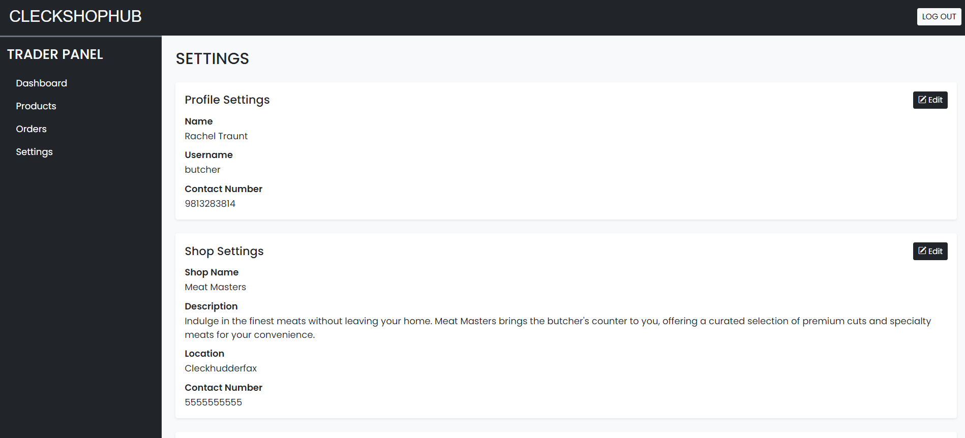

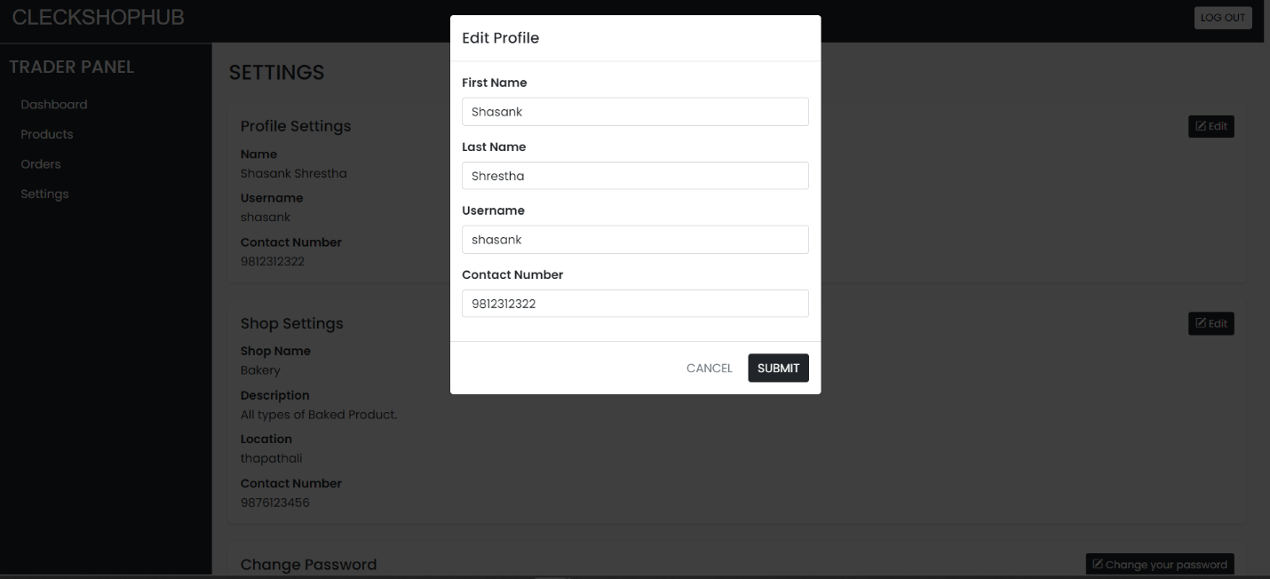

* If the trader clicks on “edit” button on shop settings then the trader can edit their shop details

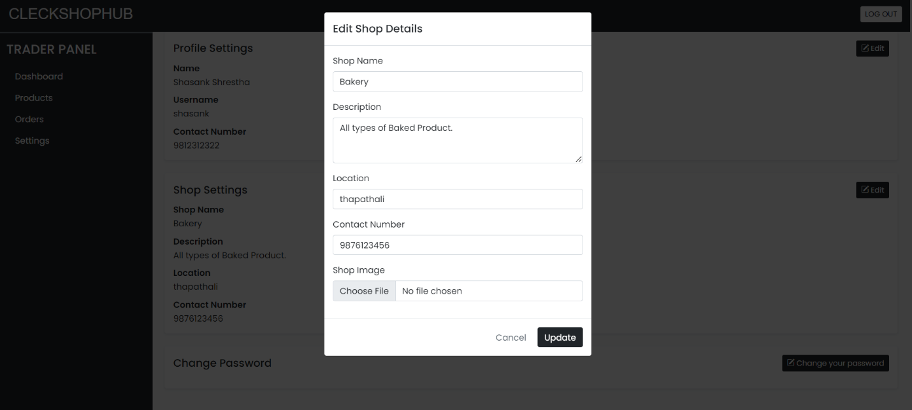

* If the trader clicks on change password button then trader can change password from the trader panel

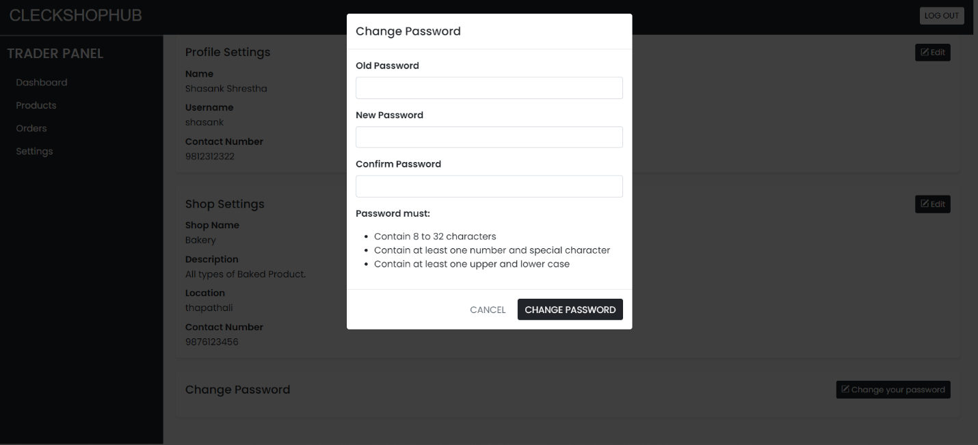

[Products Testing]

* If the trader clicks on Products tab on right side then trader can view all the product they have on their shop

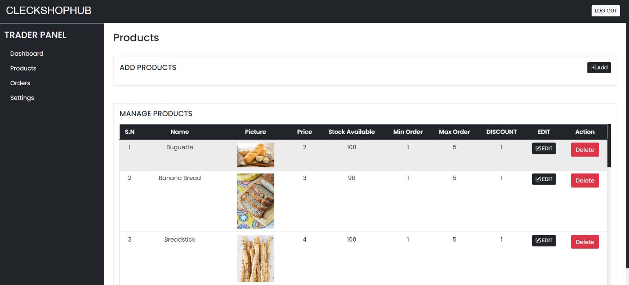

* If the trader clicks on “add” button on Products tab then the trader can insert their products in the shop after providing details about their products such as the product name, quantity and allergen information along with a picture of their product.

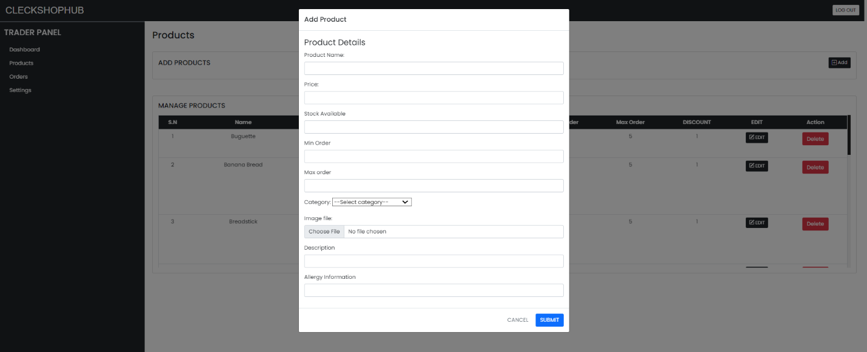

* If the trader clicks on “edit” button on products tab then the trader can edit the details about existing products in their shop

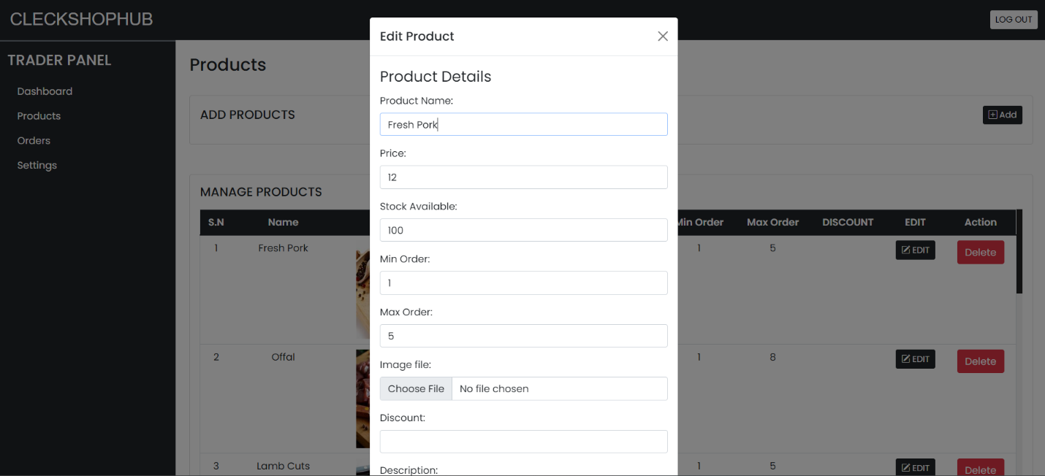

* If the trader clicks on the red “delete” button then the trader can delete products from their shop

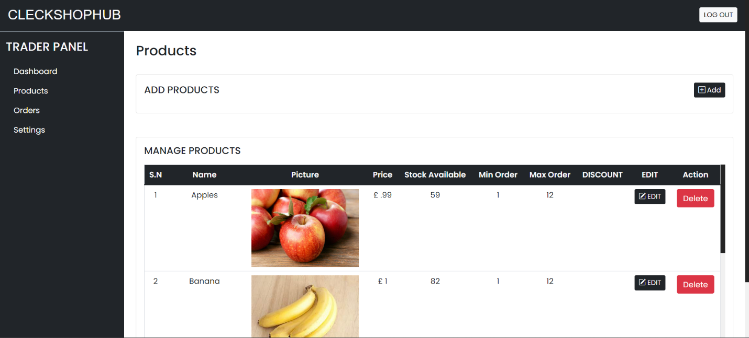

[Orders Testing]

* If the trader clicks on “View Order” button on Orders tab then the trader can view all the order summary

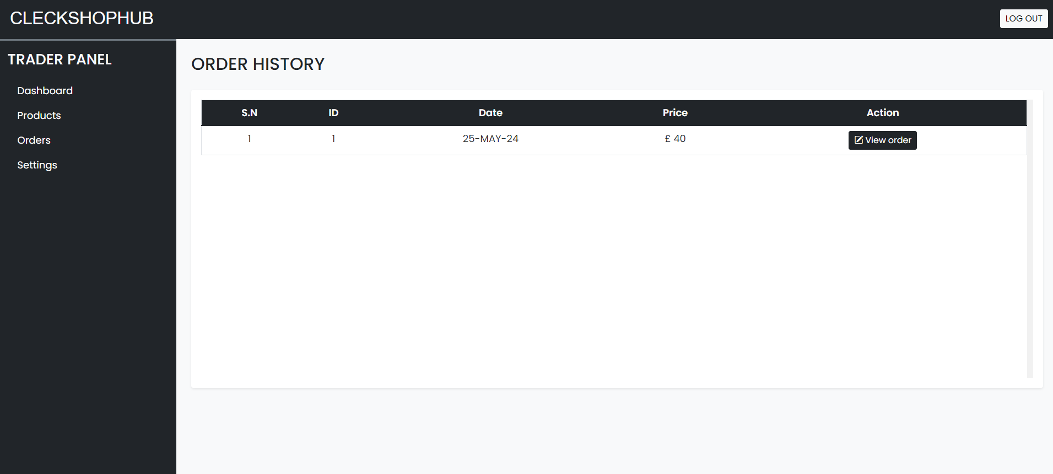

[Logout Testing]

* If the trader clicks on logout button on top right of the navigation bar then the trader gets logged out and redirected to the homepage.

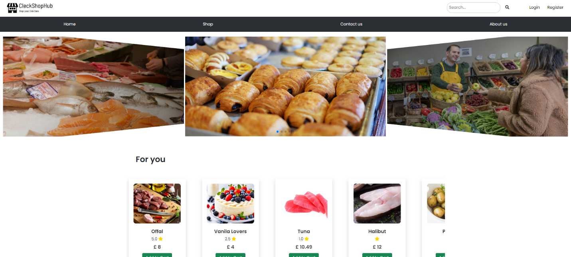

1. **ADMIN Interface Testing PHP**

* Firstly, to get into the admin panel, first you must click on the login button at the top right of the navigation bar

[Login Testing]

* If the admin provides valid email/username or password then the admin is redirected to admin panel

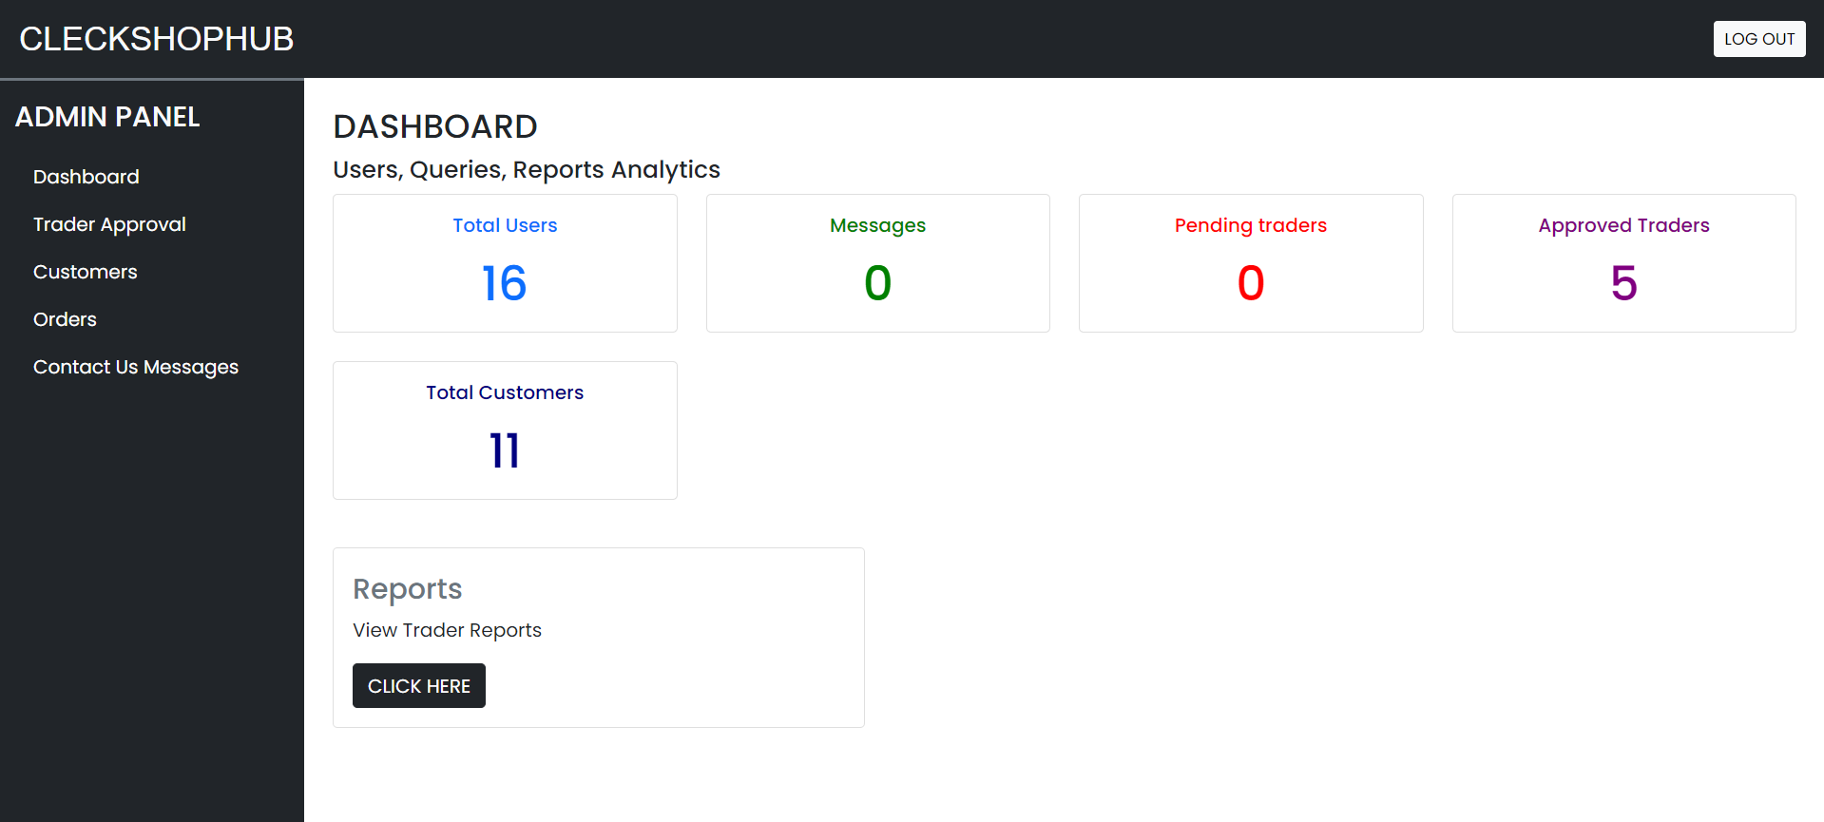

* If the admin provides an invalid email/username or password then a red error message is shown displaying the email/username or password is invalid

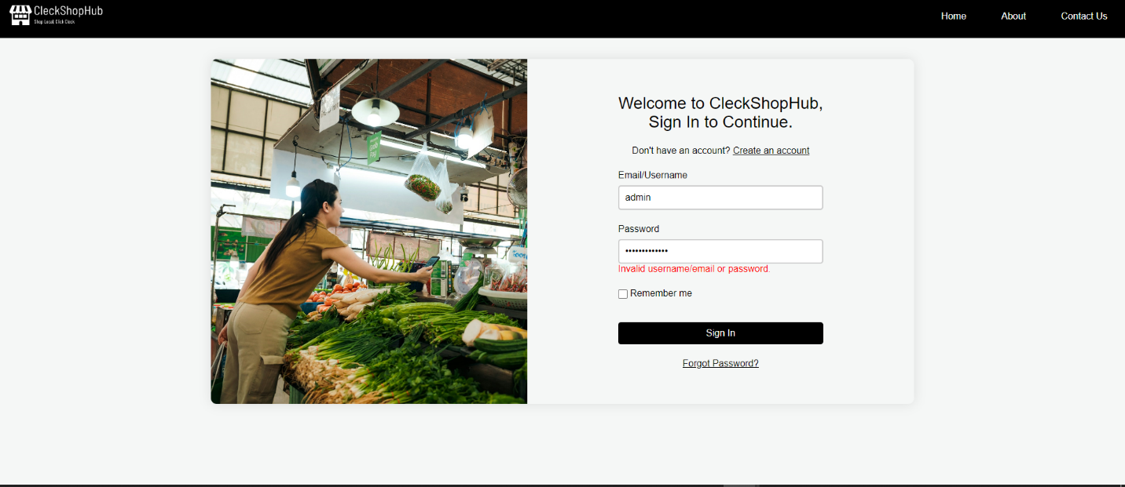

* If the admin ticks the remember me button then the admin is not required to enter the username or email details again

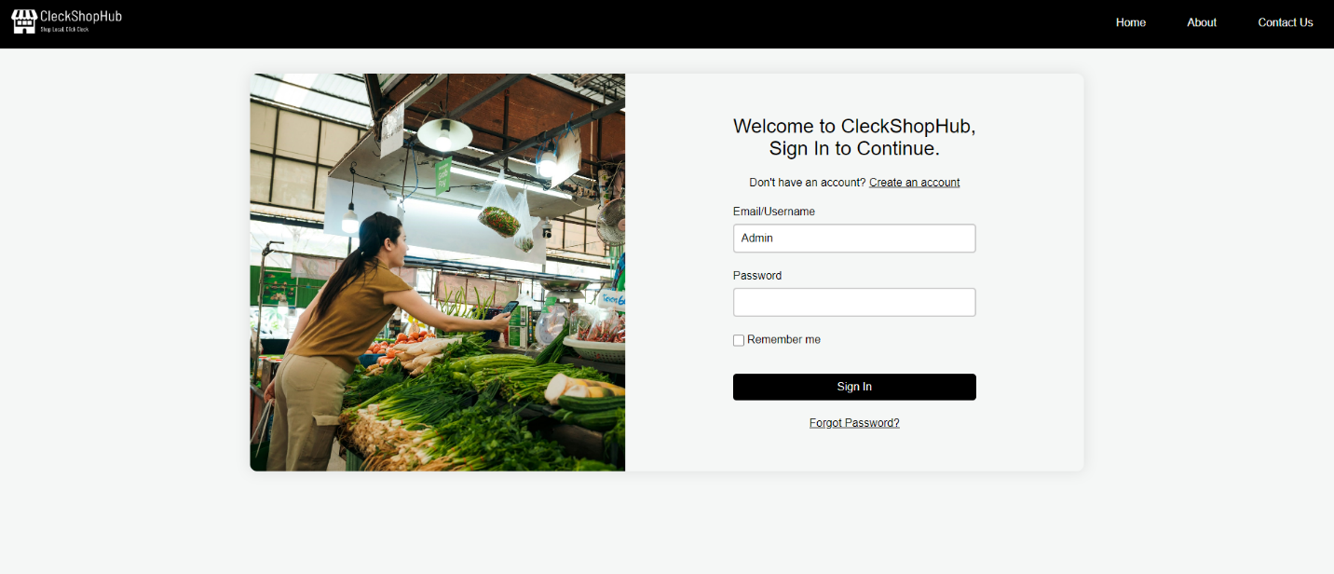

* If the admin clicks Sign In without providing any details then a message is displayed prompting the admin to fill in the empty input fields



* If the admin clicks on forgot password link then the admin can change their password after providing their email address then receiving an OTP code for validation, then finally the admin is able to successfully change the password







[Dashboard Testing]

* If the admin clicks on the “Click Here” button in Report section then the admin is redirected to the Oracle Apex Application

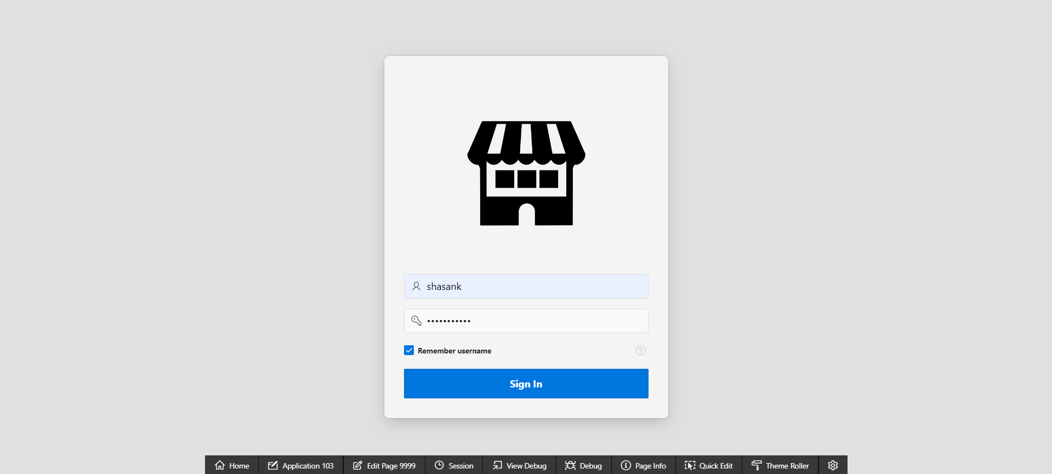

[Trader Management Testing]

* If the admin clicks on the green “approve” button in the Pending Traders section then the trader is shifted to Approved Traders section

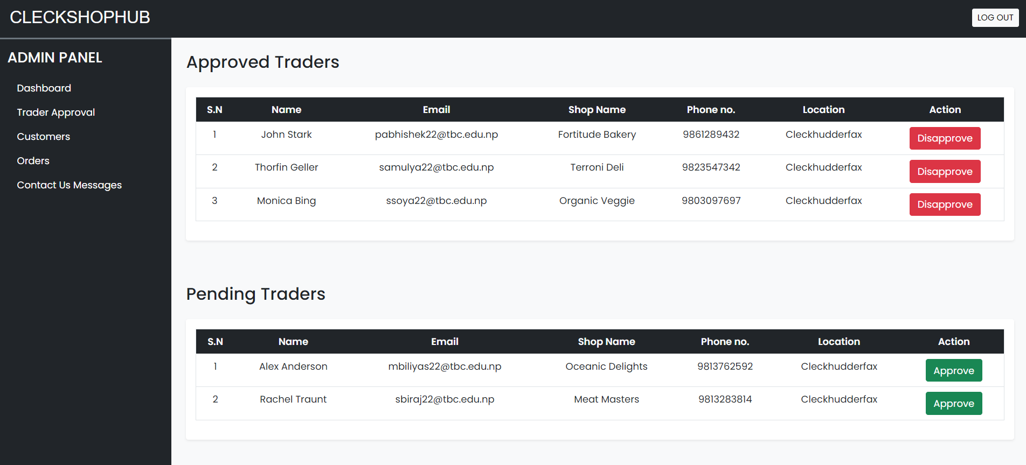

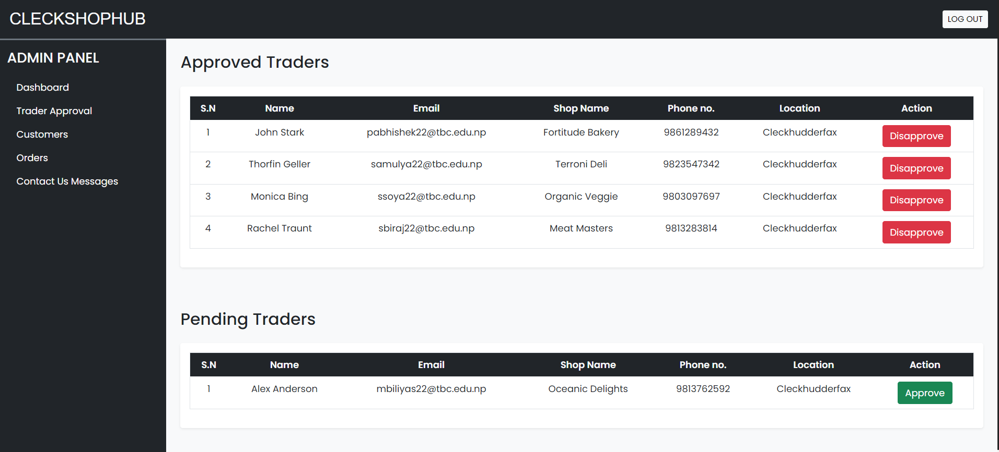

* If the admin clicks on the red “disapprove” button in the Pending Traders section then the trader is disapproved.

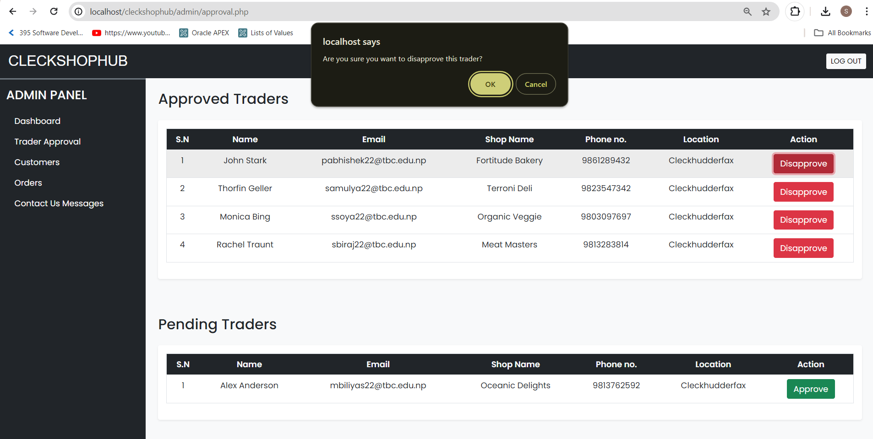

[Customer Management Testing]

* If the admin clicks on the “delete” button then the admin can remove the customer with all their associated records with a pop up message.

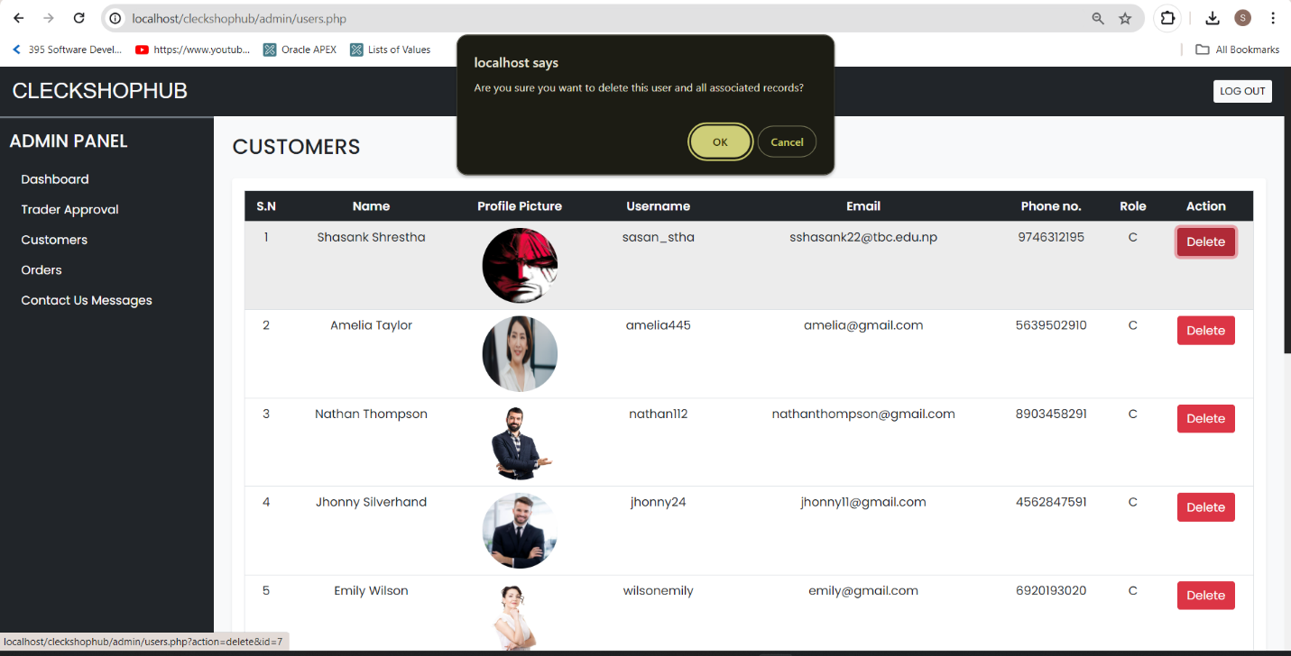

[Orders]

* If the trader clicks on order tab then customer can view all the orders customer has made

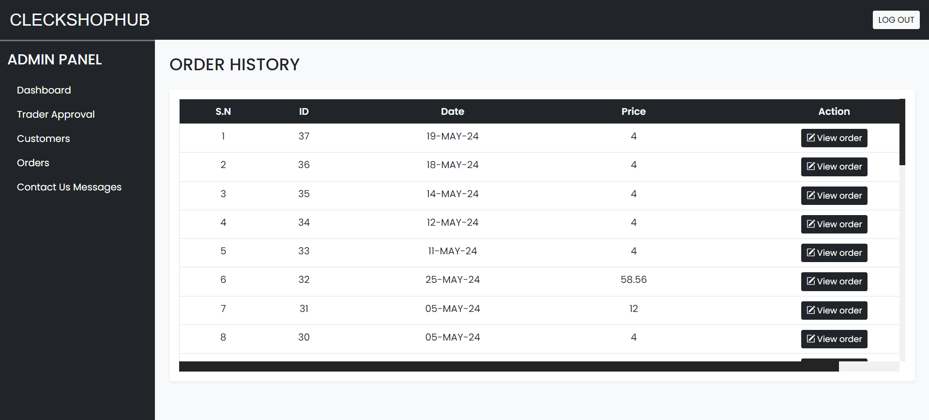

[Contact Us Message Testing]

* If the admin clicks on the “delete” button in the user queries tab then the user query or message is removed

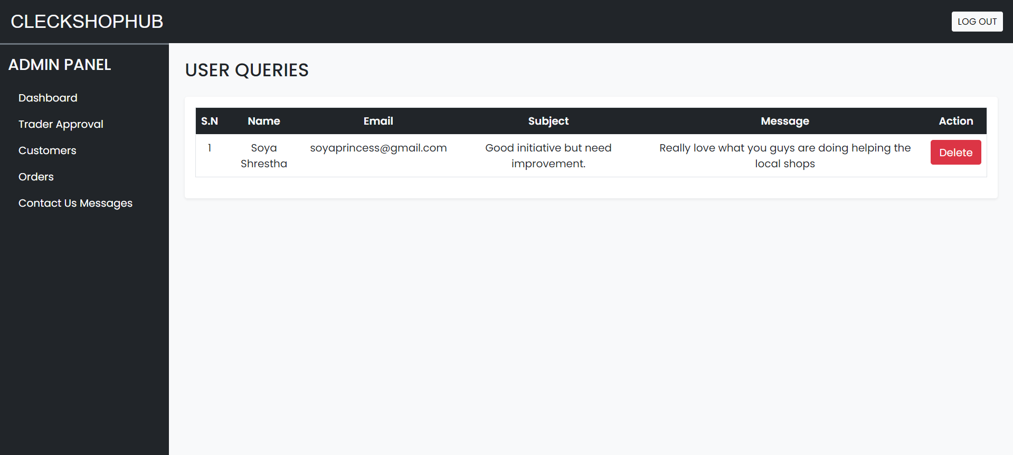

[Logout Testing]

* If the admin clicks on the logout button at top right of the navigation bar then the admin is redirected to homepage.

1. **Trader Interface Testing Oracle**
2. If you want to view reports of all the traders, then you need to click on Report (View Traders Report) **CLICK HERE** button on the middle left of our Dashboard. After clicking on it will redirect you to Oracle Dashboard from where you can login with your username and password.

* Invalid Login Credentials.

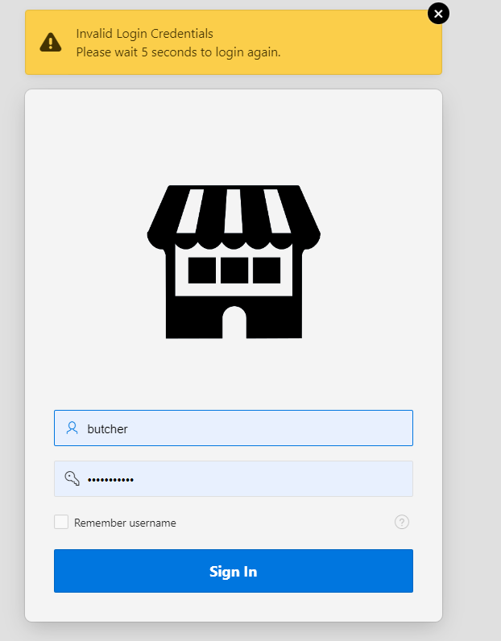

* Valid Login Credentials.

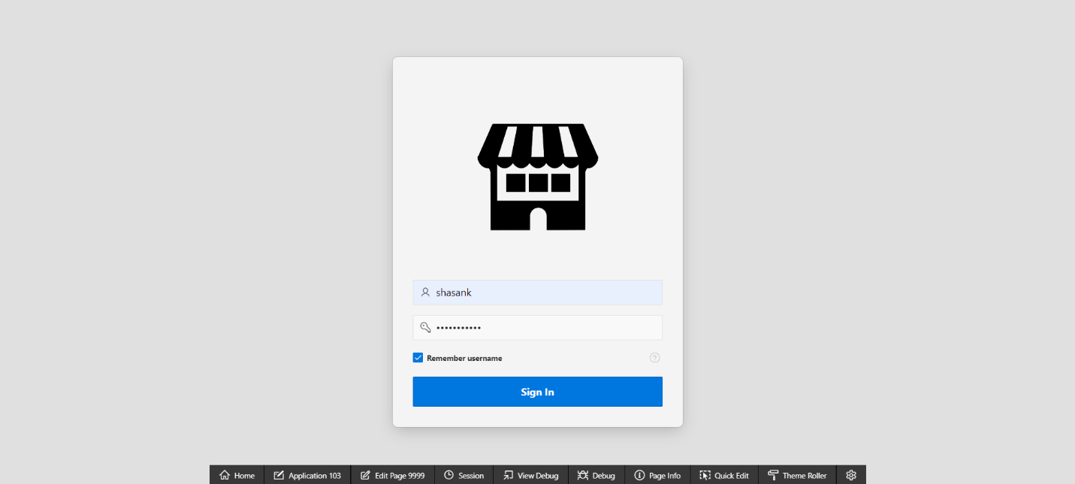

1. After logging in with correct login credentials, you’ll have access to the various reports of trader. You can see Monthly Sales Performance, Sales Report, Product Review, and Pending Orders through various reports and graphs.

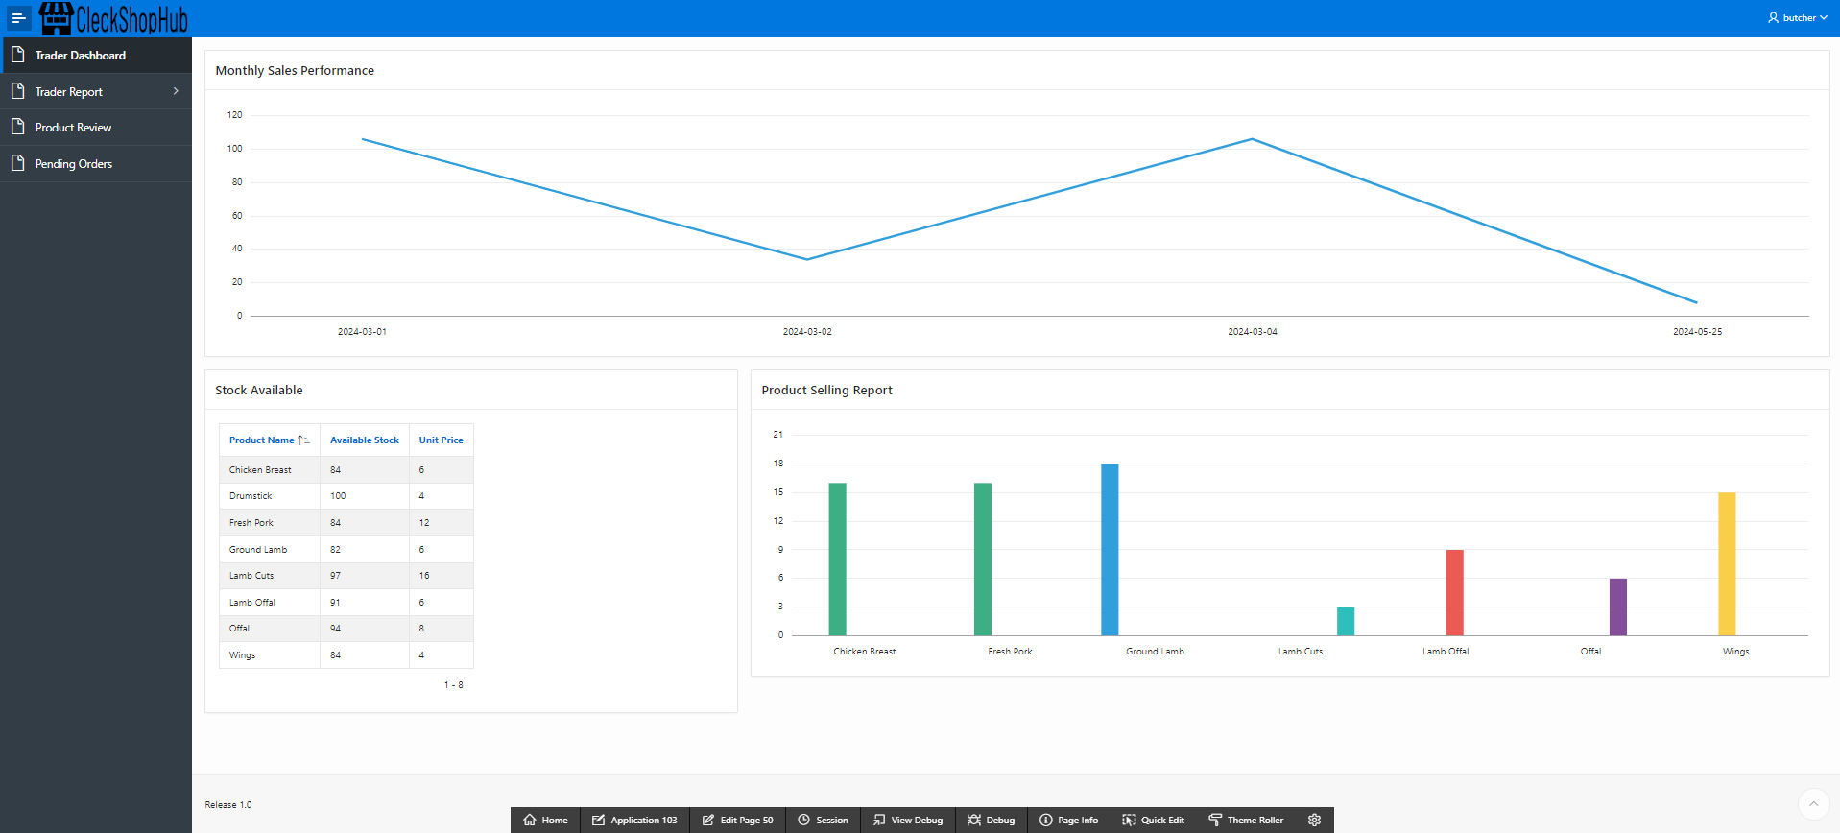

1. MONTHLY SALES REPORTS OF SHOP display reports of sales of various months and also specific report of product sold in past 30 days.

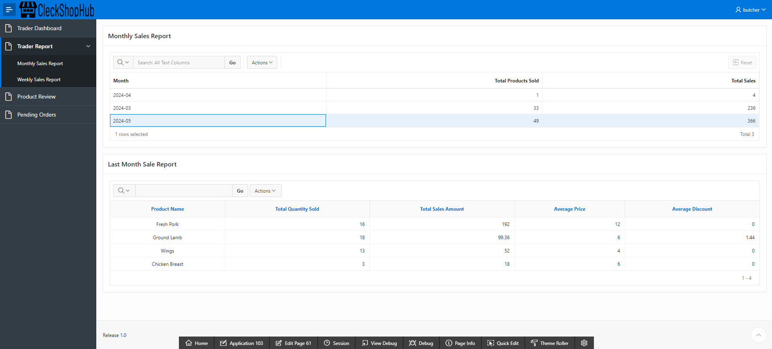

1. WEEKLY SALES REPORTS OF SHOPS display reports of sales of various week and also specific report of product sold in past 7 days.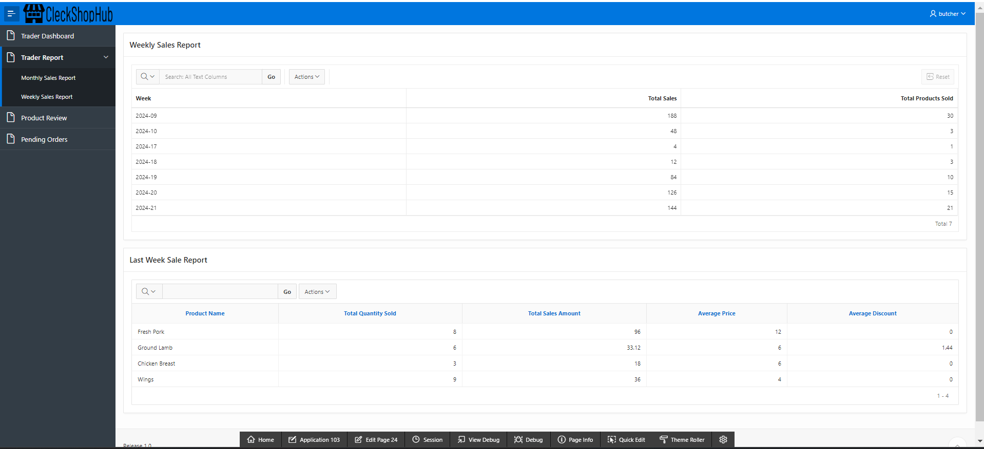
2. PRODUCT_AND_REVIEWS display all the product and their reviews in master-detail page. The product is the master table and reviews are in the detail table.

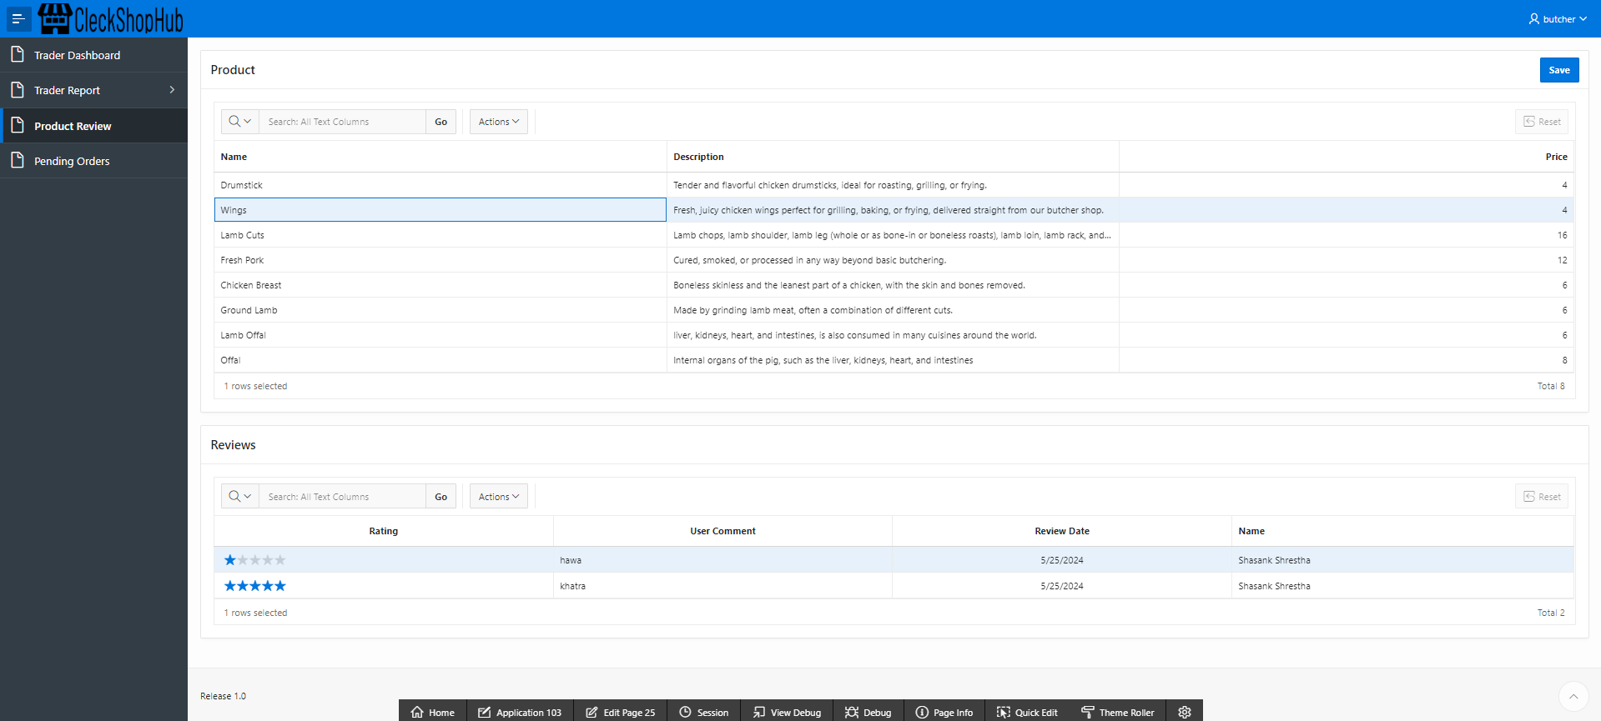

1. Pending_Orders shows the orders that are not yet delivered or in collection slot. Orders part is master table that shows the pending order detail and products part is detail table that shows the product of that shop from the specific order.

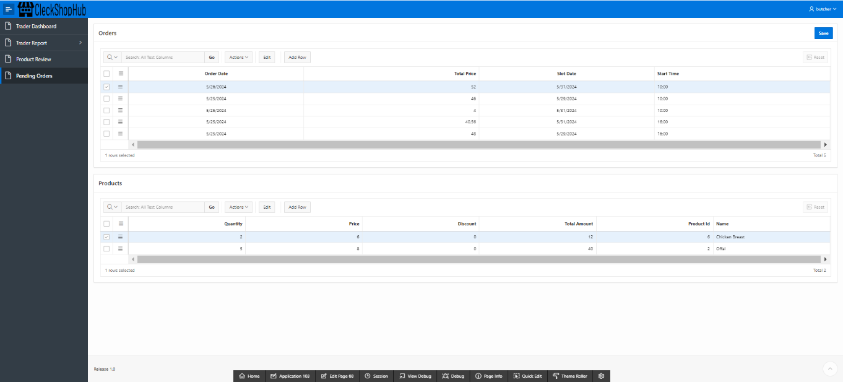

1. You can logout by clicking on username and then Sign out.

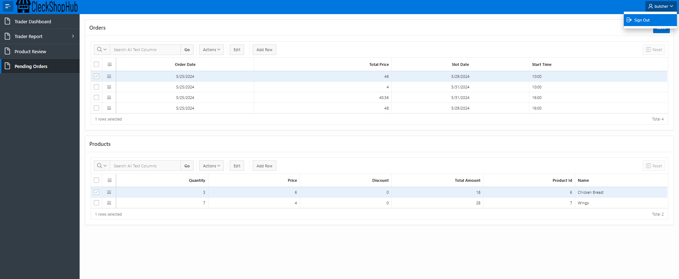

1. **Admin Interface Testing Oracle**
2. If you want to view reports of all the traders then you need to click on Report (View Traders Report) **CLICK HERE** button on the middle left of our Dashboard. After clicking on it will redirect you to Oracle Dashboard from where you can login with your username and password.

* Invalid login credentials.

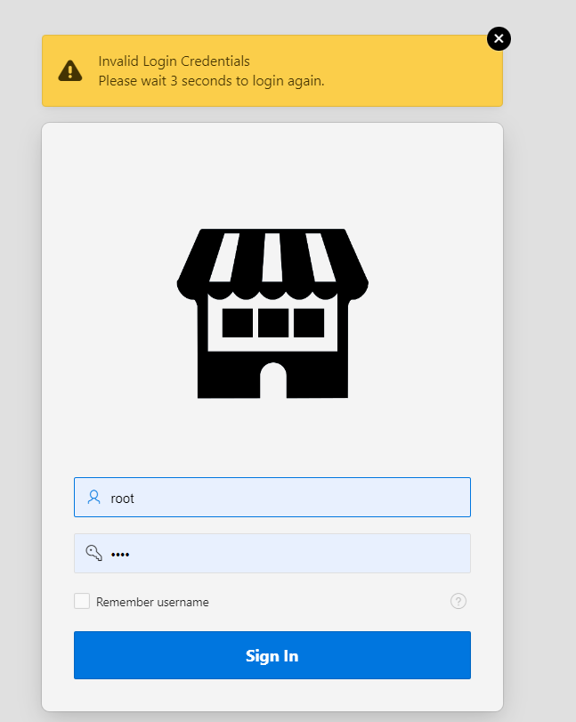

* Valid login credentials.



1. After logging in with correct credentials as Admin you’ll have access to the different reports of shops, products, reviews and many more information like highest selling shop, top selling products etc. through different graphs.

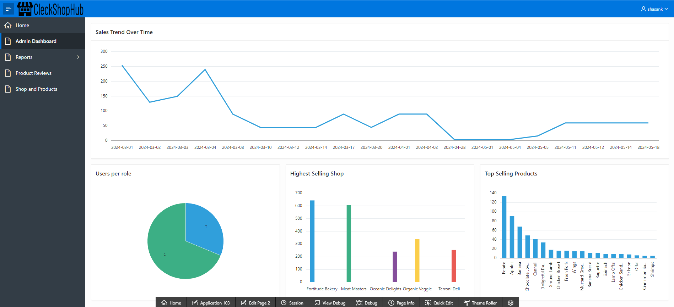

1. ADMIN_DASHBOARD displays sales over time, user role, highest selling shop and top selling products.



1. Product Reviews display all the details about product and it’s reviews in master- detail form where the master form is Product whereas the detail form is Reviews of the Products.

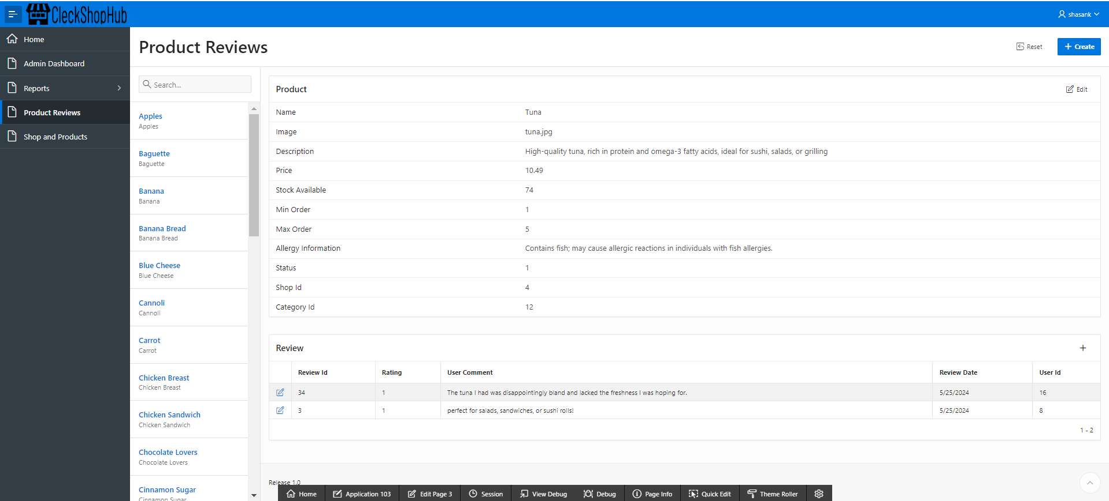

1. SHOPS_AND_PRODUCTS display all the shops and their products in master-detail page. The shop is the master form and products are in the detail report.

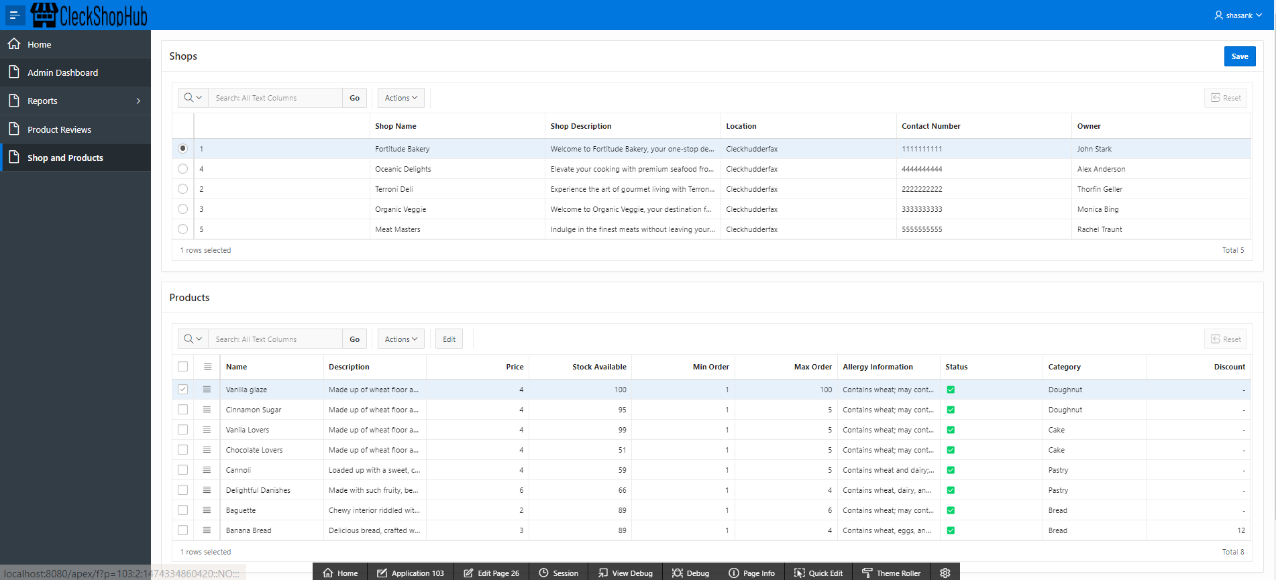

1. WEEKLY SALES REPORTS OF SHOPS display the sales and income of all the shop in past 7 days.

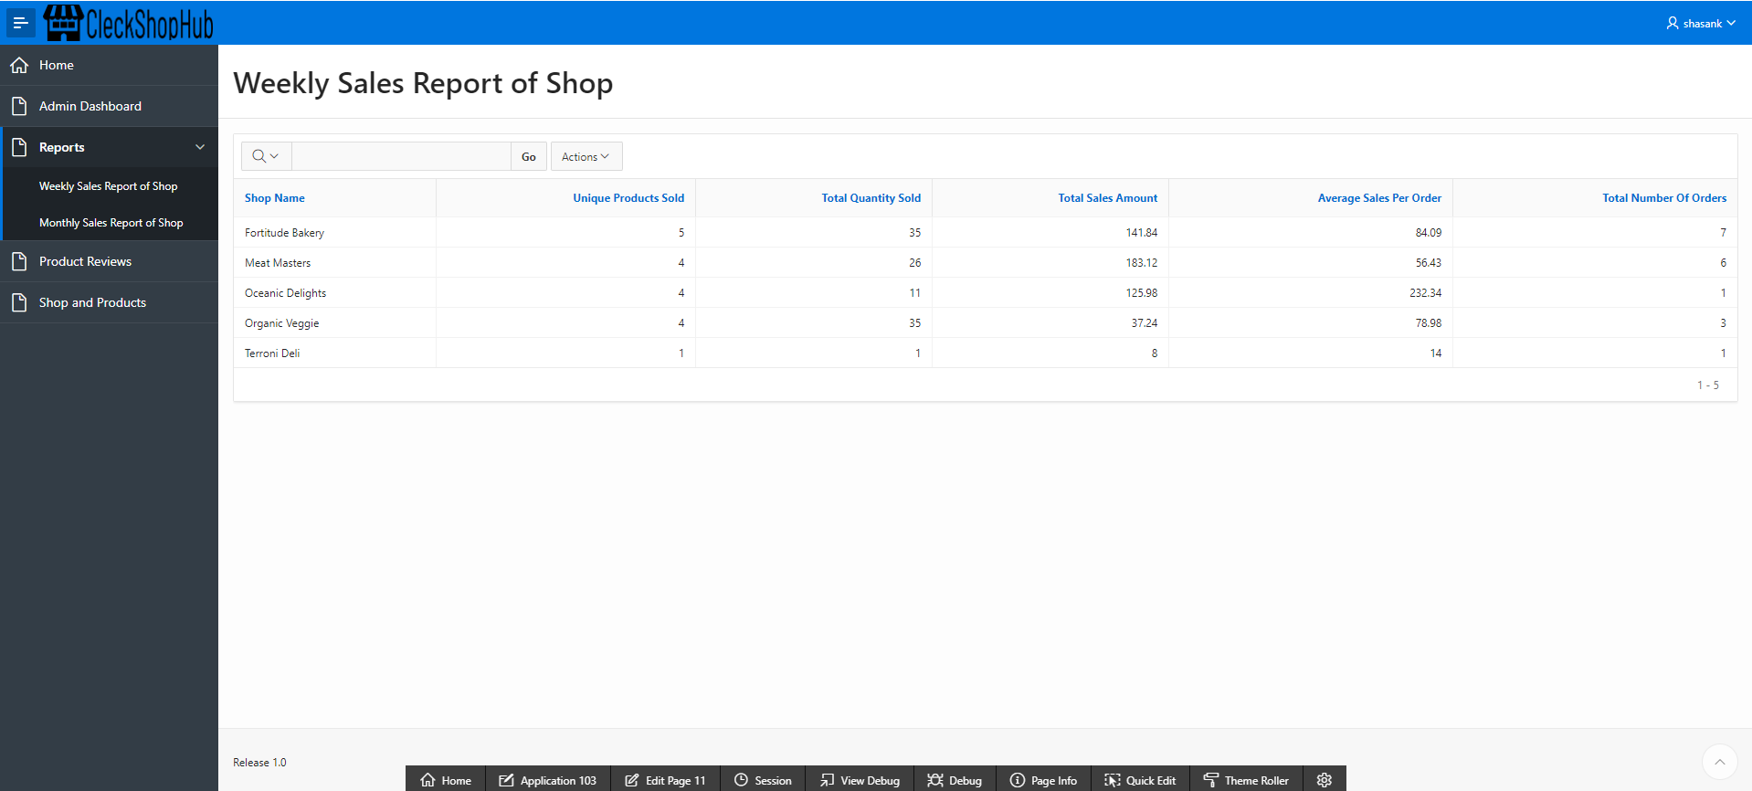

1. MONTHLY SALES REPORTS OF SHOP display the sales and income of all the shop in past month.

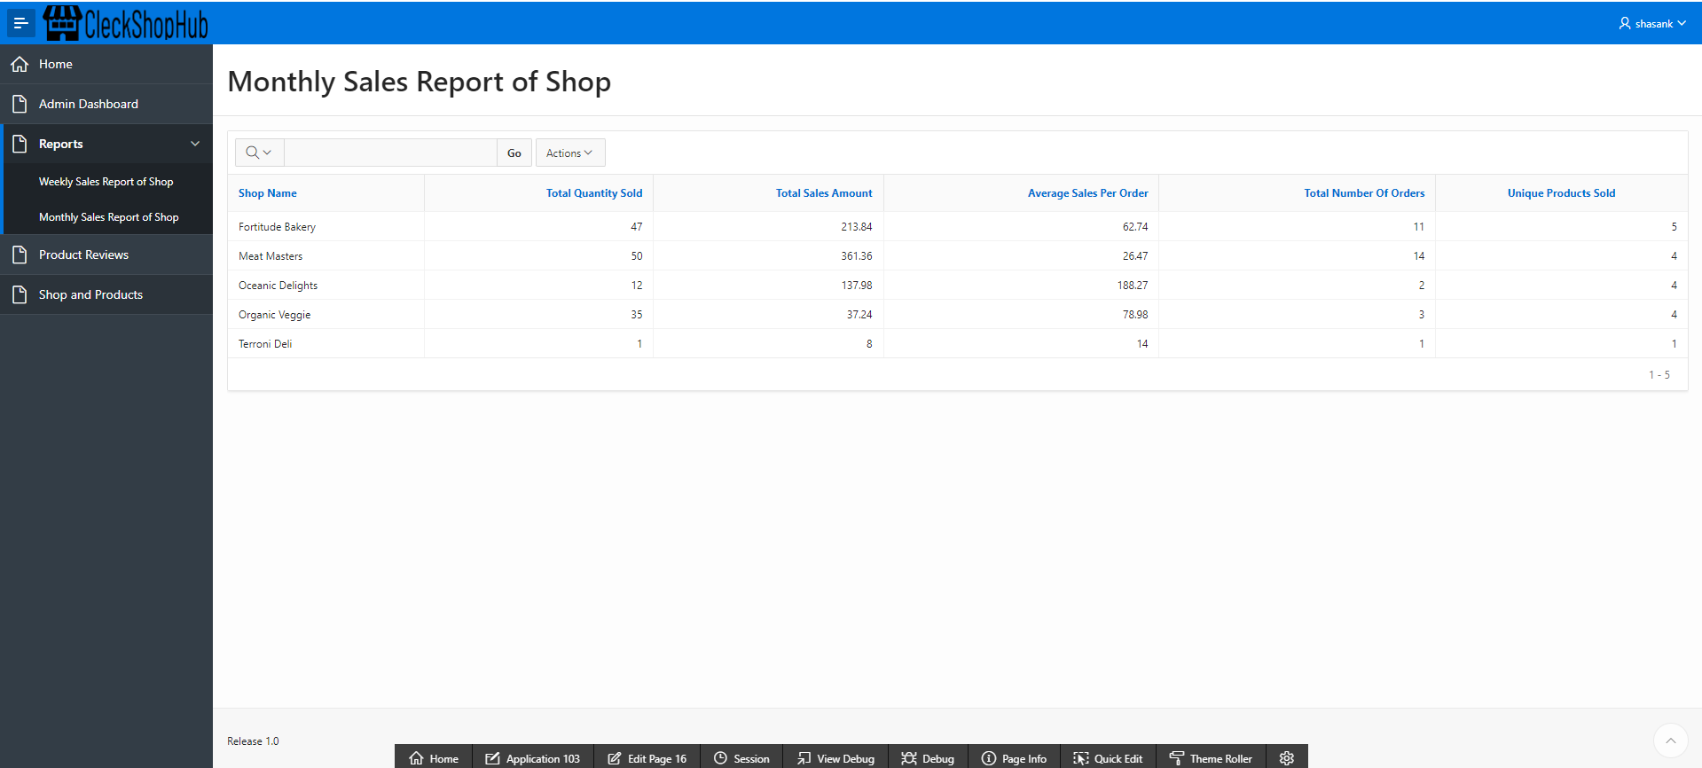

1. You can logout by clicking on username and then Sign out.

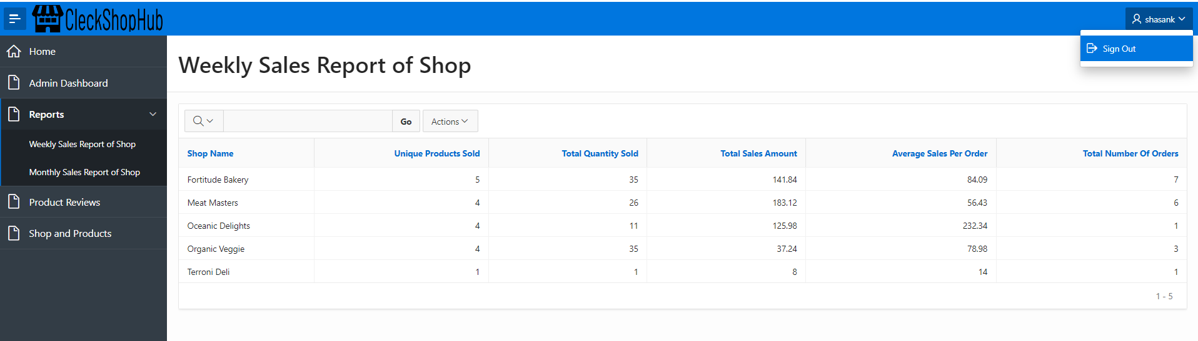

# 5. Frequently Asked Questions

i. What is CleckShopHub?

CleckShopHub is an innovative e-commerce platform tailored for independent local businesses in Cleckhuddersfax, offering a wide range of locally sourced products. It provides customers with convenient access to diverse offerings from various shops, enhancing the local shopping experience and fostering community support.

ii. Why use our service?

Our service, CleckShopHub, offers a convenient solution for customers seeking locally sourced products from independent businesses in Cleckhuddersfax. By using our platform, customers can easily browse a diverse range of offerings, support local businesses, and enjoy a pleasant purchasing experience, all from the comfort of their homes or on the go.

iii. Can I return an item?

As we specialize in offering fresh, locally sourced products through CleckShophub, we prioritize maintaining the highest standards of quality and freshness. Due to the nature of our offerings, we do not accept returns on items.

iv. Why use our service?  
Our service, Cleckshophub, offers a convenient solution for customers seeking locally sourced products from independent businesses in Cleckhuddersfax. By using our platform, customers can easily browse a diverse range of offerings, support local businesses, and enjoy a pleasant purchasing experience, all from the comfort of their homes or on the go.

v. How does Cleckshophub benefit local businesses?

Cleckshophub helps local businesses reach a wider audience and extend their business hours by providing an online platform for showcasing their products. It fosters community support and encourages customers to shop locally.

vi. Is Cleckshophub available for businesses outside Cleckhuddersfax?

Cleckshophub is specifically designed for businesses located in Cleckhuddersfax to promote and sell their products online. It focuses on supporting the local economy and strengthening community ties within the suburb.